REVERBERATION TIME

REVERBERATION

TIME
Introduction
Introduction
Definition
Sabine’s Formula

INTRODUCTION

The concept of reverberation time is central to acoustics and is considered the mindstorm of modern acoustics. It is related with the sound decay in time and was invented by professor Wallace Clement Sabine in 1902.

In general reverberation is the persistence of sound in a particular space after the original sound is produced.

Sabine started his experiments using an organ as a sound source, a stopwatch and his ears; he measured the time from interruption of the source to inaudibility (approximately 60 dB) and found that the reverberation time is proportional to the dimensions of the room and inversely proportional to the amount of absorption present.

It is very important to notice that before the studies carried out by professor Sabine the acoustical evaluation of a room was only empirical.

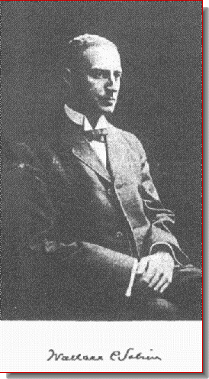
Professor Sabine in 1902

DEFINITION

If we consider a room containing an active sound source and abruptly interrupt the emission of sound energy once it has reached a steady state we obtain the following results as shown in the charts below:

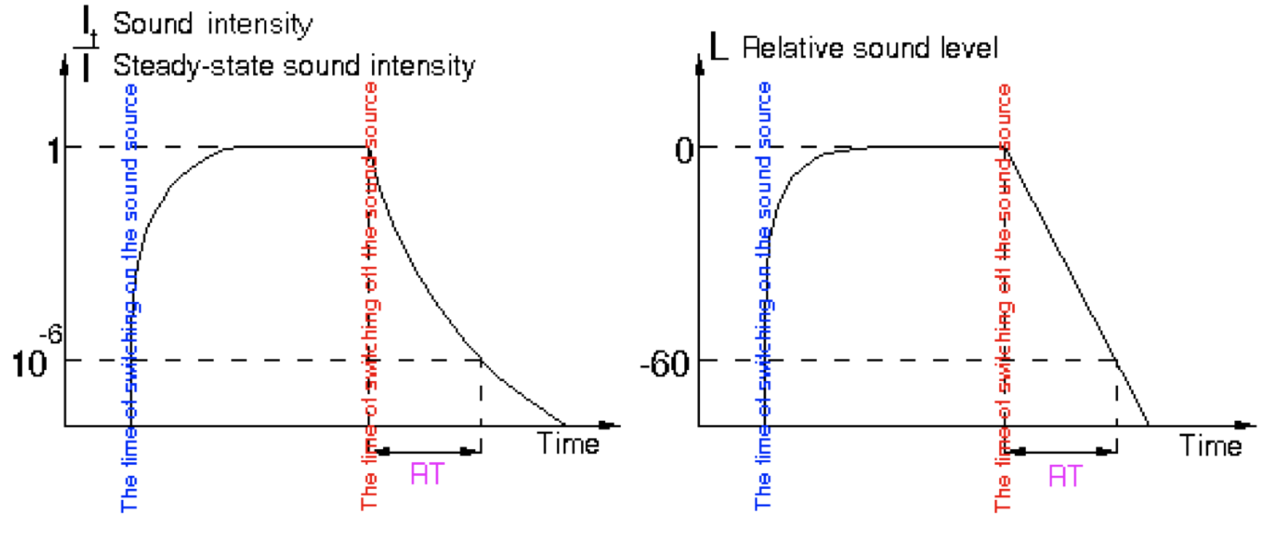

When we switch on the source the sound energy density increases until we reach an equilibrium in which as much power radiated by the source in one second is dissipated in one second.

After we have reached the steady state of sound energy density (in which the room is leaking sound at the boundaries but is continuously getting new sound from the source) we abruptly switch off the sound source.
We can easily verify how the decay is NOT constant.

But if we consider a chart of sound pressure level (dB) shown on the right we can observe that the decay is not exponential like before but linear; in other words the slope of the decay is CONSTANT.

The reverberation time is a strange way of expressing this slope; as a matter of fact normally the slope would be expressed by a quantity in dB/s. Instead the reverberation time was defined as how much time it takes for decaying a certain number of decibels (in particular 60 dB because in his experiment Sabine noticed that the distance between the sound produced by his organ and the backroom noise was 60 dB).

Reverberation time is therefore defined as the time necessary for the sound energy density to decrease to a millionth (60 dB) of the value it had before the source was switched off.

The formal definition although isn’t accurate in practical situations because in a room the sound doesn’t really decay of 60 dB.

First of all the decay is not the continuous line which you would expect by the charts illustrated above.

In fact at the beginning for a certain number of decibels we can see some “gradons” that represent the loss of discrete contribution of the total energy every time a single discrete reflection goes away.

These gradons keep getting smaller in time but at the beginning they are very easy to distinguish.

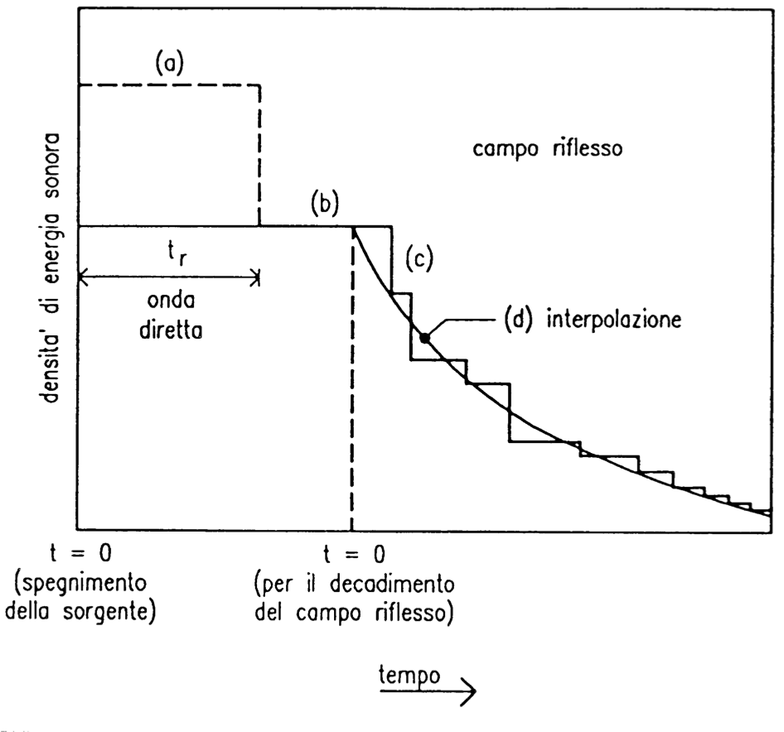

A much more realistic chart is shown below:

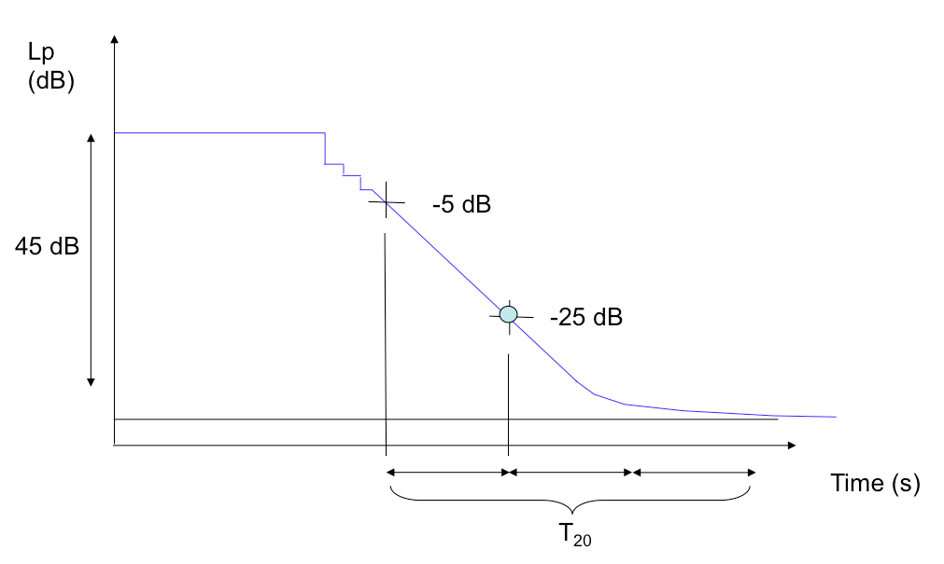
When the sound source is on we have a perfectly costant level, at a certain time the direct sound is interrupted so the sound level falls for a couple of dB.

Then for a short time the sound is still constant until the first reflection goes away and so on (sound reflections become smaller and smaller). After a while we see a decay going down with a certain slope. The curve in the end asymptotically approaches the background noise that is always present in a room.

The current international standard ISO 3382 – 2011 requires to compute not a reverberation time over a decay over 60 dB but recommends to measure the time for a decay starting at -5dB (relative to the steady state level) and ending at -25 dB.
By multiplying this decay time for 3 you easily obtain the True Reverberation Time (T₂₀).

The standard also defines T₃₀ , T₁₀ (unused) and EDT (early decay time).
T₃₀ measures the decay between -5 dB and -35 db, T₁₀ between -5 dB and -15 dB and EDT between 0 and -10 dB.
T₁₀ ,T₂₀, and T₃₀ need to be multiplied by a number of times so that the decay is 60 dB.
If the decay is perfectly linear T₁₀ = T₂₀ = T₃₀

In addition, for the measurements to be correct the end point of the decay must be at least 15 dB above the background noise level. If this does not happen the measurement must be repeated by using a more powerful sound source or by reducing the background noise level.

SABINE’S FORMULA

Professor Sabine defined the concept of Reverberation Time in Boston in 1902. Not only did he explain how to measure it but he also found the way of predicting the reverberation time of a not existing room; in this way you can know in advance how the reverberation time will be depending also on the type of materials of the room.

If the environment is perfectly reverberant the value of the reverberation time is the same in all points and is:

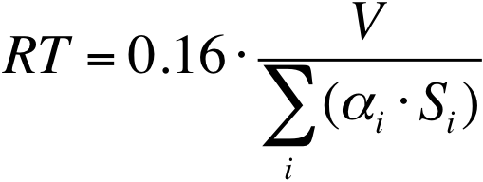

where V is the volume of the environment. It is also possible to determine the equivalent area of acoustic absorption A = α S

If we reverse the formula we can directly obtain the total acoustical absorption area:

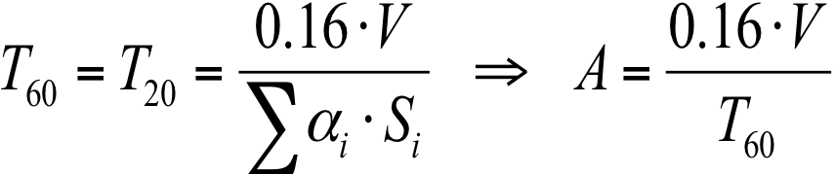

Substituting in the critical distance formula:

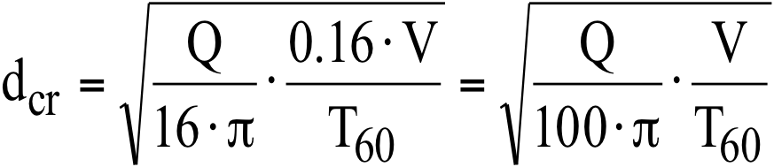

As we can see the critical distance is directly proportional to the volume of the room and inversely proportional to the reverberation time.

