Outdoors propagation of spherical waves in free field

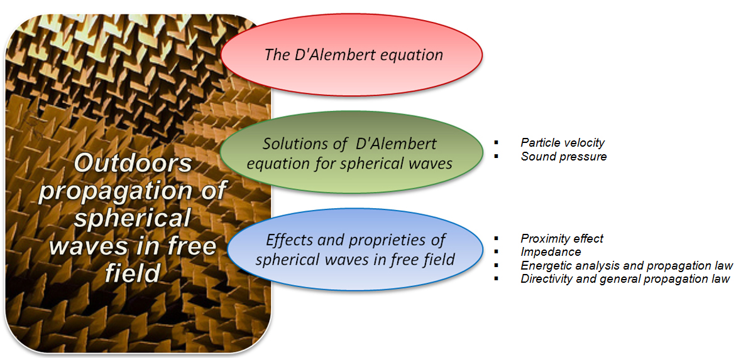

The D’ Alembert equation

Sound is produced by a source and it’s transmitted as propagation to a receiver. Propagation is a phenomenon which is just wave-like and that it could occur both outdoors and indoors.

In order to study the case of outdoors propagation in free field it has been introduced the so-called D’ Alembert equation, which takes its name from the physicist, mathematician and French philosopher who lived between the first and the second half of eighteenth century and who computed the equation.
In particular it is a combination of the continuity equation for fluid motion and of the first Newton equation.
First, in order to write it, let’s consider the Euler’s equation:

$\text{grad}(p)=ρ⋅\frac{∂v}{∂τ}$ (1)

Next we can introduce a scalar variable, that is called potential Φ of the acoustic field, which represents a sort of “common base” of sound pressure p and particle velocity v. Indeed we can note that the spatial and temporal gradient of the potential gives exactly the sound pressure and the particle velocity, as shown here:

$p=−ρ_{0}⋅\frac{∂φ}{∂τ}$ $\vec{v}=\text{grad}(φ)$ (2)

Finally it’s enough substituting these two identities in Euler’s equation to get the following formula:

D ’Alembert equation
$\frac{∂^{2}φ}{∂τ^{2}}=c^{2}⋅∇^{2}φ$ (3)

The D’ Alembert equation permits us to study sound wavefronts propagation in every point of a free field.

Integrating this formula, in fact, we can get the potential Φ and of consequence the pressure and velocity field.
Unfortunately this solving method results so much mathematically hard so we can get solutions only in a few cases. This is possible for progressive plane waves, standing plane waves and spherical waves radiated by a point source.

Solutions of D’ Alembert equation for spherical waves

Let’s consider a sound point source that produces spherical waves.
These waves are generated by a pulsating sphere of radius R, even called “monopole” source, which is represented in Figure 1.

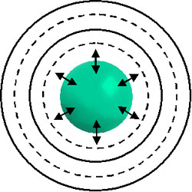
Fig.1 –Schematic representation of a pulsating sphere

This one is defined “pulsating” due to its continuous and periodical expansions and compressions.
Furthermore it’s possible supposing to know and to define two quantities related to this sphere:

- Volume velocity or Source strength (where S is the area of the spherical surface):

$Q=v_{\text{max}}⋅S$ (4)

- Radial velocity of the sphere’s surface (where $ω=2πf$ is the angular velocity):

$v(R,τ)=v_{\text{max}}⋅\text{cos}(\text{ωτ})$ (5)

This formula could be written as in the following expression::

$v(R,τ)=v_{\text{max}}⋅e^{j\text{ωτ}}$ (6)

where $e^{j\text{ωτ}}=\text{cos}(\text{ωτ})+j\text{sin}(\text{ωτ})$
$\text{cos}(\text{ωτ})$: real part
$j\text{sin}(\text{ωτ})$: imaginary part

In the previous equation we can note an imaginary exponential term, which represents the periodicity of the surface’s velocity. This representation is acceptable because, as we can see above, it could be written as a sum of periodic functions. In particular the imaginary unit is a mathematic artifice which doesn’t exist in the real world, where waves occur. Because of this it will be possible to neglect the fictitious imaginary part from the expression of the exponential term, obtaining back equation (5).
Finally we deduce that both (5) and (6) are the same in the real world, where imaginary numbers do not exist.
Now, known these quantities, we consider the pulsating sphere of radius R and in particular the outgoing waves, which means that $r≥R$.
In this condition it’s quite easy to solve the D’ Alembert equation of the previous paragraph for spherical waves, extracting the value of particle velocity at any radius r:
Particle velocity
$v(r,τ)=v_{\text{max}}⋅\frac{R^{2}}{r^{2}}⋅\frac{1+j⋅k⋅r}{1+j⋅k⋅R}⋅e^{j\left[\text{ωτ}−k\left(r−R\right)\right]}$ (7)

Then, thanks to Euler’s equation, it’s possible to compute the value of sound pressure:
Sound pressure
$p(r,τ)=ρ_{0}⋅c⋅v_{\text{max}}⋅\frac{j⋅k⋅R^{2}}{r⋅(1+j⋅k⋅R)}⋅e^{j\left[\text{ωτ}−k\left(r−R\right)\right]}$ (8)

where in both cases $k=\frac{ω}{c}=\frac{2πf}{c}=\frac{2π}{λ}$

In particular k is called the wave number.

Let’s take now the particle velocity (7), and let’s evaluate the modulus of the oscillating velocity:

$\left|v(r,τ)\right|=v_{\text{max}}⋅\frac{R^{2}}{r^{2}}⋅\sqrt{\frac{1+(k⋅r)^{2}}{1+(k⋅R)^{2}}}$ (9)

Looking at this formula it appears that the dependence of the modulus of particle velocity v from radius r follows a not-linear law, which can be approximated by a proportionality to 1/r² for small values of kr, and by a proportionality to 1/r for large values of kr.

Effects and proprieties of spherical waves in free field

Proximity effect

The analysis of the solutions (8) and (9) of the D’ Alembert equation can be studied in two different kinds of sound field: the far field and the near field. These ones are not absolute definitions as meaning that, in any case, the real distance between source and receiver couldn’t be the only value to be considered, but it must be compared to the wavelength.
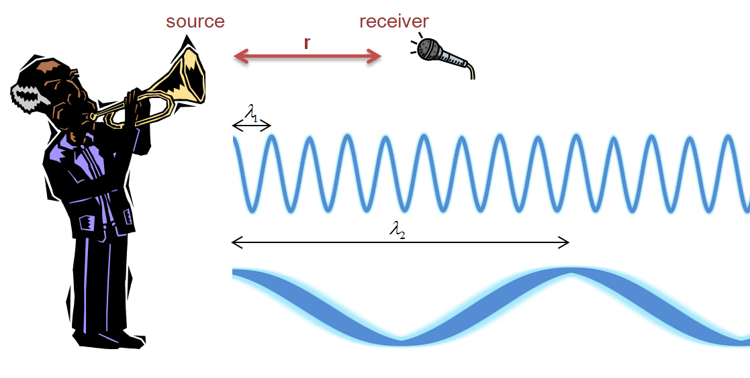
Fig.2 –Far and close field difference

By the example in Figure 2 we note that the distance between source and receiver remains the same, however the field definition changes depending on the wavelength (in particular we get a far field if we consider the high frequency of the first wave and instead a near field considering the low frequency in the second wave).

So let’s study the proprieties and effects of both fields:

- Far field ($r\text{>>}λ$): in this kind of field it’s possible to suppose $k⋅r\text{>>}1$.
Then we realize the term 1 in the velocity nominator (9) is insignificant compared to kr. So computing and simplifying, the square of r in the denominator disappears. At the same time the relationship between pressure and r is not affected by the value of kr.
Of consequence the proportionality laws in far field are the following:

Far field
$p∝\frac{1}{r}$ $v∝\frac{1}{r}$ (10)

- Near field($r\text{<<}λ$): as opposite of the first kind of field we get $k⋅r\text{<<}1$.
In this case, in the velocity nominator (9) the insignificant term will be $\text{kr}$ and no simplification occurs. The term $r^{2}$ will still be in the denominator. The relationship between pressure and distance will remain the same as before.
At last the p and v tend to these:

Near field
$p∝\frac{1}{r}$ $v∝\frac{1}{r^{2}}$ (11)

This means that close to the source the particle velocity becomes much larger than the sound pressure. Furthermore a close field will often occur for low frequencies. Then, this will be important related to the different kind of microphones which exist; the more a microphone is directive, as cardioids or hyper cardioids ones, the more it will be sensitive to the particle velocity, as opposite to an omnidirectional microphone which senses only the sound pressure. So, the more a microphone will be placed close to the source the more low frequencies will be boosted, and this is called proximity effect.

The capability of understanding and taking advantage of this effect could be really useful for singers.

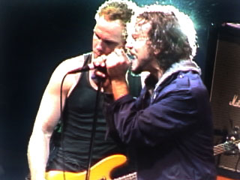
Fig.3 –A singer who is “eating” the microphone

The more the microphone is placed far from the singer’s mouth the more high frequencies will be captured (in proportion to low frequencies). This is the perfect situation for making high notes with voice. At the same time, in order to sing in a deeper way, the singer may decide to approach more and more the microphone, until giving the impression of “eating” it. And this boosts the low end of the spectrum of his voice.

Impedance

The impedance of a spherical field is a characteristic quantity, which is defined as the ratio of sound pressure and particle velocity. We can get the following expression of impedance using the solutions of D’ Alembert equation:
$Z(r)=\frac{p(r,τ)}{v(r,τ)}=ρ_{0}⋅c⋅\frac{\text{jkr}}{1+\text{jkr}}=ρ_{0}⋅c⋅\left(\frac{k^{2}⋅r^{2}}{1+k^{2}⋅r^{2}}+j⋅\frac{k⋅r}{1+k^{2}⋅r^{2}}\right)$ (12)

Then it’s possible to analyse this quantity far or close to the sound source. For the following cases let’s consider this expression of impedance:

Impedance
$Z(r)=ρ_{0}⋅c⋅\frac{\text{jkr}}{1+\text{jkr}}$ (13)

- Far from the source: as it has been already explained the distance has to be evaluated in comparison with the wavelength. The far field occurs when it’s possible to suppose $r\text{>>}λ$ and of consequence $k⋅r\text{>>}1$.
In the impedance’s denominator the term 1 will be insignificant compared to $\text{jkr}$, and simplifying we get $Z(r)=ρ_{0}⋅c$. This represents the same impedance of a plane, progressive wave, as the imaginary part vanishes. This means that pressure and velocity are in phase far from the source: the more the wavefront travels away from the source, the larger will be its curvature radius, meaning that it actually behaves as a plane wave.
This is the most usual case of wave propagation.

- Close to the source: again the distance must be compared to the wavelength $\left(r\text{<<}λ\right)$ and we can suppose $k⋅r\text{<<}1$.
In this condition the denominator becomes substantially 1, so we get finally $Z(r)=ρ_{0}⋅c⋅\text{jkr}$. Impedance is an imaginary number and of consequences velocity and pressure will have a phase shift of 90° (when the value of velocity is at maximum the value of pressure is null and vice-versa).

Then, for a little sphere in which $\left(R\text{<<}λ\right)$, it will be difficult to radiate energy. The sound intensity is given by:

$I=p_{\text{rms}}⋅v_{\text{rms}}⋅\text{cos}\left(φ\right)$ (14)

If we consider now the phase shift φ becoming very close 90°, Intensity will tend to zero. This is a sort of paradox, in which, while this small sphere is pulsating with extremely large velocity, it seems to not irradiate any energy.
We conclude that a “little” sphere will be able to irradiate less energy than a bigger one.

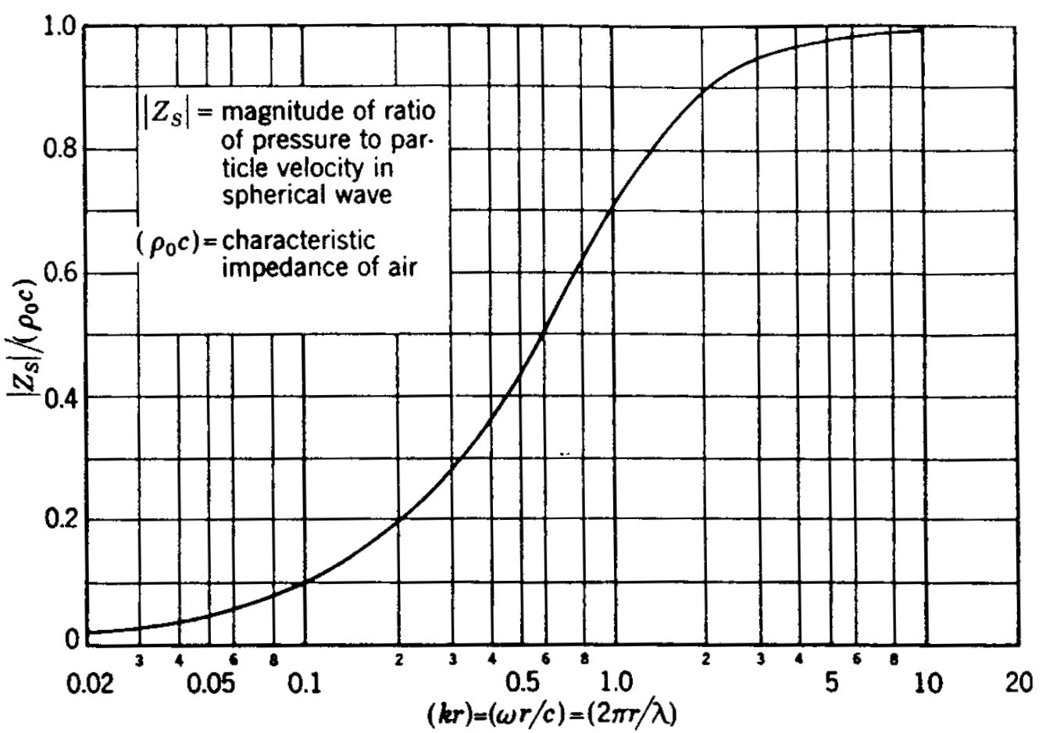
Fig.4 –Impedance (Magnitude)

Figure 4 shows us the chart of normalized impedance magnitude, given by the ratio of impedance’s magnitude $\left|Z_{s}\right|$ and the characteristic impedance of air $ρ_{0}⋅c$, plotting in abscissa the value of $\text{kr}$ and so either distance or frequency. When $\text{kr}$ increases the curve of impedance boosts up. Above a value of $\text{kr}=5$ energy transmission will be easier and easier. Oppositely, when $\text{kr}$ becomes small, the impedance decreases significantly and energy transmission will be harder and harder.

It is possible to draw another chart as in Figure 5. In the abscissa we still have $\text{kr}$, while in ordinate we see the phase angle φ in degrees. So we can see here an explicit representation of the phase’s variation and of what it implies. When $\text{kr}$ decreases the phase shift tends to 90°, while if $\text{kr}$ increases pressure and velocity result in phase. So it is clear that in the first case energy transmission will be hard because the Intensity tends to zero.

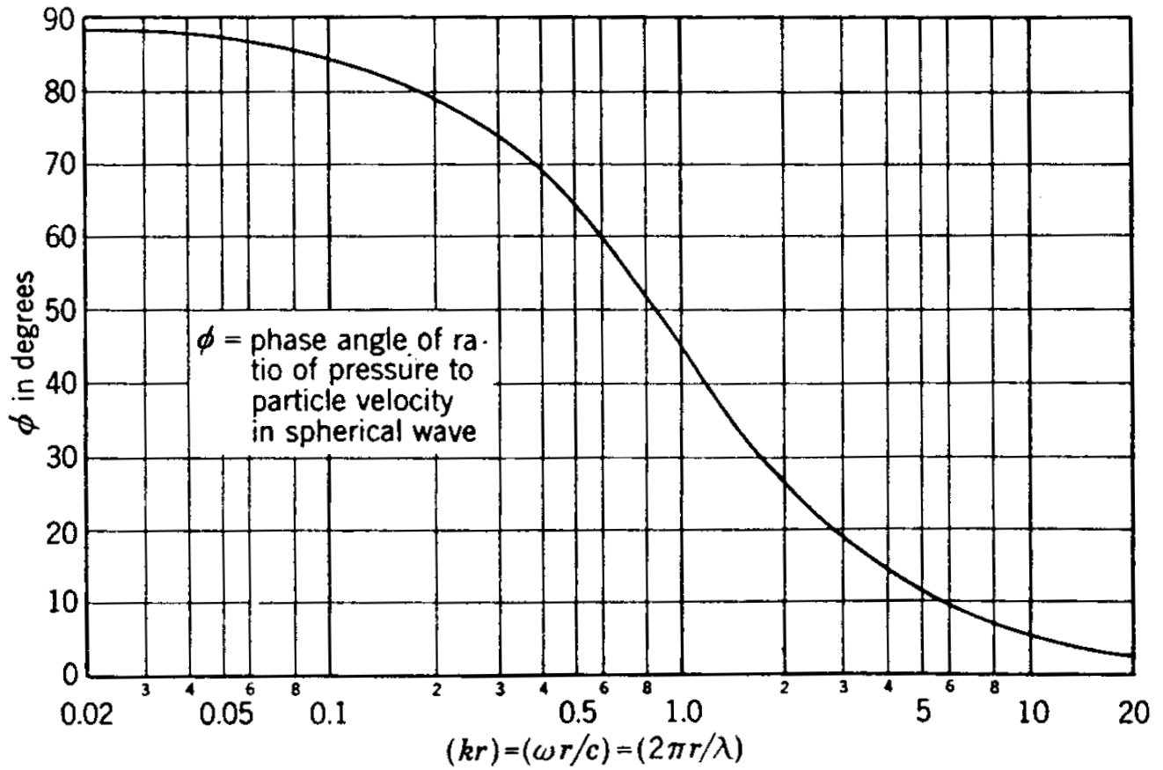
Fig.5 –Impedance (phase)

Energetic analysis and propagation law

Let’s consider a far field, the most common one, in which sound pressure and particle velocity are in phase and an energetic analysis is easy.
We defined the sound intensity I as the ratio of sound power and surface:

Sound intensity
$I=\frac{W}{S}$ (15)

Then, if we get a point source of power W , it’s possible to note that a geometrical divergence occurs according to the increase of the distance.
In particular the area over which the power is dispersed increases with the square of the distance as shown in Figure 6.
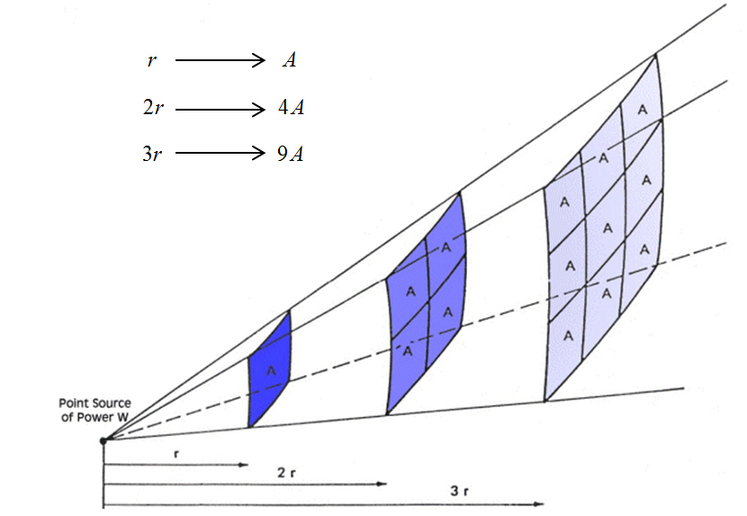
Fig.6 –Geometrical divergence

Now, remembering that a point source irradiates a spherical wave over a spherical surface S, we can write the following expression:

$I=\frac{W}{S}=\frac{W}{4{πr}^{2}}$ (16)

Using this formula it is possible to find the equation which describes the spherical waves free propagation from an omnidirectional source (meaning that for every direction the same sound intensity is transmitted and that the space is free form any reflecting surfaces).
In order to find this equation let’s compute the intensity level $L_{I}$, which is the representation in $\text{dB}$ of the sound intensity:

$L_{I}=\text{10}\text{log}\frac{I}{I_{0}}$ $\left(\text{dB}\right)$ (17)
Employing the value of intensity as we see in formula (16) and multiplying and dividing for $W_{0}$ (in order to extract the power lever $L_{w}$) we have:
$L_{I}=\text{10}\text{log}\frac{I}{I_{0}}=\text{10}\text{log}\left(\frac{\frac{W}{4{πr}^{2}}}{I_{0}}\right)=\text{10}\text{log}\left(\frac{\frac{W}{4{πr}^{2}}}{I_{0}}⋅\frac{W_{0}}{W_{0}}\right)$ (18)
Next, computing and reorganizing the terms in logarithm:

$L_{I}=\text{10}\text{log}\frac{W_{0}}{W_{0}}+\text{10}\text{log}\frac{W_{0}}{I_{0}}+\text{10}\text{log}\frac{1}{4π}+\text{10}\text{log}r^{−2}$ (19)
where:
- $\text{10}\text{log}\frac{W_{0}}{W_{0}}$ is the power level $L_{w}$
- $\text{10}\text{log}\frac{W_{0}}{I_{0}}$ is a null term. Indeed $W_{0}$ and $I_{0}$ have different measurement units but the same numerical value ${\text{10}}^{−\text{12}}$. Of consequence $\text{log}\left(1\right)=0$
- $\text{10}\text{log}\frac{1}{4π}$ is equal to -11
- $\text{10}\text{log}r^{−2}$ can be written as $−\text{20}\text{log}r$

Finally for a spherical and omnidirectional wave far from any reflecting plane the d’ Alembert equation could be replaced with the following one, that is the free field propagation law in dB:

Propagation law in free field
$L_{I}=L_{w}−\text{11}−\text{20}\text{log}r$ $\left(\text{dB}\right)$ (20)

Unfortunately a spherical wave can propagate free from any reflecting surface in a really few cases. Free field conditions can be obtained in a lab, inside an anechoic chamber, which is shown in Figure 7.
So, if the point source is near a reflecting surface it will be necessary to introduce a corrective factor.

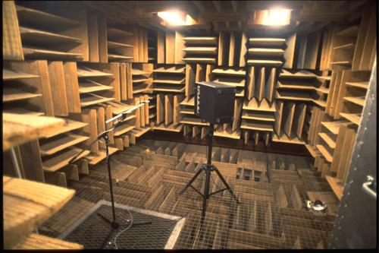
Fig.7 –An anechoic chamber
Directivity and general propagation law

As it has been said the formula (20) has limitations according to the position of the sound source
It’s possible to introduce the directivity factor Q, which is the ratio of sound intensity in direction $ϑ$ and the average sound intensity in the case of an omnidirectional source:
Directivity
$Q=\frac{I_{ϑ}}{I_{0}}$ (21)

Figure 8 shown us schematically the difference between the waves radiated by an omnidirectional source (blue) and by a generic one (red).
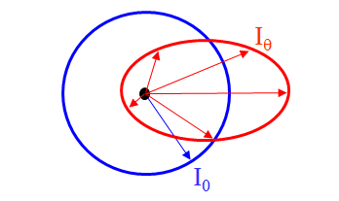
Fig.8 –Omnidirectional source (blue) and generic source (red)

So directivity will change according to the direction and to the frequency.
In order to write a new general propagation law the directivity factor will assume a logarithmic form.
Then we introduce the directivity index DI:
Directivity index
$\text{DI}=\text{10}⋅\text{log}\left(Q\right)$ $\left(\text{dB}\right)$ (22)

This index will be added to the formula (20).
In most cases we can assume to be in far field, in which case sound pressure and velocity are in phase and in this means that $L_{p}=L_{I}$ (to express the formula with $L_{p}$ is much reasonable because of our ears, which sense pressure, not intensity).
At last the general propagation law will be written as the following one:

General propagation law
$L_{p}=L_{I}=L_{w}−\text{11}−\text{20}\text{log}r+\text{10}\text{log}Q$ $\left(\text{dB}\right)$ (23)

We even note that the pressure level changes according to the distance from the source. If it is doubled, having so $r⋅2$, the first logarithm in formula (23) will be:
$−\text{20}\text{log}\left(r⋅2\right)=−\text{20}\text{log}\left(r\right)−\text{20}\text{log}\left(2\right)=−\text{20}\text{log}\left(r\right)−6\begin{matrix} \\ \text{dB}\end{matrix}$ .
This means that for spherical waves every time the distance is doubled the value of $L_{p}$ decreases by $6\text{dB}$.
This value is called decay factor ${ΔL}_{2}$ and it will change according to the different kind of waves (for cylindrical waves the decay factor is 3 dB instead of 6).

Finally it’s possible to study the directivity factor when a point source is placed near one or more reflecting surfaces. We can for example differentiate four cases, as shown in Figure 9.

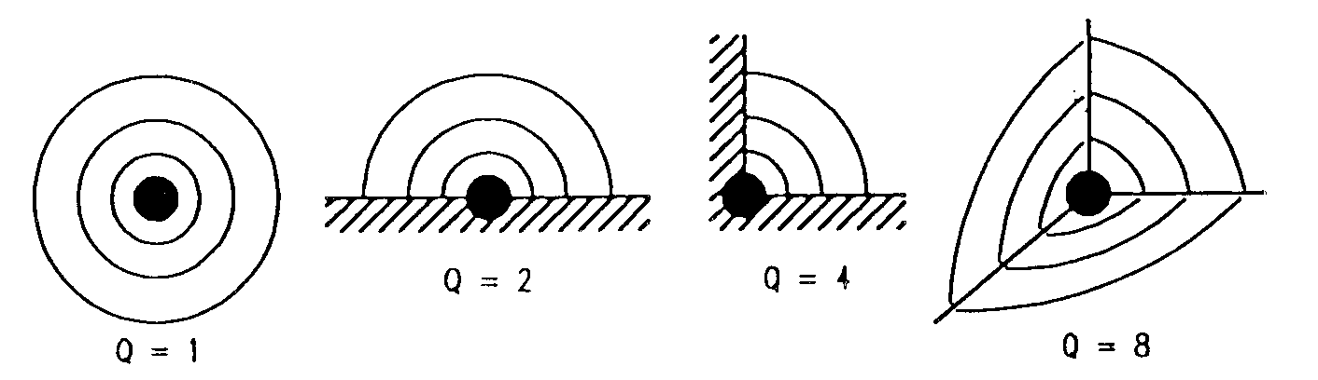
Fig.9 –Q value according to its position close to reflecting surfaces

We differentiate these four cases:

- $Q=1$ when the source is far from any reflecting surface. In this case it will be possible to use formula (20), in which the directivity index disappears: $\text{DI}=\text{10}⋅\text{log}\left(Q\right)=\text{10}⋅\text{log}\left(1\right)=0$

- $Q=2$ when the source is over a reflecting surface. Above the reflecting plane the intensity will disperse on a hemisphere and not on a sphere. So its value will be doubled because of reflection.

- $Q=4$ when the source is in a corner. The intensity will be dispersed on a quarter of sphere, so its value will be 4 times the free field intensity.

- $Q=8$ when the source is in vertex. As the previous cases the intensity grows of factor of eight.

