Numerical model of the sound field inside cars
for the creation of virtual audible reconstructions

- Farina (1)
E. Ugolotti (2)

- Industrial Eng. Dept., University of Parma, via delle Scienze
43100 Parma (ITALY) - Email: farina@pcfarina.eng.unipr.it

HTTP://pcfarina.eng.unipr.it

(2) ASK Automotive Industries s.p.a., via F.lli Cervi 79

42100 Reggio Emilia (ITALY) - Email: tec_ask@sirnet.it

Main Steps

Experimental measurements  Aurora plug-ins + CoolEdit  Maximum Length Sequence  excitation signal  1:5 Scale Model  Binaural microphones | Numerical simulation  Low frequency simulation with Boundary Elements  High frequency simulation with  Pyramid Tracing (Ramsete)  Conversion to wide-band pressure impulse responses | Auralization  Aurora Real-Time  convolution plug-ins  Stereo-Dipole reproduction over closely-spaced loudspeakers  Subjective listening tests

Experimental measurements

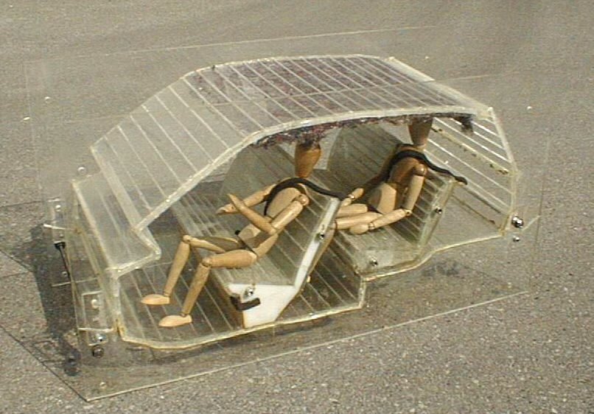

1:5 scale model built with Plexiglass
and sound absorbing wool

Experimental Results (binaural impulse responses)
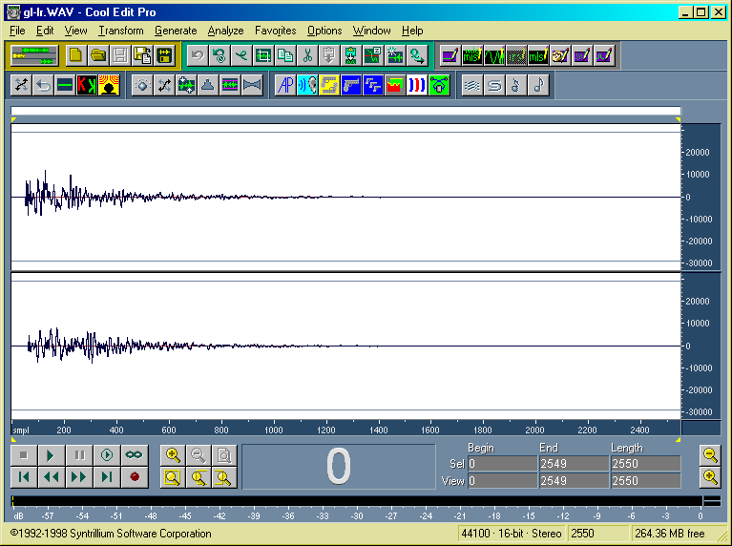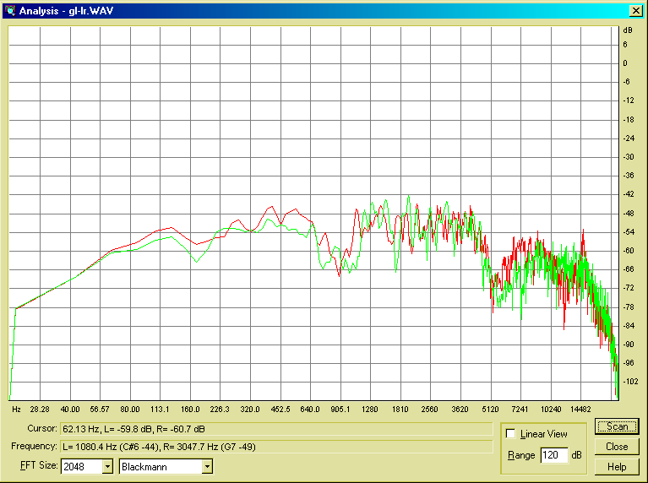

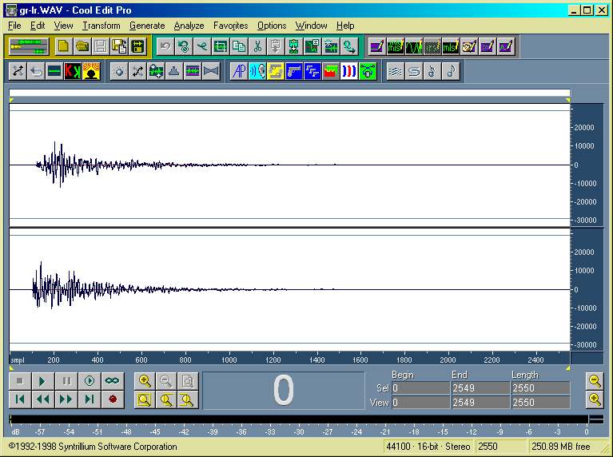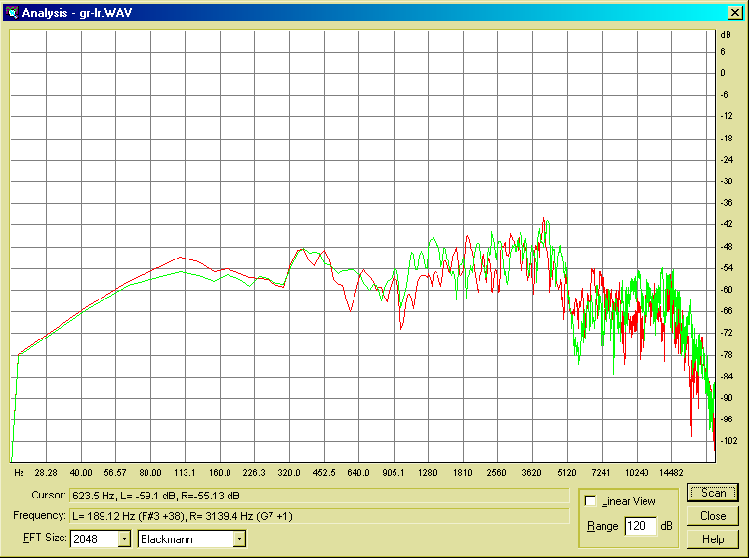

Numerical simulation
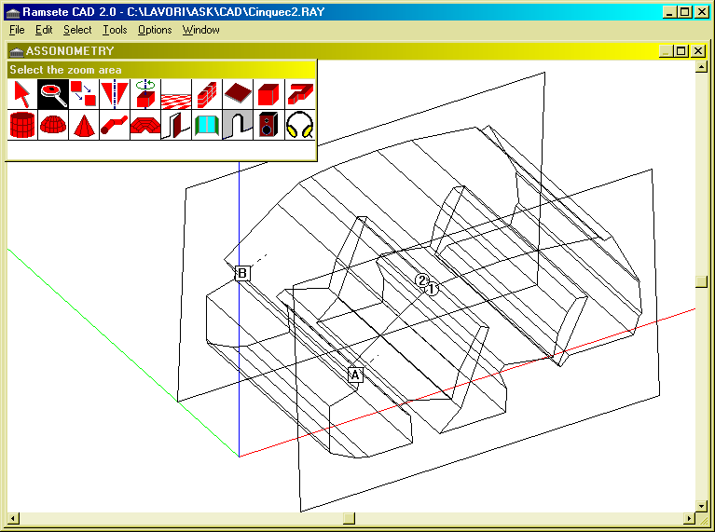

3D surface model of the car compartment, with 2 loudspeakers and 2 microphones

Ramsete Pyramid Tracing program

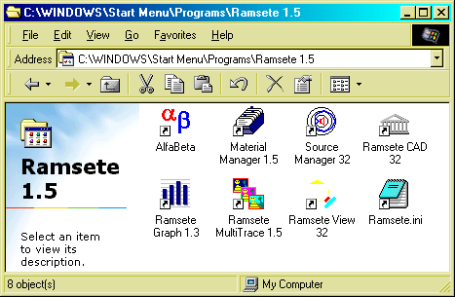

The Pyramid Tracing algorithm is based on the Geometrical Acoustics assumptions, but it takes into account random scattering and boundary diffraction. Ramsete is a WIN32 program, including a dedicated surface CAD, utilities for managing databases of sound sources and material properties, a fast multi-tracer capable of batch processing, and advanced graphical post-processing and colour-mapping tools.

Look at HTTP://www.ramsete.com for more info.
Computation of the energetic impulse responses inside the car’s numerical model

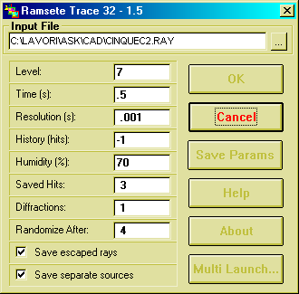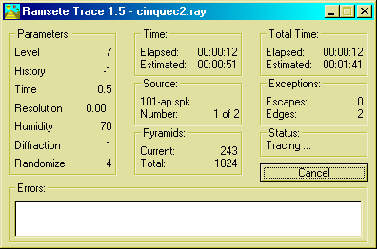
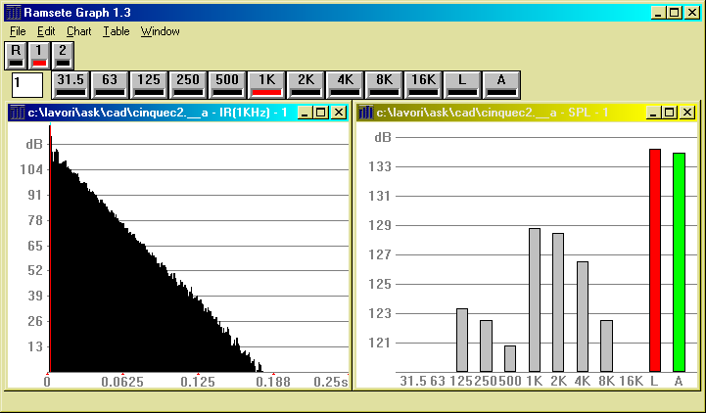
At each receiver point and for each source, the results are computed in octave bands

Graphical analysis of the sound propagation inside the car

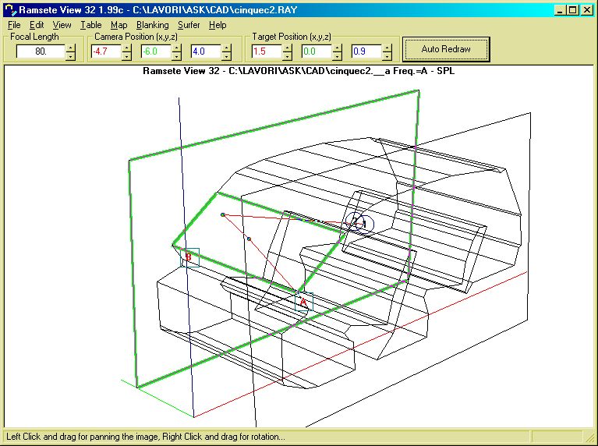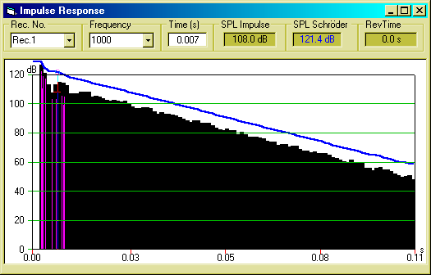

The ray paths are evidenced both in 3D geometry and over the energetic impulse response, for each sound source and each receiver.
Conversion of octave-band energetic impulse responses
into wide-band pressure impulse responses

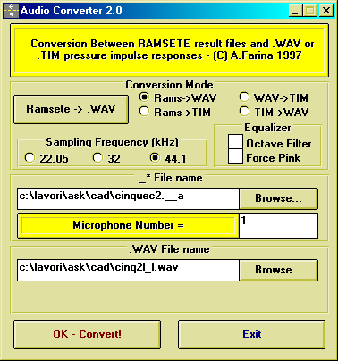  Automatic translation of the Ramsete results into .WAV impulse responses | 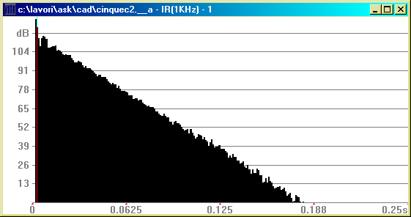  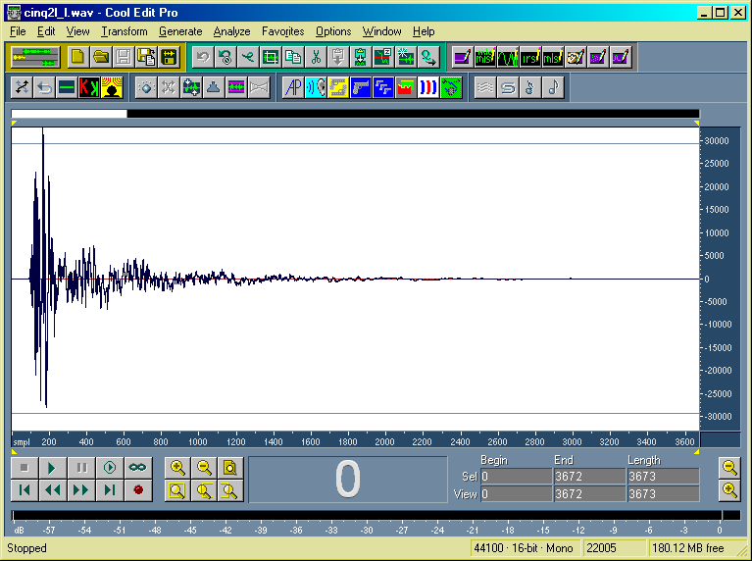
Directivity patterns of the loudspeakers

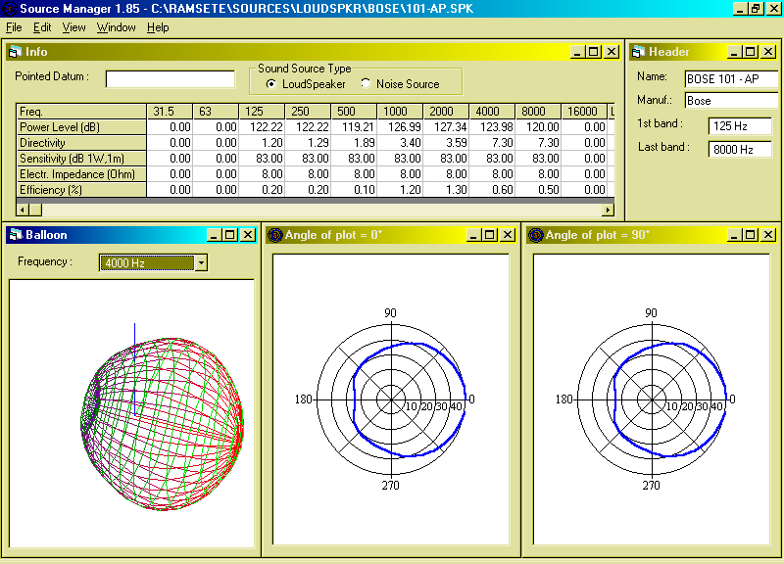
The Source Manager program maintains the source directivity data-base
for hundredths of different sound sources

Numerical Results (binaural impulse responses)
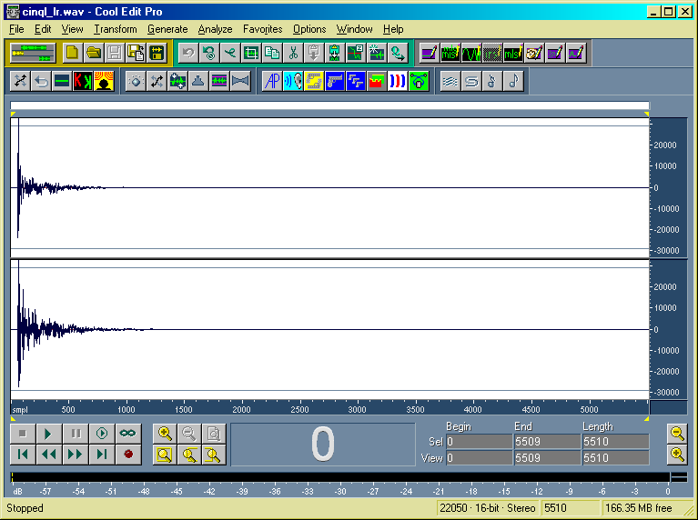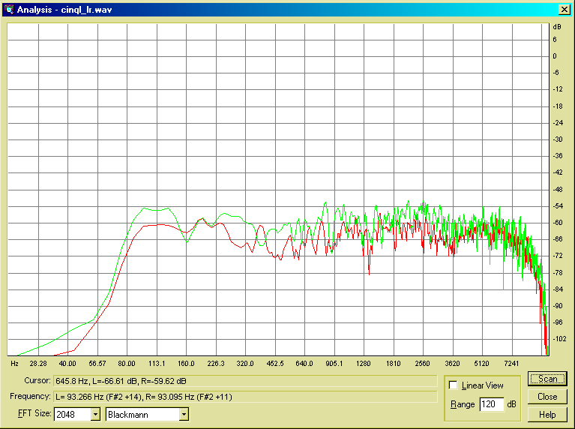
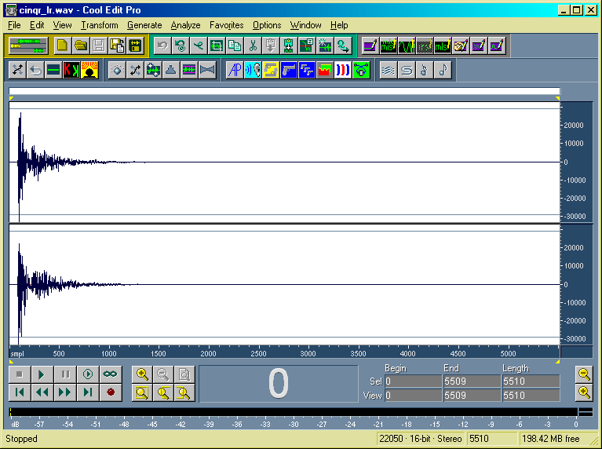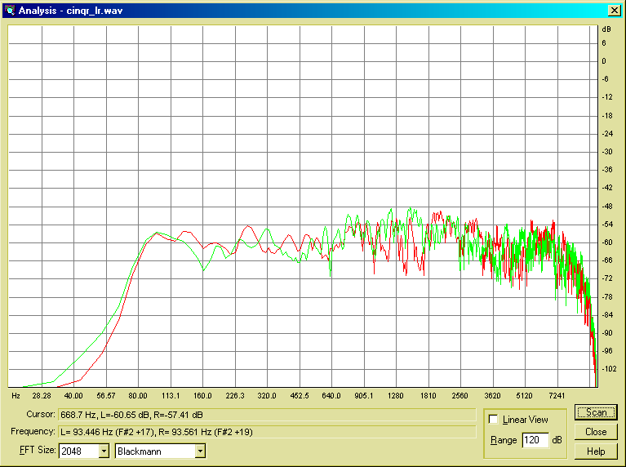

Auralization

An audible reconstruction of a complex sound field can be obtained by the CONVOLUTION
of the original signals with the impulse responses which connect
each sound source position with each receiver.

AURORA Plug-ins for CoolEdit

The following plug-ins have been produced for the program CoolEdit 96/ CoolEdit Pro (by David Johnston)

-  Generate MLS signal  -  Generate IRS signal  -  Deconvolve MLS signal  -  Deconvolve IRS signal  -  Convolve with clipboard  -  Real-time convolver  -  Acoustical parameters (ISO 3382) | -  Inverse filter (Mourjopoulos least-squares technique)  -  Flatten spectrum (Nelly and Allen)  - Inverse filter (Kirkeby frequency-domain regularization)  -  Cross-talk cancellation (Stereo Dipole)  -  MLSSA files import/export filter  -  RAMSETE files import filter

Automated subjective listening tests

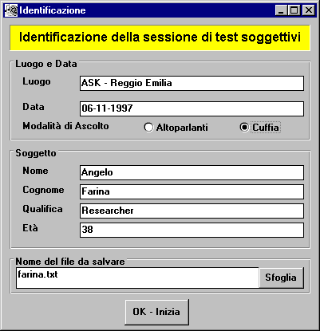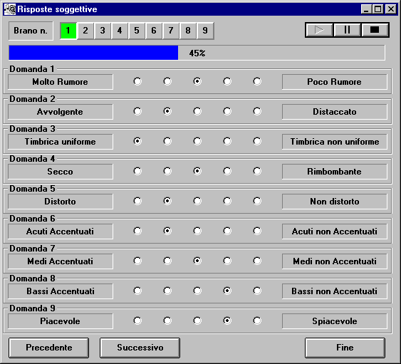

User’s interface of the subjective test program

GENERATION OF THE EXCITATION SIGNALS

Basic shift register for the creation of the MLS signal
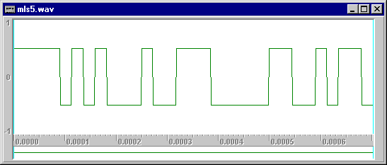
MLS sequence of order 5

The MLS signal is very similar to a very stable with noise, with low crest factor (3 dB).
It is employed for stimulating the system under test, and from the response of it, the impulse response can be easily obtained thanks to the Fast Hadamard Transform. A further improvement of the S/N ratio can be achieved by synchronous averaging.

Deconvolution of the system’s response

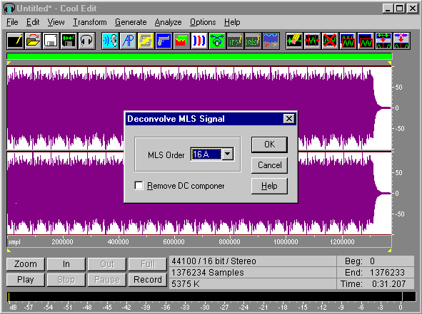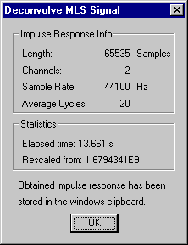
Deconvolution of the system’s impulse response
from the sampled signal

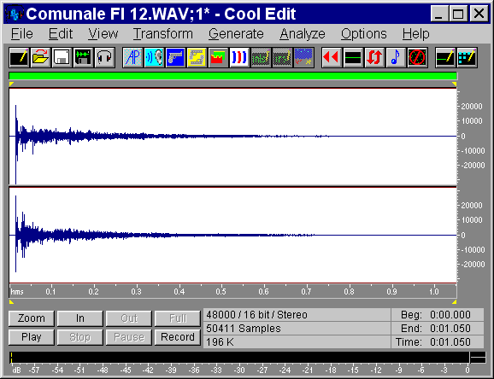
Deconvolved binaural impulse response

4-channels car-audio measurements

Layout of the measurement system with 2 dummy heads

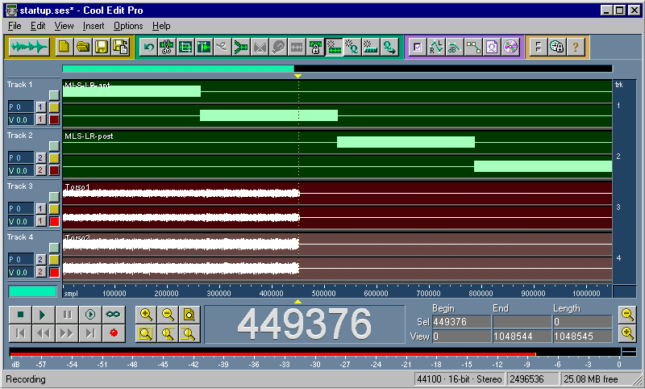

Cool Edit Pro during the simultaneous Playback & Record

Post-processing software for car audio

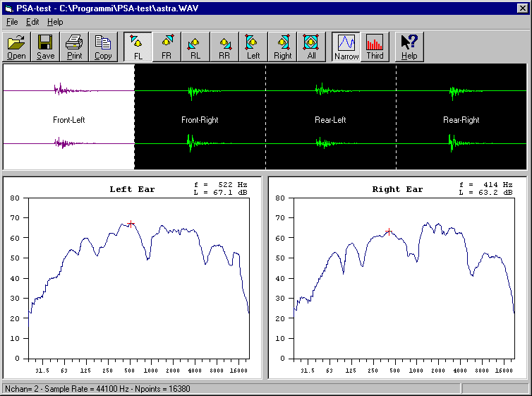
Post-processing window, narrow-band mode of a single loudspeaker

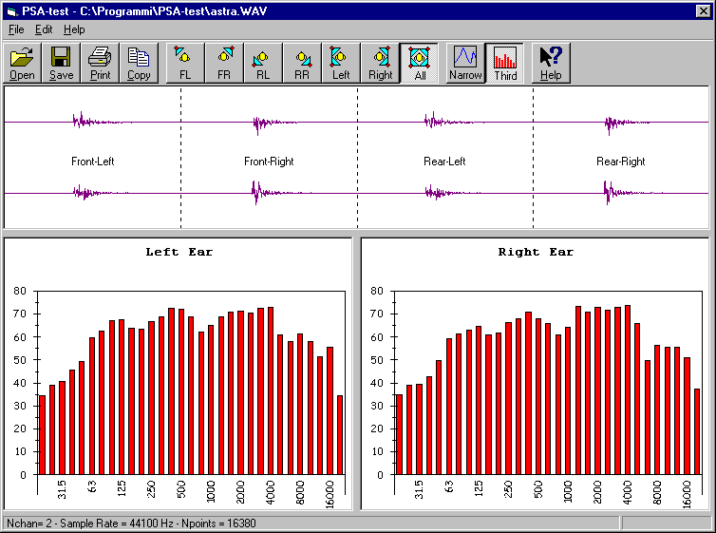
Post-processing window, 1/3 octave mode of all 4 loudspeakers

Real-time software convolver

The convolution of a continuos input signal x(t) with a linear filter characterized by an impulse response h(t) yields an output signals y(t) by the well-known convolution integral:
$$y(τ)=x(τ)⊗h(τ)=\int_{0}^{∞}{x(τ−t)⋅h(t)⋅\text{dt}}$$
When the input signal and the impulse response are digitally sampled (t = i·Dt) and the impulse response has finite length N, such an integral reduces to a summation:
The sum of N products must be carried out for each sampled datum, resulting into an enormous number of multiplications and sums!
But the Select-Save algorithm operating in the frequency domain, dramatically reduces the number of required computations, allowing the real-time implementation on a (fast) PC:

As the process outputs only M-N+1 convolved data, the input window of M points must be shifted to right over the input sequence of exactly M+N-1 points, before performing the convolution of the subsequent segment.

Real-Time I.R. limit length on a Pentium Pro 200

I.R. Channels | 1 | 2 | 4
Mono Input | > 800,000 taps | 210,000 taps | -----
Stereo Input | 280,000 taps | 60,000 taps | 12,000 taps

Real-time software convolver

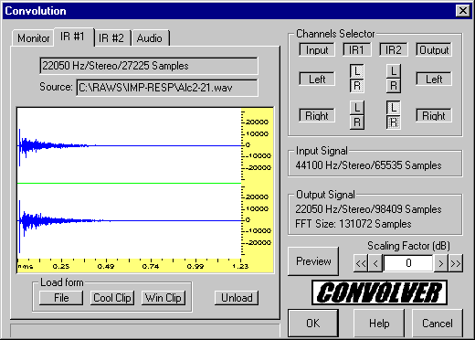

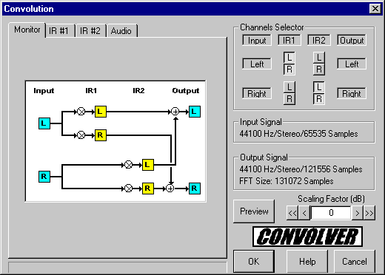

User’s interface of the real-time convolver module

CONCLUSIONS

- The experimental technique based on MLS measurements revealed to be very fast and reliable, even on an 1:5 scale model
- The numerical simulation at medium and high frequency was conducted with the Pyramid Tracing program Ramsete, which produced reasonable results (as of computed decay times and spectra)
- The addition of the low-frequency response, computed with a Boundary Element program, revealed to be difficult, due the fact that this technique does not produce a suitable impulse response
- The auralization of the computed impulse response made it evident that the simulation IS NOT identical to the experimental measurements

Future Developments
- It will be attempted to improve the simulation by introducing loudspeaker’s directivity data obtained by the tweeters actually employed in the scale model, introducing the geometrical description of the head and body of the passengers, and refining the geometrical description.
- Furthermore, a direct experimental measurement of the impedance/absorption coefficient of the boundaries should also improve the simulation’s accuracy.
- The Ramsete software will be further improved, introducing directly inside it the complex formulation required for taking into account the wavy effects at low frequency, so that a separate simulation with a different computer code will be no more necessary

