rLesson 1: NATURE OF SOUND

Ingredients for sound
Sound is basically caused by pressure fluctuations, which are what humans can perceive through air.
We must deal with quantities that relate to the nature of sound and other ones that are prettily descriptive, such as amplitude, frequency, period and wavelength.
It’s important to underline that there is no mass-transfer: it seems like a contradiction but there’s no air coming out from speaker’s mouth and arriving to listeners’ ears.
To have sound we must have BOTH

- SOUND SOURCE and an
- ELASTIC MEDIUM

The sound source is the object where energy generates and is transformed, usually mechanical energy is transformed into acoustic energy.
To hear sound far from the source, an elastic medium, or an almost elastic medium is needed. Otherwise a bit of energy is dissipated and sound extinguishes in a few meters.

Harmonic motion of a piston
Let’s imagine a circular and infinitely long tube like this:

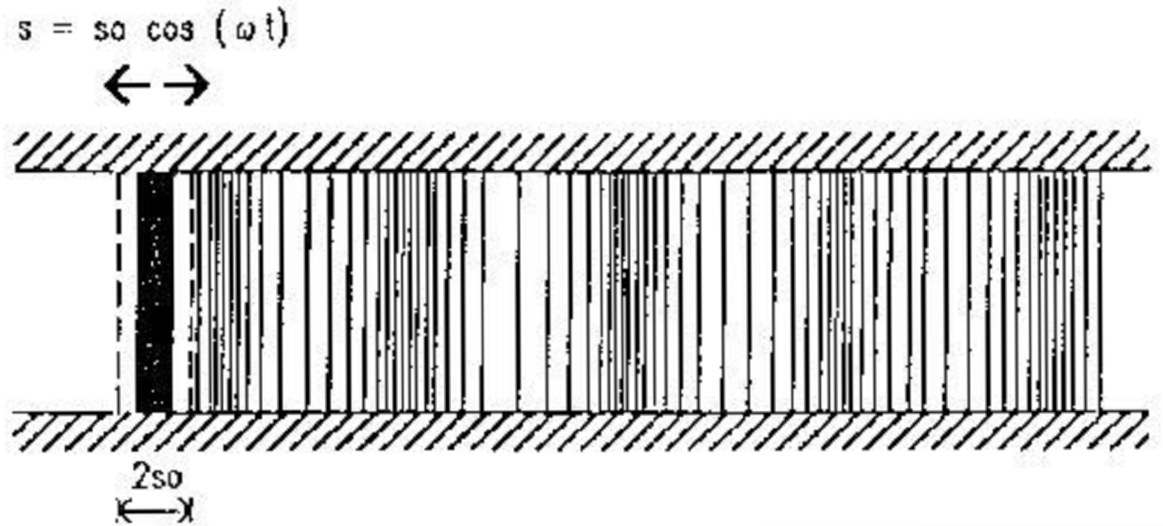
The piston moves back and forth along the axis of the pipe.
The law that describes the particle movement is a harmonic law:

$$s=s_{o}⋅\text{cos}(ω⋅t)$$

where ω= pulsation, or angular velocity, in rad/s
t= time in s
The total piston run is long 2·s_{o} , half length on the left (-s_{o} ) and half on the right (+s_{o} ) of “zero”, which is the origin of the axis.
We impose a motion to the air moving the piston: when the piston is on the left, it leaves more space and air expands (specific volume increases), when the piston is on the right, on the other hand, air is locally compressed because there is less volume available, and hence the specific volume decreases.
The presence of an elastic medium translates these volume variations in pressure fluctuations.
Pressure fluctuations propagate through the tube.

If we look at the motion of one particle we see that it moves back and forth, it does not go away. What flows towards right is the wave.
So with “speed of sound” we mean the speed of the wave, it’s up to the characteristics of the medium, and it does not depends on the sound’s loudness.
The “particle velocity” is the motion of particles around their equilibrium position. It can be large or small if the particles move quickly or slowly, depending on the sound’s loudness.
The “sound pressure” at one point is the instantaneous deviation of the pressure from the average air pressure.

Here we see three important quantities and their relationships:
- f= frequency the number of cycles performed by the planar surface in one second, measured in Hertz.
- T= period time required to make a complete cycle.
- ω = angular velocity (rad/sec)

These three quantities are related by the following formulas:

$f=\frac{1}{T}$ (1) and $f=\frac{ω}{2π}$ (2)

The wavelength
Another very important quantity is the wavelength λ: it is described as the distance travelled by the wave in 1 period.
As the period is usually much smaller than 1s, the wavelength λ is always smaller than the speed of sound c, as shown in the following figure:

wavelength = distance between two peaks of the wave

Wavelength λ changes with inverse proportionality to frequency, as shown here:
$$λ=\frac{c}{f}$$
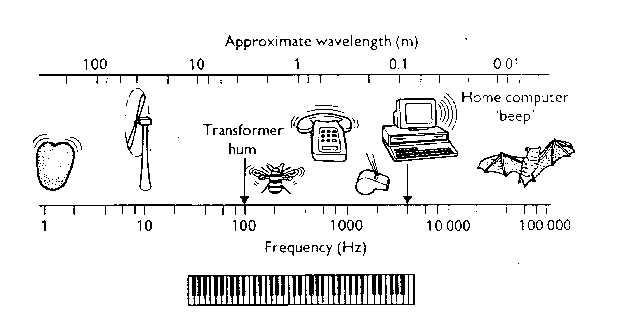

Audibility range
The phenomenon that occurs between 20 and 20,000 Hertz is called “sound” and it can be perceived by humans, below 20 Hertz it is called “infrasound”, above 20,000 Hertz it is called “ultrasound”.

1 – 20 Hz: Infrasound
20 – 20.000 Hz : Audible sound
> 20 kHz: Ultrasound

There are three kinematical descriptors of the motion of a body:

- Displacement : $s=s_{0}⋅\text{cos}(ω⋅τ)$ (3)
- Velocity : $v=\frac{\text{ds}}{\text{dt}}=−ω⋅s_{0}⋅\text{sin}(ω⋅τ)$ (4)
- Acceleration : $a=\frac{\text{dv}}{\text{dt}}=\frac{d^{2}s}{{\text{dt}}^{2}}=−ω^{2}⋅s_{0}⋅\text{cos}(ω⋅τ)$ (5)

If the piston is connected to a rotating wheel, the displacement, or in other words the distance between the centre of the rotor and the centre of the rod driving the piston, is constant, but we can make the system move faster or slower by changing the angular speed.

The most relevant quantity is velocity, for two reasons: it is proportional to pressure (and what we hear is pressure), and the energy involved is proportional to the square of velocity.

The Sound Speed
The sound speed in air, or in another perfect gas, is given by this exact formula:

$c=\sqrt{γ⋅R⋅T}$ speed of sound
$γ=1\text{.}\text{41}$ exponent of adiabatic law

$R=\text{287}\begin{matrix} & \end{matrix}\left[\frac{J}{\text{kg}⋅K}\right]$ constant of perfect gas law for air
$T=(t+\text{273})\begin{matrix} & \end{matrix}\left[K\right]$ absolute temperature

At temperatures around 20°C, the above exact formula can be approximated as:

c = 331.4 + 0.6·t
At 20°C: $c_{0}=\text{343}\begin{matrix} & \end{matrix}\frac{m}{s}$

In fresh water, sound’s speed is much larger than in air, as shown in the following table:

Speed of Sound in Water at various temperatures

In salt water that is free of air bubbles or suspended sediment, sound travels at about 1560 m/s. The speed of sound in seawater depends on pressure (hence depth), temperature (a change of 1 °C ~ 4 m/s), and salinity (a change of 1‰ ~ 1 m/s), and empirical equations have been derived to accurately calculate sound speed from these variables. Other factors affecting sound speed are minor. Since temperature decreases with depth while pressure and generally salinity increase, the profile of sound speed with depth generally shows a characteristic curve which decreases to a minimum at a depth of several hundred meters, then increases again with increasing depth (right).

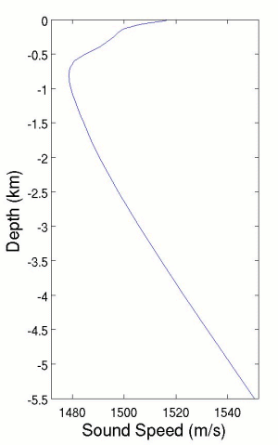

In solids, the speed of sound depends on stiffness and density, according to the following formula:
$c=\sqrt{\frac{E}{ρ}}$ (7)
E= elastic modulus (N/m²)
ρ= density (kg/m³)
c_{o}= speed of sound in air (m/s)

The sound travels faster if E is large and ρ is small.

The following table contains several values of speed of sound in solids:

Density and Speed of Sound of solids
Material | Speed
Material | (m/s)
Aluminum | 6420
Brass | 3475
Brick | 4176
Concrete | 3200 - 3600
Copper | 3901
Cork | 366 - 518
Diamond | 12000
Glass | 3962
Glass, Pyrex | 5640
Gold | 3240
Hardwood | 3962
Iron | 5130
Lead | 1158
Lucite | 2680
Rubber | 40 - 150
Steel | 6100
Water | 1433
Wood (hard) | 3960
Wood | 3300 - 3600

Physical Quantities

In order to characterize the sound we need, first of all, to define five principal physical quantities:

- Sound Pressure (symbol: p, measured in Pascal (Pa)). It represents a deviation from the average value of the pressure of the elastic medium in a certain point of space and in a defined time.

- Particle velocity (symbol v, measured in m/s). It represents a deviation from the average value of the velocity of the particles of the elastic medium in a certain point of space and in a defined time. Air is usually assumed as still with some exceptions, as the presence of an air conditioning system.
These two first quantities are both Field Quantities: they are function of both time and space and their value may be different from point to point in space. It is obviously very difficult to associate to each point of the space its correct value of sound pressure and particles velocity.

Being the propagation through the elastic medium of the sound not a flow of particles but the propagation of physical quantities, in the shape of waves, air motion and pressure differences are strictly bound by a cause effect relationship.

This relationship, under the simplest conditions (a plane wave propagating inside a duct), becomes:

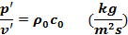

is the density of the elastic medium and c₀ is the speed of sound in the elastic medium. Z= ρ₀c₀ is called Acoustic Impedance of the plane wave, and it is measured in kg/sm², or in its own unit of measure, which is the rayl.

N.B.: Impedance is generally a complex number when the waves are not in phase. Pressure and velocity are both real numbers, but their ratio is a complex one: this is mathematically incorrect, but it works in practice. (It is regarded as a weak point of the acoustic theory).

For complex wave fronts the maximum values of pressure and velocity are not enough to describe the SOUNDFIELD (made of 4 scalar quantities, 3 for particle velocity, one for pressure). Generally it is used the RMS (Root mean squared) value to evaluate the average amplitude of the values of pressure and velocity.

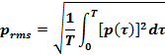

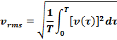

Both the RMS values have an energy meaning, being related to squared velocity (kinetic energy) and squared pressure (potential energy).
The last three quantities we use to characterize the sound are energetic ones. They are usually averaged quantities, both in time and in space.

- Sound energy density (symbol D, measured in J/m³). It represents the energy contained in a cubic meter of the elastic medium.
In case of plane, progressive waves the sound energy density is the sum of a kinetic and a potential contribution.

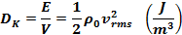

Where D_{k} is the kinetic energy density and the RMS value of particles velocity is the same velocity of the piston.

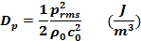

D_{P} is the density of the energy stored due to the elastic compression of the medium (potential energy). Therefore:

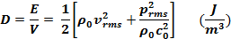

In the general case, it is required to know D for complete assessment of the Sound Field.

- Sound Intensity (symbol I, measured in W/m²)
Intensity is a vector quantity that measures the flow of a physical quantity through a surface; in particular the Sound Intensity is defined as the energy passing through the unit surface in one second:

In case of plane waves, Intensity is proportional to the energy density and to the speed through which the elastic medium flow through the section of the pipe.

- Sound power (symbol W, measured in Watt).
The sound power is a measure of the capability of the sound source to radiate sound, while Sound Intensity is a measure of the effects of the radiation. This cause-effect relationship is shown here:

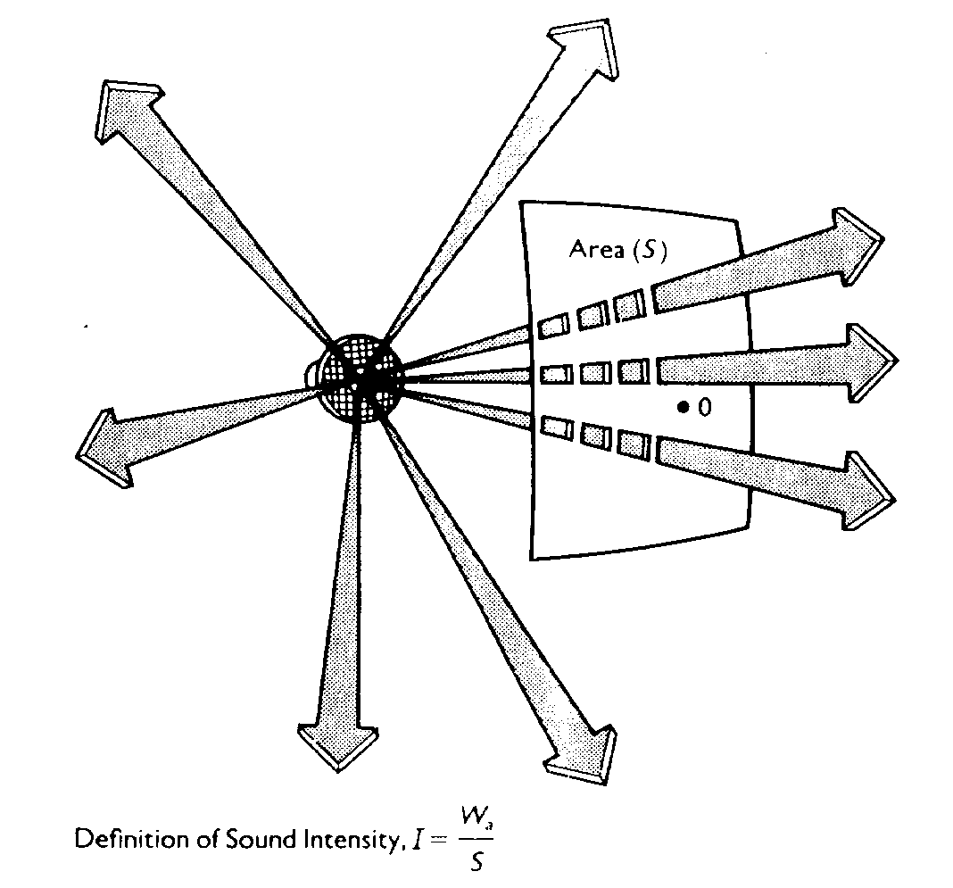

As shown in the figure above, a source of given sound power W produces a sound intensity I which reduces as the square of distance. So the cause (the power) is always the same, the effect (the intensity) reduces with distance.
In the general case of not-uniform radiation, the sound power W emitted by a sound source is given by the surface integral of the sound intensity I:

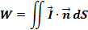

And, if the total surface S can be divided in N elementary surfaces S_{i}, each one characterized by a sound intensity I_{i}:

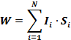

The Decibel Scale

The decibel scale is a logarithmical scale used to express physical quantities related to Acoustic and other sciences. The decibel scale is mainly used in order to:

- Compress the huge dynamic range of the physical quantities:
Human hearing threshold ÷ Pain Threshold
I= 1pW/m² (10¹² ratio) I= 1W/m²
P= 20 μPa (10⁶ ratio) P= 20 Pa
- Mimicking the human perception law: loudness doubles in our perception when intensity increases of a factor of 10.
- Make many operations easier.
When expressed in decibels, physical quantities are followed by the term “level”:

Sound pressure level: L_{p} = 10 log p²/p_{rif}² = 20 log p/p_{rif} (dB)
where p_{rif} = 20 μPa. It refers to the squared value of pressure because it is related to potential energy. As human ears are pressure sensors, this is “what we ear”....

Particle velocity level: L_{v} = 10 log v²/v_{rif}² = 20 log v/v_{rif} (dB)
where v_{rif} = 50 nm/s. The squared value of velocity is related to kinetic energy.

Sound intensity level: L_{I} = 10 log I/I_{rif} (dB)
where I_{rif} = 10⁻¹² W/m² (hearing threshold: a negative value of Li can’t be heard by human). Propagating in different direction, L_{I} is generally lower than the energy density level.

Energy density level L_{D} = 10 log D/D_{rif} (dB)
where D_{rif} = 3·10⁻¹⁵ J/m³. It is generally bounded between L_{p} and L_{v.}

All these 4 levels refer to how loud a sound is perceived (EFFECT).
In the particular case of plane progressive waves:

p/v= ρ_{o}c_{o} ÷ I = p²/ρ_{o}c_{o} = D·c₀ ⇨ L_{p} = L_{v} = L_{I} = L_{D}

In the general case, L_{p} is different from L_{v}; L_{D} is intermediate between L_{p} and L_{v}, representing the sum of kinetic energy (proportional to the square of particle velocity) and of potential energy (proportional to the square of sound pressure).
L_{I}, finally, is always systematically lower than L_{D}, as some fraction of the total energy is propagating (causing the sound intensity flow), but some other part is “standing”, not propagating, and hence not contributing to L_{I}.
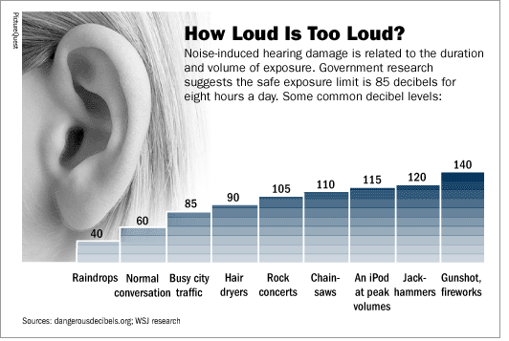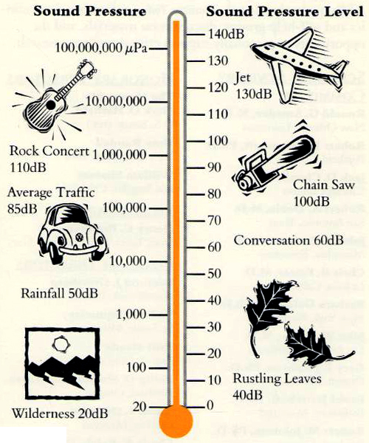
Figure 1- Loudness of sounds in Decibel scale.

- Sound Power Level: L_{W} = 10 log W/W_{rif} (dB) W_{rif} = 10⁻¹² W.
Then we have the Sound Power Level L_{W}: its meaning is completely different, as it does not represent how loud the sound is perceived, it represent the sound emission capabilities of a given sound source. It has to do with the CAUSE, whilst the other 4 levels in dB are related to the EFFECT.
L_{W} usually has a value larger than the other Levels and in case of a plane progressive wave it is related to the Intensity level by the relationship:

Where S is the area through which the sound intensity is being radiated. If the surface area S represents the whole area through which the power flows away from the source, the relationship above is still valid, even when the waves are not plane, progressive ones.

Figure 2- Sound Power Level L_{W} obtained by integrating sound intensity
over the whole radiation surface.

