REPUBBLICA ITALIANA |  | Ing. Angelo Farina
 | DIPARTIMENTO  DI INGEGNERIA INDUSTRIALE | PROFESSORE ASSOCIATO  Dottore di Ricerca in Fisica Tecnica  Cod.Fisc. FRNNGL58P25G337F  ------------------------------------------------------------
I-43100 PARMA – Parco Area delle Scienze, 181/A  Tel. 0521 - 905701 Fax. 0521 - 905705  P.IVA: IT 00308780345  C.F.: 00308780345 |  | Abitazione: Viale Duca Alessandro n° 8 - 43100 PARMA  Tel. 0521 207718 – Fax. 0521 389552  HTTP://pcfarina.eng.unipr.it  E-MAIL: farina@pcfarina.eng.unipr.it

Gerhard Müller & Jürgen Reinhold
Müller-BBM
Robert-Koch-Strasse 11
D-82152 Planegg
München - GERMANY

Parma, 8 February 2004

Subject: comparison between the acoustical behaviour of the new Auditorium
“N. Paganini” in Parma and the ancient Teatro Regio in Parma

In a letter dated 27/10/2002 I reported some complaints about the acoustical behavior of the new Auditorium, accompanied by a preliminary technical analysis. At that time it seemed that the complaints were emerging just from a small number of the listeners, so the situation did not require strong reaction.
During the second regular season of the new Auditorium, more complaints arose between the frequent concert-goers regarding the acoustical behaviour of the room, and particularly with reference at the very different acoustical conditions in comparison with those of the Teatro Regio. Now this opinion is widespread in Parma (also due the typical character of local music lovers, and to the charisma of which certain respected crictics are equipped).
The local newspaper picked these rumours and amplified them, marking on the difference between the “good and old” Teatro Regio and the excessively reverberant new room.
As it is foreseeable that it will be necessary to take some corrective actions for reducing the difference between the two rooms, the undersigned performed a quick comparative analysis for assessing such a difference, both from an objective point of view (acoustical parameters) and from a subjective point of view (preparation of suitable music samples for conducting comparative listening tests by means of the auralization technique).
A lot of acoustical measurements were already performed, both my me and by You, during the first season inside the Auditorium. Furthermore, I conducted a second series of measurements in March 2003, with state-of-the art instrumentation and methods.
I recently repeated the measurements with the very same technique inside Teatro Regio (on 2 february 2004), and consequently it is now possible to make a detailed analysis of the real differences between the two rooms.
It must be understood that most of the concert-goers in Parma hold a yearly subscription, know each other very well, and are quite aged (although some young people also appears, but only on certain top-level concerts). They were used to listen to symphonic music in the very dry environment of Teatro Regio since decades, with little or no experience of the acoustics of a true “concert hall”. Their maximum experience could have been to go to La Scala in Milan (which was also very dry), or to similar opera houses in other cities of the north Italy (Cremona, Reggio Emilia, Bologna, Verona, etc.). So, most of them are in the position to think that this is the way in which symphonic music has to be listened to.
I know very well that in other countries symphonic music is only performed in concert halls, and opera houses are employed only for their original purpose (Italian-style opera), or perhaps as drama theatres or ballets.
However, it must be clear that here in Parma the large number of the audience are this kind of listeners. It is almost impossible that more “international” listener are present, because in most concerts all the seats are sold-out.
Whatever was the initial idea of the architect, and the goal of the acoustical design, it is now very clear that such goal was unappropriate to the type of audience which we have here.
I am not saying that the new Auditorium had to recreate exactly the same acoustical conditions of the Teatro Regio (which, in my opinion, is too much dry, and should be made more brilliant), but I understand that the distance between the two theatres is too large, and must be reduced.
In the following I will report briefly the comparison between the two rooms, with particular focus on the value of the Strenght G and of the reverberation time T20.

Measurement of the Strenght G
The measurement were peformed in both theatres employing an omnidirectional sound source (dodecahedron) equipped with a subwoofer unit and digitally equalized in such a way to irradiate a perfectly flat (pink) spectrum. The measurement of the power of the sound source and the equalization were performed by measuring the effective Sound Power following the ISO standard 9614/2 (Sound Intensity measurements), as shown in the following picture:
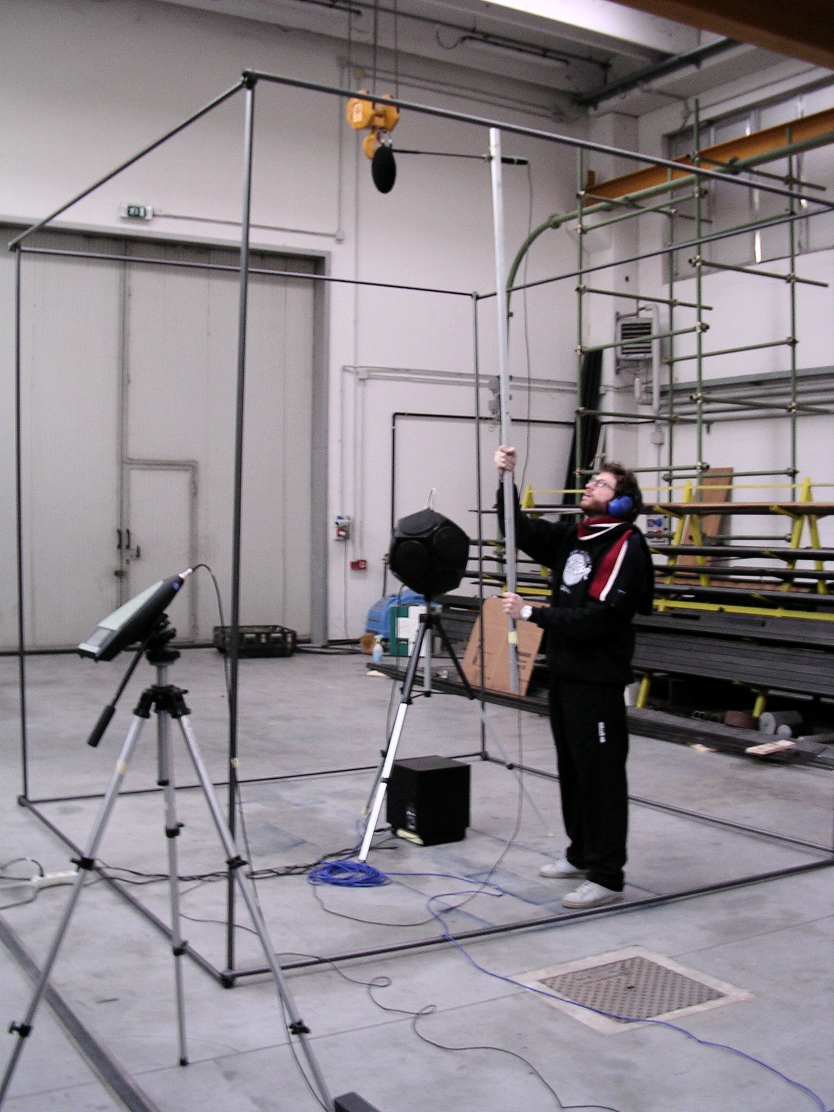

The following figure shows the sound power spectra before and after the digital equalization:

The measurements were performed placing the source in two positions in each of the two rooms. S1 is the source position closer to the audience, representing the typical location of the 1st violin (which is inside the orchestra pit in the case of the Teatro Regio), whilst the second is more far from the audience, and represents the typical position of a singer located behind the orchestra (on the stage, 1m behind the fire curtain in the case of the Teatro Regio).
The following two plans show the location of the sources S1 and S2 and of the listener’s positions where the sound level measurements were performed (employing a B&K 2260 real-time analyzer).

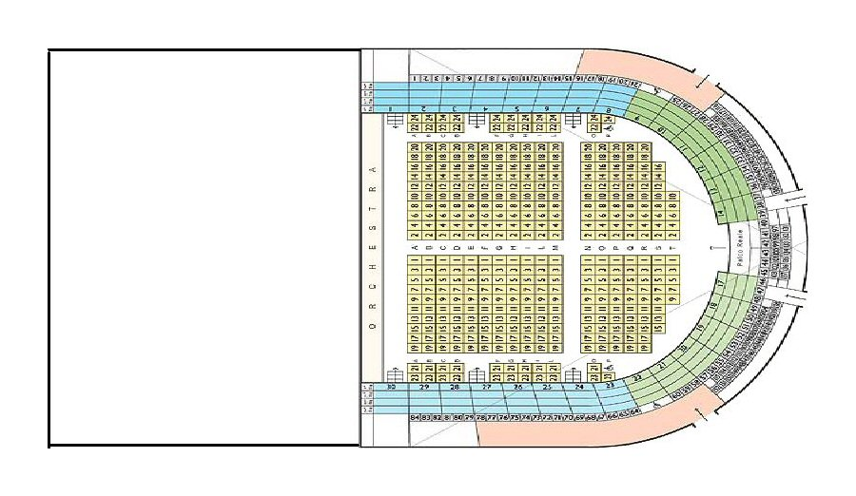
Sipario Tagliafuoco
1m
1m
Teatro Regio di Parma
The following photographs show the rooms during the measurements.

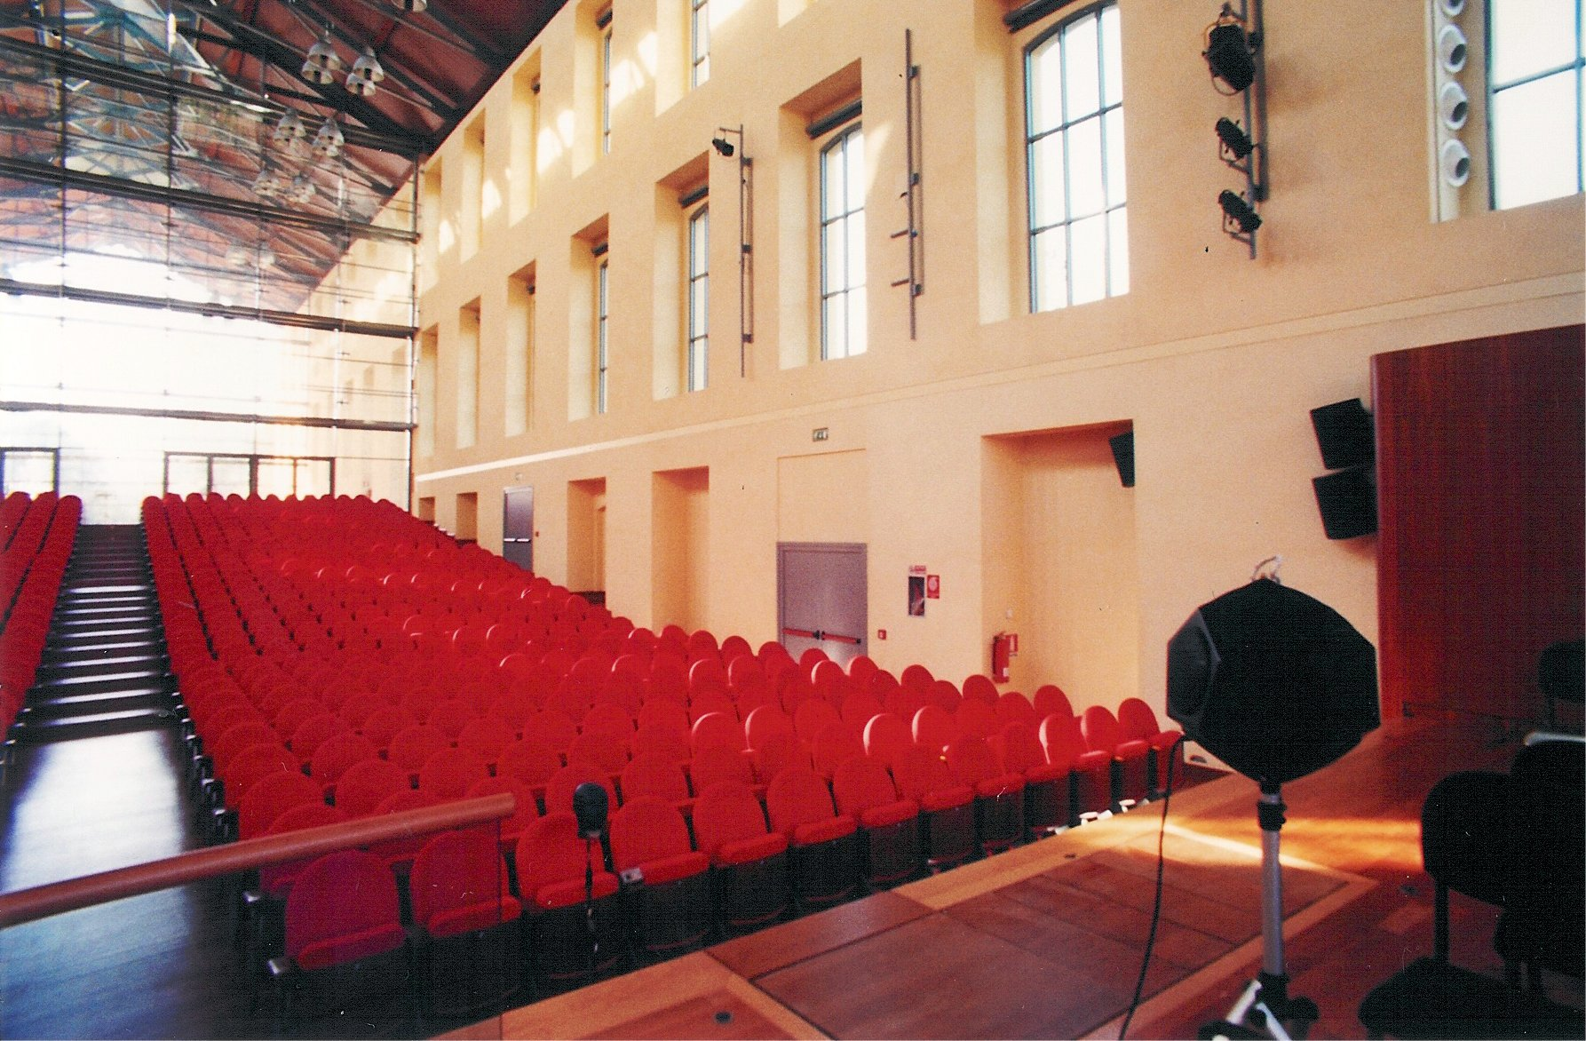

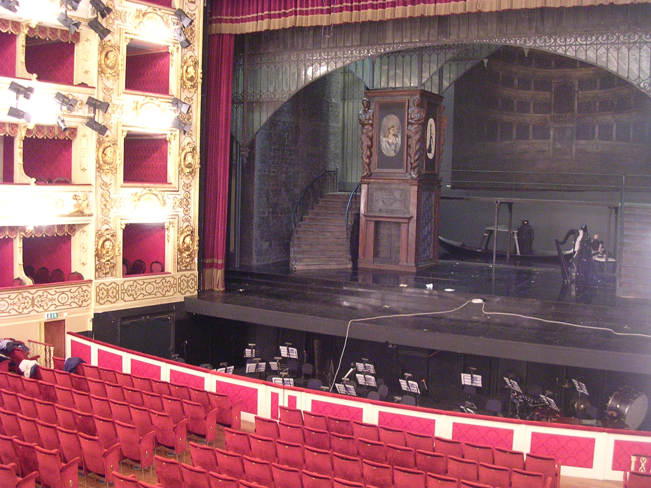

The following graphs show the values of the Strenght G along the measurement path in both rooms. The first one is the total A-weighted value, the second one only shows what happens in the central octave band (average between 500 Hz and 1 kHz).

It can be observed that the values of G are much larger in the Auditorium. Furthermore, whilst in the Teatro Regio the source over the stage (S2) has louder strength than S1, instead in the Auditorium the far source (S2) is always weaker than the close source (S1), although this difference tends to reduce in the rear part of the room.
Furthermore, a “typical” position was chosen in the main audience area: it is position n. 9 in the Auditorium, and row seat I in the Teatro Regio.
In this specific position, the comparison between the octave-band spectra of G was performed, with the source in S1, as shown in the following picture:
Measurement of the Reverberation Times
In the above two “typical” receiver positions, measurements of the impulse responses were performed.
The source was placed in the same two positions already denoted with S1 and S2, and two additional positions were added, named L and R, moving the loudspeaker 5m on the Left and Right side of S2. These additional two measurements were performed specifically for providing impulse responses suitable for the auralization process.
The impulse responses were measured with a complex microphonic setup, as described in [1]. In practice, three different microphonic systems are employed: a binaural dummy head (Neumann KU-100), a pair of cardioid microphones in ORTF configuration (Neumann K-140) and a special three-dimensional pressure-velocity probe (Soundfield ST-250).
The use of a specially-designed exponential sine sweep allowed for measurement of the impulse response characterized by:
- flat frequency response between 25 and 18000 Hz.
- wide dynamic range (wide-band peak-to-noise ratio > 85 dB)
- complete absence of artifacts due to nonlinearities and system’s time-variance
The following graph shows one of these impulse responses, measured in the Auditorium (source S1, microphone Soundfield channel W).

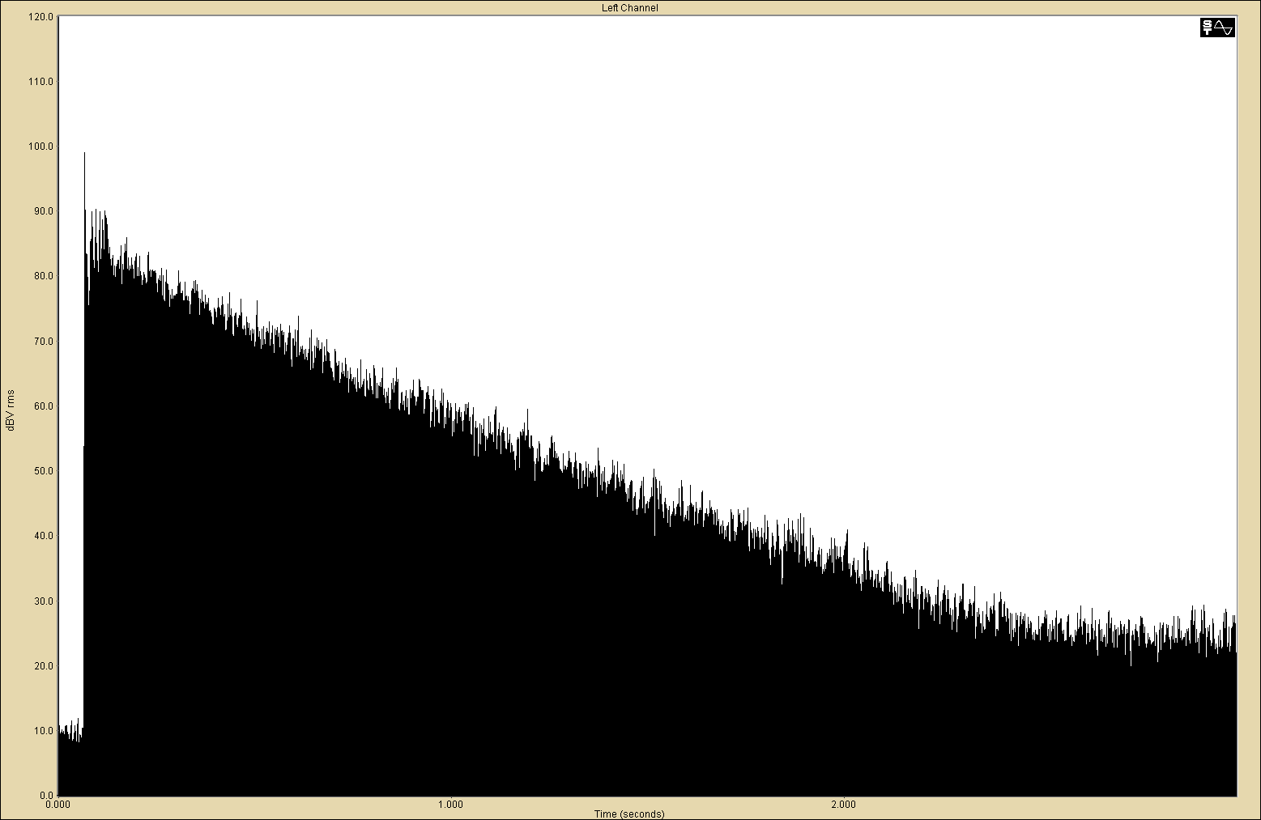

The impulse responses were measured and processed employing the Aurora software, developed by the undersigned [2]. The following picture show the ISO 3382 parameters computed from the above impulse response, employing the proper Aurora plugin.
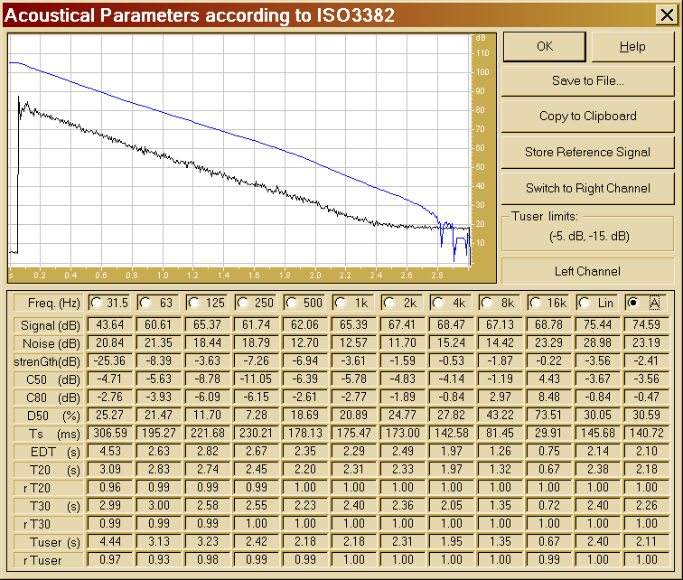

After proper averaging over all the source positions and the various microphone orientations, the following values of the reverberation time T20 have been computed.

In the previous graph also the reverberation times measured in Teatro Valli in Reggio Emilia are shown. It is interesting to notice that, although Teatro Valli is a typical Italian-style opera house of approximately the exact shape and size of Teatro Regio, its reverberation times are much larger (albeit of course still smaller than the Auditorium of Parma).
Going to the comparison between Teatro Regio and Auditorium Paganini, it is easy to see how the reverberation times of the first are substantially less than half than those of the second. This explains most of the perceived differences.
The difference in Strenght, approximately 4 dB, is also perfectly correspondent with the difference in reverberation time.
In substance it can be seen how the Teatro Regio is definitely too dry, particularly at medium and high frequencies, whilst the Auditorium is also definitely too reverberant, considering its seating capacity and the typical utilization.
One could argue that the measurements were performed with the rooms empty, and that the presence of the audience would reduce the difference.
But the undersigned performed a specific set of measurements, on 15 January 2002: the reverberation time was measured in three positions inside the Auditorium, repeated before the entrance of the audience inside the room, and after the room was full at 95% of the seat capacity. The following photo shows the room during the measurement with the audience.

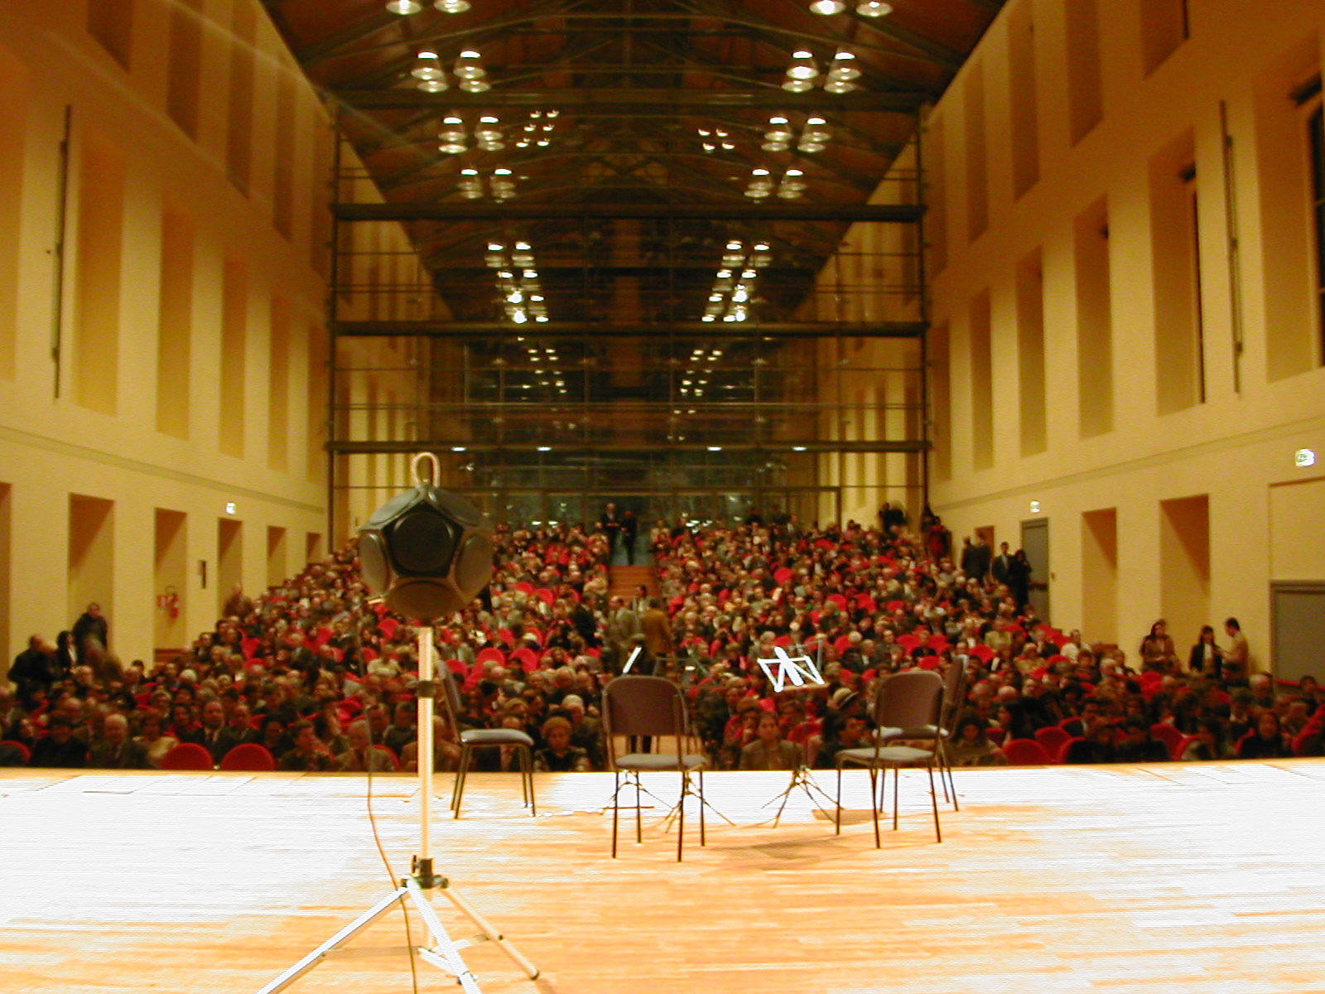

The results of the measurement was that the presence of the audience had a very limited effect, even lower than that expected by the designers: in practice the seats are really very good, as their absorption is substantially uninfluenced by the occupance.
The variation in rev.time due to the presence of the audience is of the same magnitude as the measurement uncertainty, which appears when comparing several series of measurements performed inside the Auditorium.
The following picture shows such a comparison.

Probably the Teatro Regio exhibits a larger reduction of reverberation time due to the audience occupying the seats, because the chairs are not so well designed, and because the seat capacity is larger. This means that, with occupied rooms, the difference is most probably even greater than that appearing with the rooms empty.

Analysing now the actions to be taken, it is obvious how the best would be on one side to increase the reverberation time in the Teatro Regio, on the other side to reduce it in the Auditorium.
In my opinion, the reverberation time at medium frequencies (500 – 1000 Hz) should be regulated just below 2.0 s in the Auditorium and around 1.5 s in the Teatro Regio. This would make both rooms optimal for their intended use.
But, as it will be probably impossible to modify substantially the Teatro Regio (an action here would be fiercly opposed by some of the concert-goers), and considering that the reverberation time in the Teatro Regio will continue to remain below 1.1 s, it is advisable to reduce further the reverberation time in the Auditorium, approximately around 1.7s at medium frequencies.
I understand that this goal can be reached only with substantial addition of absorbing material, and it remains to be decided where to place it and what kind of material to employ. My point is however that a limited action, such as the proposed placement of a 100mm-thick mineral wool carpet above the stage reflectors, is not enough for causing the required reduction in reverberation time.
This proposed correction is certainly beneficial, and will produce a reduction of the reverberation time around 0.3 s. This should be enough if the Auditorium was not to be compared with the Teatro Regio. But, for the reasons explained above, the comparison is unavoidable, and the distance between 1.1 s and 2.0 s would still be too large for satisfying the requests emerging from the population…

Auralization and subjective tests
With the goal of performing some blind subjective tests, the undersigned prepared three music samples suitable for comparative listening by headphones or through a Stereo-Dipole cross-talk cancellation systems.
Binaural impulse response were employed for all the cases.
The first music piece is sung by a soprano and accompanied by a pianoforte. The piece is from Mozart’s “Così fan tutte”, and is titled “Fedeltà”. The piano was placed in S1 (which means in the orchestra pit in the Teatro Regio), and the soprano was placed in R (back over the stage, on the right, aligned with S2).
The second music piece is Strauss “Pizzicate Polka” (purely instrumental), a good piece for assessing the reverberant effects, although with limited usage of various instruments. As this is symphonic music, in this case the simulation was done employing the L and R sources on the stage in both theatres.
The third music piece is a full orchestra prelude: Glinka’s “Ruslan and Lyudmila”. It contains various instruments, and has both percussive events mixed with continuous musical phrases. Also in this case it was assumed that the piece was purely symphonic music, being performed on-stage also in Teatro Regio.
Each of the three music pieces was convolved with three sets of impulse responses:
- The Teatro Regio as measured
- The Auditorium as measured
- The Auditorium, with T20 shortened to 1.7s by pitch-preserving stretching.
Multichannel sessions were created inside Adobe Audition, making it possible to listen to the three pieces, and to switch instantaneously among the three “virtual” rooms.
These music pieces have been temporalily placed on my web site, at:
HTTP://pcfarina.eng.unipr.it/Public/Regio_vs_Auditorium
The files have been compressed with MP3-Pro at VBR, maximum quality, so their size is compatible with Internet download.
Listening at these music samples with headphones provides a faithful reconstruction of the different acoustic conditions in the Teatro Regio and in the Auditorium, and presents a realistic simulation of how the Auditorium could sound after a proper treatment.
I am looking to meet You on next 11 February, when we will be able to discuss in more depth these topics and get some “live” impression of the situation.
Sincerely Yours

Prof. Angelo Farina



Notes:
[1] A. Farina, R. Ayalon – “Recording Concert Hall Acoustics for Posterity” – 24th AES Conference, Banff (Canada), 26-28 June 2003.
[2] A. Farina – Aurora Software Suite – HTTP://www.ramsete.com/aurora

