Applied Acoustics (Engineering) – 23/01/2015

Surname and Name:
A
B
C
D
E
F

Matricula:

1) A sound source produces a sound pressure of 10+F Pa at a frequency of 100*(1+E) Hz. Compute the unweighted sound pressure level in dB:
L_{p} = dB

2) In the same case of the previous exercise, compute the A-weighted sound pressure level in dB(A):
L_{p,A} = dB(A)

3) A weather station observes a lightning. The thunder, detected by a microphone, arrives 10+F s later than the light, detected by a high speed camera. Find the approximate distance of the lightning assuming standard values of speed of sound in air (340 m/s) and of speed of light (300000 km/s).
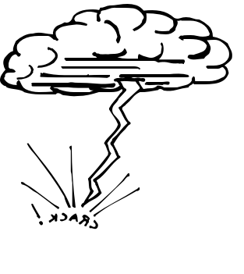

d = m
d

4) A room is (5+D) meters long, (3+E) meters wide and (2+F) meters tall. The average absorption coefficient α of the internal surfaces is 0.05+E/100. Compute the value of rev.time T₂₀
5+D

2+F
Τ₂₀ =
3+E

5) The reverberation time in the previous room is reduced to half, thanks to the insertion of 20+D upholstered seats. Compute the equivalent absorption area of one seat.
A = m²

Note: each correct answer gives 6 points (tolerance: +/- 0.5 dB, +/- 5%).

Total score of exercises:
Oral examination:
TOTAL SCORE Points:

