Sound Pressure Level Measurements

Lesson Index – Topic: Sound Pressure Level Measurements

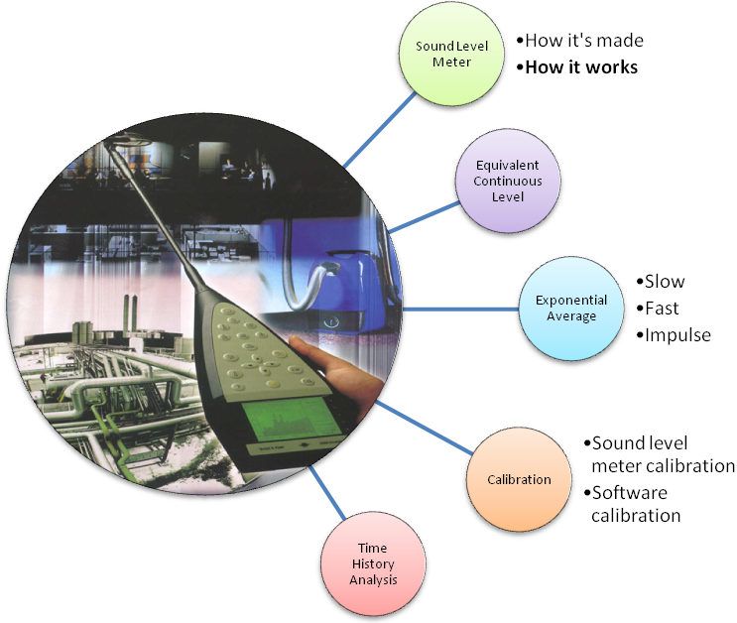

The Sound Level Meter

A sound level meter (SLM) is an instrument which measures sound pressure level. The current international standards that specify sound level meter functionality and performance are the IEC 61672:2003 for non-integrating instruments, and the IEC 61803:2003 for integrating instruments (which are mandatory by law, in Italy).
Today’s sound level meters are bottle-shaped and high-tech instruments, and most of them have the same parts. Figure 1 shows the general structure of a sound level meter.

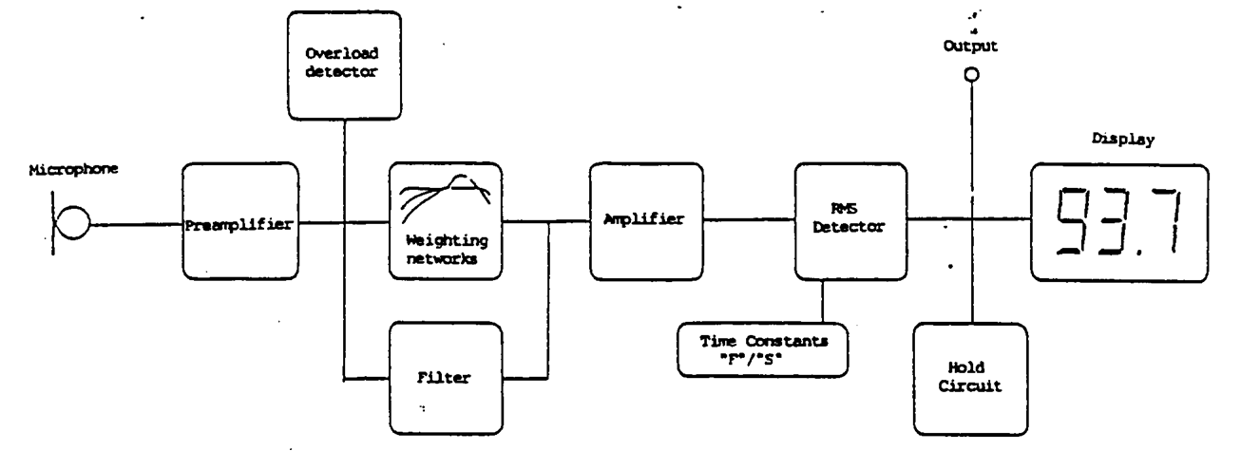
Figure 1 – Sound pressure level structure

- Microphone: even the cheapest sound level meter employs a condenser microphone, also called capacitor microphone, because this is the only type of microphone able to perceive pressure variations perfectly. A Condenser, in fact, tends to be very sensitive and responsive, making these microphones well-suited in capturing subtle nuances in a sound.

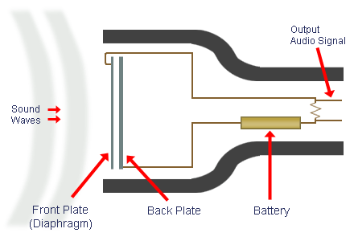
Figure 2 - Condenser microphone

- Preamplifier: this block has the function of increasing, or decreasing, the gain of the system, in order to set the range of values within which the sound pressure level should be. In fact, sound level meters often have a limited range of measurement values, of just 60 or, more usually, 80 dB. The measurement can be considered valid only if result is inside this range. Because of this, the user must be able to change the gain, using some keys, placed in front of the instrument, making the instrument more or less sensitive
Two wrong cases can occur:
- the SPL is too small (sound level meter is under range);
- the SPL is too large (sound level meter is overloaded).
In these cases, the user has to change the full scale value and repeat the measurement.
Some modern instruments, indeed, have a dynamic range exceeding 110 dB, and thus there is never any need to change the full scale value, which is fixed.

- Frequency weighting filter: in front of a sound level meter, we can generally find keys which allow to choose which frequency weighting to use in sound analysis. We will discuss only about A-weighting and C-weighting.

- AC output: it can be used to record analyzed sounds by means of an external digital audio recording unit (which usually stores the recording as a WAV file on an SD card, or the like). “Compressed” formats such as MP3 cannot be used for digital sound recording to be used for acoustical analysis, because these compressed formats are “lossy”, and the analysis resulting from them would be wrong.

- Overload detector: if the sound pressure level is out of the valid range, this detector tells to the user, trough the display, that full scale value has to be changed.

- RMS detector: this is the main block. It performs the most important function, in fact it computes the average sound pressure level, as shown in the following formula:

$p_{\text{rms}}=\sqrt{\frac{1}{T}⋅\int{p^{2}\left(t\right)⋅\text{dt}}}$ (1)

This value is now in Pascal and it’s converted in decibel (dB), using this formula:

$L_{p}=\text{10}⋅{\text{log}}_{\text{10}}{\left(\frac{p_{\text{rms}}}{p_{0}}\right)}^{2}$ (2)
where $p_{0}=\text{20}μ\text{Pa}$

The sound level meter only measures pressure, the sound pressure level, and it’s displayed in dB.

- Display: shows information graphically and numerically, providing results in both analog and numerical forms.

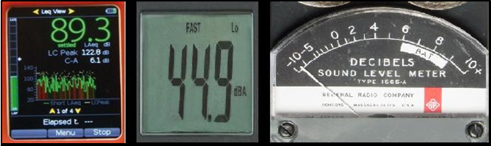
Figure 3 - Graphical, numerical, pointer displays

Now we have seen how a sound level meter is generally structured. In the next part we will discuss in detail on how RMS block works.

The Equivalent Continuous Level

The equivalent continuous level is the average effective value of sound pressure, computed over a time interval T, and it’s defined as:

$L_{\text{eq},T}=\text{10}⋅{\text{log}}_{\text{10}}\left[\frac{1}{T}\int_{0}^{T}{\frac{p^{2}(t)}{p_{0}^{2}}⋅\text{dt}}\right]$ (3)

This is a time-averaged value, and this is easier to understand looking at Figure 2. The rectangle’s area is equal to the one subtended by the instantaneous sound pressure level profile.

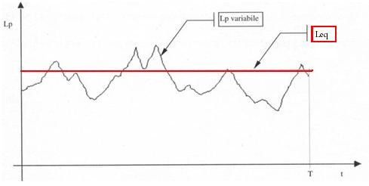
Figure 4 – Equivalent sound level

This value is computed trough a linear time average, so it’s very reliable and easy to compute. Every digital SLM can perform linear integration easily, and the long-term Leq is the quantity to be measured according to current law and regulations.
However, Leq can also be recomputed in post-processing, after a number N of short-term measurements have been done. In the most general case, each of these N measurements is a short-term average over a different measurement time T_{i}.
Thus we get:
$L_{\text{eq},T}=\text{10}⋅{\text{log}}_{\text{10}}\left[\frac{\sum_{i=1}^{N}{T_{i}⋅{\text{10}}^{\text{Lpi}\text{10}}}}{\sum_{i=0}^{N}{T_{i}}}\right]$ (4)

Exponential Averaging: Slow, Fast, Impulse

Decades ago, when the SLMs were analog, an exponential averaging was easier to perform than a linear one, by means of a very simple and cheap circuit: a resistance and a condenser (RC circuit). Nowadays, on digital SLMs, performing the emulation of the behavior of an RC circuit is much more difficult than performing basic linear averaging, and only top-grade instruments can perform exponential averaging, with different time constants, while performing standard linear averaging.
In the case of exponential averaging, the “running” root mean square (RMS) value is computed by the following formula:

$p_{\text{rms}}(τ)=\sqrt{\frac{1}{T}⋅\int{e^{−\frac{t}{T}}⋅p^{2}\left(τ−t\right)⋅\text{dt}}}$ (5)
The main difference between linear and exponential averaging is that, in linear averaging, the same weight is given to all the signal along the whole integration time T; now instead, with exponential averaging, the importance of sound events occurred in the past progressively decreases, more or less quickly, depending on the chosen value for the time constant T.

Setting | Slow | Fast | Impulse
T = RC | 1s | 125ms | 35 ms (rise)  1.5 s (fall)

Figure 5 shows how the Slow setting determines progressive loss of weight for more ancient sounds.

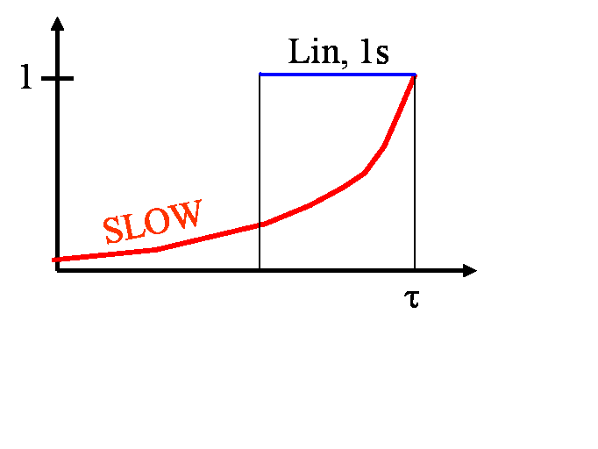
Figure 5 - Slow

The Fast setting is really useful: in fact it generates sound charts corresponding to human hear perception. This is possible because the human auditory system has about 100 ms of latency, similar to Fast value (125 ms). In order to obtain such a result, weighting frequency filter has to be set on A-weighting.
Impulse setting, instead, is an old instrument’s legacy. In fact, as we see in Figure 3, they displayed information by means of a moving pointer. A very intense and short sound results in a rapid and an hard-to-see movement of the pointer. Because of this, the Impulse setting was introduced: in fact, it forces the pointer to raise very quickly but it slows the falling, helping users in seeing results.
Nowadays, the Impulse setting survives for a different reason. Impulsive sounds are annoying, and a good sound technician must consider them, so they have to be detectable. Impulsive sounds can be detected using the Impulse setting. An impulsive sound can be detected by a sound analysis software, performing simultaneously both Slow and Impulse analysis, and verifying this simple inequation:

$L_{p\text{,max,Im}\text{pulse}}≥L_{p\text{,max,}\text{Slow}}+5\text{dB}$ (6)

If the previous inequation is correct, then we know that an impulsive sound was occurred. Current Italian law establishes that, in this case, the equivalent sound level has to be increased by 3 dB, in order to consider the occurrence of the impulsive sound.

Calibration

In a measurement chain made by several components, used in sound measurements, there are many parts which can change gain between two different measurements. For example if we use the same sound level meter but not the same microphone, we have to re-calibrate the entire analysis system in order to obtain a reliable result.
We did not mention it before, but a sound analysis can be done even with a software, for example Audacity of other professional programs. Even in that case the chain of components may change: in fact it’s typically composed by a microphone, a sound-card and a computer equipped with a sound analysis software. If only one of these components changes we have to perform a new calibration.
Calibration, in both cases, can be done with a simple instrument: a calibrator, also known as a reference sound source. This instrument emits a fixed-frequency pure tone of very constant amplitude. We can mount it over the microphone to perform the calibration of the entire chain, as shown in Figure 6.

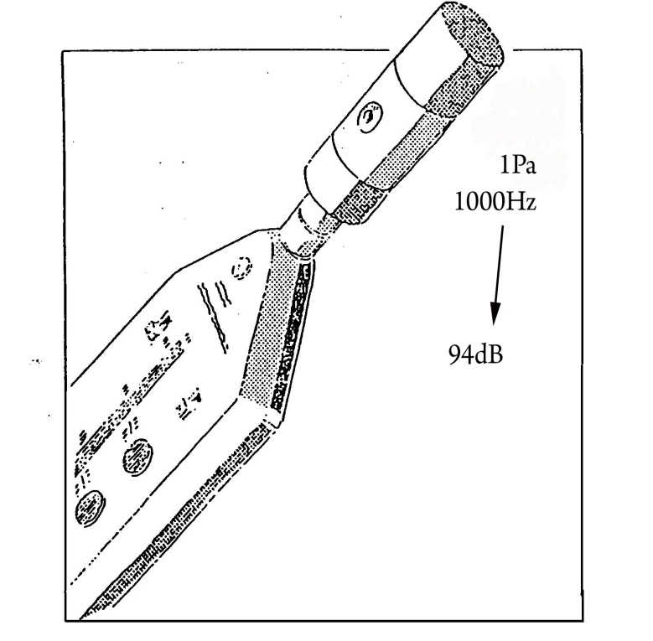
Figure 6 – Calibration

When the calibrator is operating, our sound system analysis receives the pure tone emitted by the calibrator. Now, given the sound emitted, we can check if the system is working correctly. In fact, theory tells that a pure tone, issued with a frequency of 1000 Hz and with an effective pressure of 1 Pa, generates a sound pressure level of 94 dB. So, if our analysis system detects a different sound pressure level, we have to adjust it until the correct value is displayed.
Both sound level meters and analysis software are calibrated by changing their internal settings, forcing them to show the prescribed SPL value (usually 94 dB). This procedure usually updates a numerical offset to produce the correct result. After each calibration, the sound level meter memorizes the applied offset, in order to check for possible malfunctions.

Time History Analysis

Time History Analysis is a plugin working inside some sound recording software (such as Adobe Audition or Audacity) and can be useful for many sound analysis steps. For example, it can be helpful for checking calibration. Its main function, however, is showing a time profiles of “instantaneous SPL”, and a table of results. In its result window the user can see the equivalent sound pressure level Leq of the analyzed sound, its maximum SPL values with different time constants, its fluctuations over time, and so on.
The “instantaneous” SPL profile is strongly affected by the chosen time constant (slow, fast, impulse). Figure 7 shows how a sound chart could appear if the Fast time constant is selected. Setting such a constant results in generating a profile similar to human perception of the sound.
The Slow time constant makes the chart smoother, reducing ripple. The Impulse time constant, instead, highlights rises and smoothes descents.

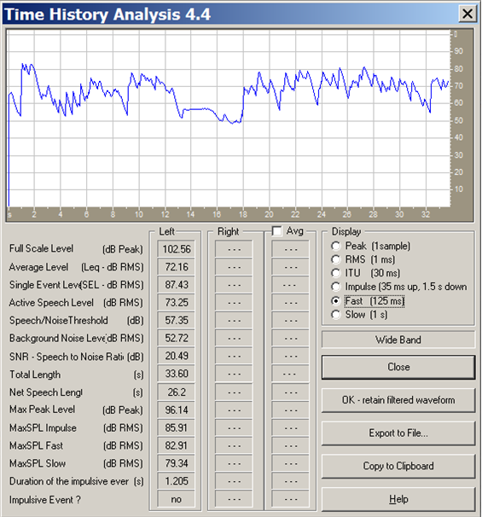
Figure 7 - Time History Analysis

It’s worth to point out that Time History Analysis plugin can also detect impulsive events. As we can see in Figure 7, if Formula 6 is verified, an impulsive event is detected and it will be reported in the last line.

