OUTDOOR PROPAGATION

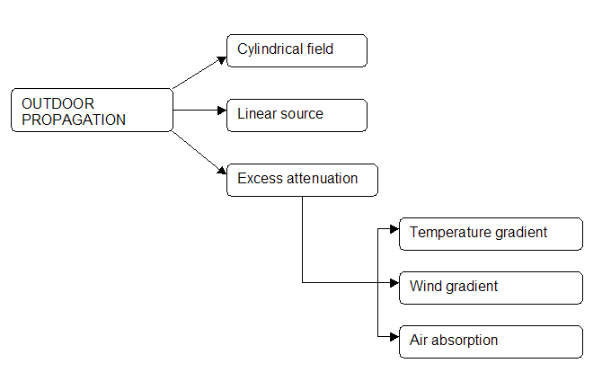

CYLINDRICAL FIELD

Differently from point sources, line sources (roads, railways, airtracks, etc.) are characterized by a cylindrical field.
Through this model, you can consider single sources moving in time on a linear trajectory (for example: cars on the road) as a continuos event, that disperse the total power of the sound over a cylindrical surface.
This equality allows an easyer approach to acoustic problems.

The cause-effect relationship giving the SPL value in a cilyndrical field is represented by two different equations:

$\begin{aligned}L_{p}=L_{W^{'}}−\text{10}\text{log}d−6\begin{matrix} & (\end{matrix}\begin{matrix}\text{incoherent} & \text{emission}\end{matrix}) \\ L_{p}=L_{W^{'}}−\text{10}\text{log}d−8\begin{matrix} & (\end{matrix}\begin{matrix}\text{coherent} & \text{emission}\end{matrix})\end{aligned}$
Where Lw’ is the sound power level per meter of a line source.

The first formula is the most used in acoustic problems, because it refers to concrete situations.
The second one refers to an unreal model (the pulsating cylinder: sound is always the same in all directions and in all points of the space), but thanks to the semplicity of the situation it represents, it is easier to prove and apply.

COHERENT CYLINDRICAL FIELD
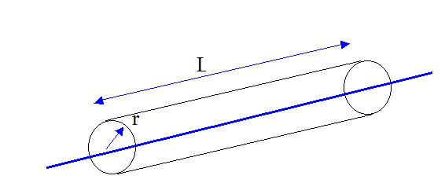

Considering an infinitely long (L>>r), pulsanting cylinder, you obtain the following formulas:

$$\begin{aligned}I=\frac{W}{S}=\frac{W}{2⋅π⋅r⋅L} \\ L_{I}=\text{10}⋅\text{lg}\left[\frac{I}{I_{o}}\right]=\text{10}⋅\text{lg}\left[\frac{\frac{W}{2⋅π⋅r⋅L}}{I_{o}}\right]=\text{10}⋅\text{lg}\left[\frac{\frac{W}{2⋅π⋅r⋅L}}{I_{o}}⋅\frac{W_{o}}{W_{o}}\right]=\text{10}⋅\text{lg}\left[\frac{W}{L⋅W_{o}}\right]−\text{10}⋅\text{lg}\left[2⋅π\right]−\text{10}⋅\text{lg}\left[r\right] \\ L_{I}=L_{W}'−8−\text{10}⋅\text{lg}\left[r\right]\end{aligned}$$

Where

I: sound intensity at distance r by the source.
W: sound power let out by the source.
S: cylindrical surface.
Lw: sound power level per meter of line source
-10log[r]: how sound power decreases with distance.

Comparing spherical and cylindrical waves, you notice an important difference: the cylindrical waves are less sensitive with distance.
In fact

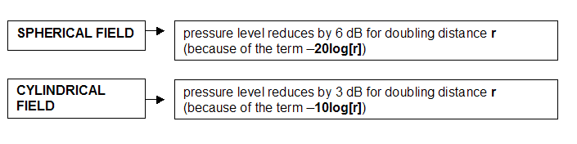

DISCRETE AND INCOHERENT LINEAR SOURCES

This figure is an example of linear source.
The horizontal line can be imagined as a road, and the single points as cars at distance a. The minimum distance between the receiver and the line source is d.
In reality, the single cars are incoherent point sources: the sounds they produce are not in phase and not correlated.
Approaching a problem as a continuous event, you can study this example and apply equations of the cylindrical field.
The average car-to-car distance, a, can be computed as:
$$a=V/N⋅\text{1000}\begin{matrix} \\ [m]\end{matrix}$$
The sound power level of each car, Lwp, is consequently distrubuted along a piece of road with a lenth of a meters, providing a power level per meter, Lw’, given by Lwp-10log(a). Hence, the cause-effect relationship becomes:

$L_{p}=L_{\text{Wp}}−\text{10}\text{log}\left(a\right)−\text{10}\text{log}\left(d\right)−6\begin{matrix} \\ [\text{dB}]\end{matrix}$ (Incoherent emission)

Where:
Lwp-10log(a) = Lw’: sound power level per meter. It depends on the power level of a single vehicle and the distance between vehicles.
Lwp: power level of a single vehicle.
-10log(d): decrement of sound with distance.This term depends on the position of the receiever.
V: speed of the vehicle [km/h].
N: number of vehicles passing in an hours [number of vehicles/h].

The sound power perceived by a listener depends on the distance d from the linear source and the sound power level per meter.
Lwp is fuction of the speed : it increases with speed.
For low speed the sound power of a single vehicle changes a little, but for high speed it changes with the square of speed.

- up to 50 km/h → Lwp is constant
- between 50 km/h and 100 km/h → Lwp increases linearly ( 3dB/doubling)
- above 100 km/h → Lwp increases with V² ( 6dB/doubling)

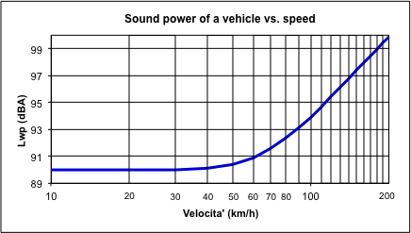

There is an important connection between the speed, the distance a and the power level: higher speed means bigger distance and power of a single vehicle Lwp, but it is not the same for the sound power level per meter Lw’.
In fact it increases with a growth of Lwp, but it also decreases with an increase of the vehicle-to-vehicle distance a.
For this reason, the link between power level per meter and speed is non-linear.

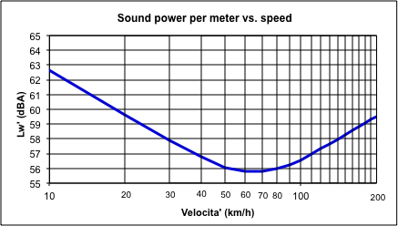

⇒ The best combination between Lwp and distance a gives us the “optimal” speed, about 70 km/h. It causes the minimum value of SPL ( and consequently less noise pollution).
Due to techological innovations the value of the “optimal speed” is becoming even larger: the features of new cars make vehicles less noisy up to higher speeds, where the aerodynamic noise becomes the predominant source.

EXCESS ATTENUATION

In reality, between source and receiver ,there are often obstacles and factors, which cause additional attenuations of sound level.
These factors are mainly:

- air absorption
- absorption due to presence of vegetation, foliage etc.
- meteorological conditions (temperature gradients, wind speed gradients, rain, snow, fog, etc.)
- obstacles (hills, buildings, noise barriers, etc.)

The term ΔL, in the free field formula, quantifies all these factors :

• LI = Lp = LW - 20 log r - 11 + 10 log Q - ΔL (dB)

Most of these effects are revelant only at large distance from the source. The exception in shielding (maximum when the receiver is very close to the screen).

TEMPERATURE GRADIENT

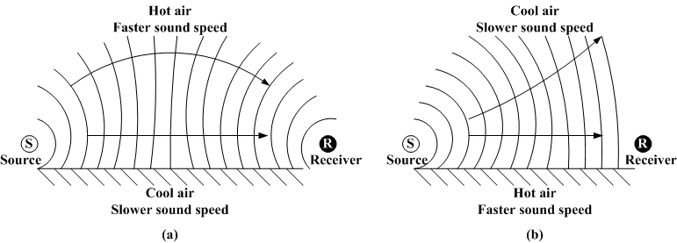

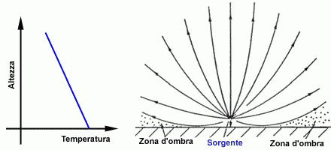

Sound speed depends on temperature gradient ⇒

Temperature decreases with height → -sound speed decreases too
-sound rays curve upward
-on the ground, at a particolar distance from the
source you find the shadow zone (there is no
sound

Temperature increases with height → -this is a particular phenomenon caused by the fog
layer above the ground
-sound rays curve downward
-due to their particular curvature, sound rays can
be perceived far from the source

WIND SPEED GRADIENT

In this case, the attenuation is not caused by the “transport” of the sound due to the wind. In fact, wind speed is very low in comparison with sound speed (1200 km/h).
The real effect produced is the curvature of sound rays caused by wind gradient (the speed increases with height), similarly to temperature.

Downwind → sound rays curve downward and step over obstacles

Windward → sound rays curve upward causing the shadow zone and strong attenuation

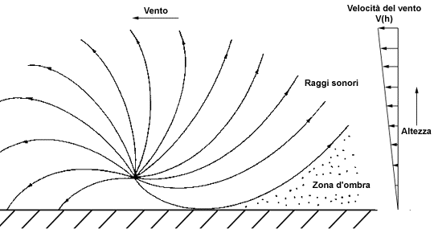

AIR ABSORPTION

 |  | Frequency (octave bands)
T (°C) | RH (%) | 63 | 125 | 250 | 500 | 1000 | 2000 | 4000 | 8000
10 | 70 | 0,12 | 0,41 | 1,04 | 1,93 | 3,66 | 9,66 | 32,8 | 117,0
15 | 20 | 0,27 | 0,65 | 1,22 | 2,70 | 8,17 | 28,2 | 88,8 | 202,0
15 | 50 | 0,14 | 0,48 | 1,22 | 2,24 | 4,16 | 10,8 | 36,2 | 129,0
15 | 80 | 0,09 | 0,34 | 1,07 | 2,40 | 4,15 | 8,31 | 23,7 | 82,8
20 | 70 | 0,09 | 0,34 | 1,13 | 2,80 | 4,98 | 9,02 | 22,9 | 76,6
30 | 70 | 0,07 | 0,26 | 0,96 | 3,14 | 7,41 | 12,7 | 23,1 | 59,3

The table above shows air absorpition coefficients [dB/km] for different combinations of frequency, temperature and humidity.

You notice →

- dry air causes more absorption than damp air
- air absorption increases with frequency (low frequencies travel easily; high frequencies are rapidly absorbed by air)

