Excess attenuation: barriers

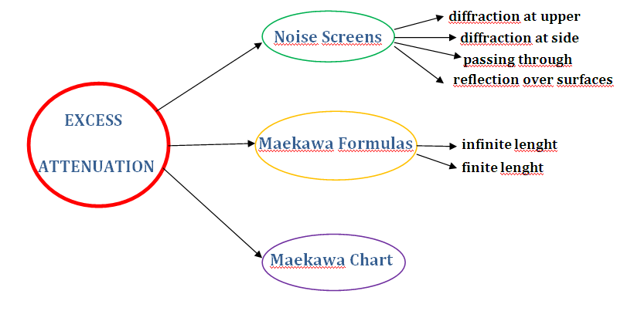

Noise screens

Commonly, a noise barrier is a solid structure ,positioned between the source and the receiver, which blocks the direct path of sound propagation.

Whenever a noise screen is positioned between the source and the receiver, it provides a reduction of the sound pressure level, and it can even eliminate it completely in those particular spaces called “shadow zones” where the sound does not travel at all.
To ensure an easier picture of the concept, in this class the noise barriers will be considered as thin walls.

The acoustic efficiency of a noise screen is represented by the insertion loss ∆L

$$ΔL=L_{0}−L_{b}\begin{matrix} & \end{matrix}(\text{dB})$$

Where L₀ and L_{b} are the SPL values with and without the screen.

In most situations there are several different paths a sound can follow to reach the receiver when the barrier is installed:

- Diffraction at upper of the screen: i.e. the barrier is very long and the effective heights not too high | 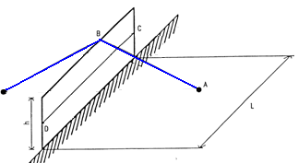
Diffraction at sides of the screen: when the distance between the source and the screen edge is less than 5 times the effective height | 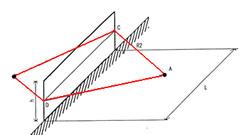
Passing through the screen | 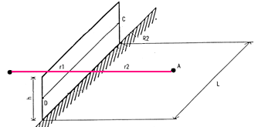
- Reflection over other surfaces present in proximity: when the location allows it | 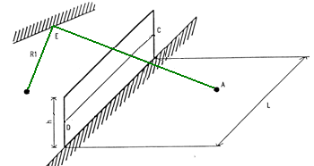

In this class we will deal only with the first two cases.

Noise screens : the Maekawa formulas

Depending on the case, we have to use different mathematical formulas to obtain ∆L.
In this class we are going to explain the different formulas for solve the first two abovementioned cases.
If we only consider the energy diffracted by the upper edge of a thin, infinitely long barrier we can estimate the insertion loss as:

$$ΔL=\text{10}\text{log}(3+\text{20}N)$$ | for N>0 (for spherical field)
$$ΔL=\text{10}\text{log}\begin{matrix}(2+5\text{.}5N) & \end{matrix}$$ | for N>0 (for cylindrical field)

We can see that in these formulas, called Maekawa’s formulas ∆L is function of the number N, which is the Fresnel number defined by:

$$N=\frac{2δ}{λ}$$

δ=difference between the diffracted path and the directed path. It is always > 1 if there is a diffraction.
λ=wavelength

The Maekawa formulas are logarithmic formulas, so we obtain a result expressed in decibel (dB).

We can also express the Fresnel number N as function of the frequency because:

$$N=\frac{2δ}{λ}=\frac{2fδ}{c}\begin{matrix} \\ \end{matrix}$$

f = frequency
c = sound speed

Maekawa chart

If we want to tabulate the results in order to see the relationship between the Fresnel number N and the insertion loss, we can use the Maekawa chart.
The line that describes that relationship is different depending on the case we are studying.
If we are studying a spherical field (generated by a point source) the Maekawa chart is the following:

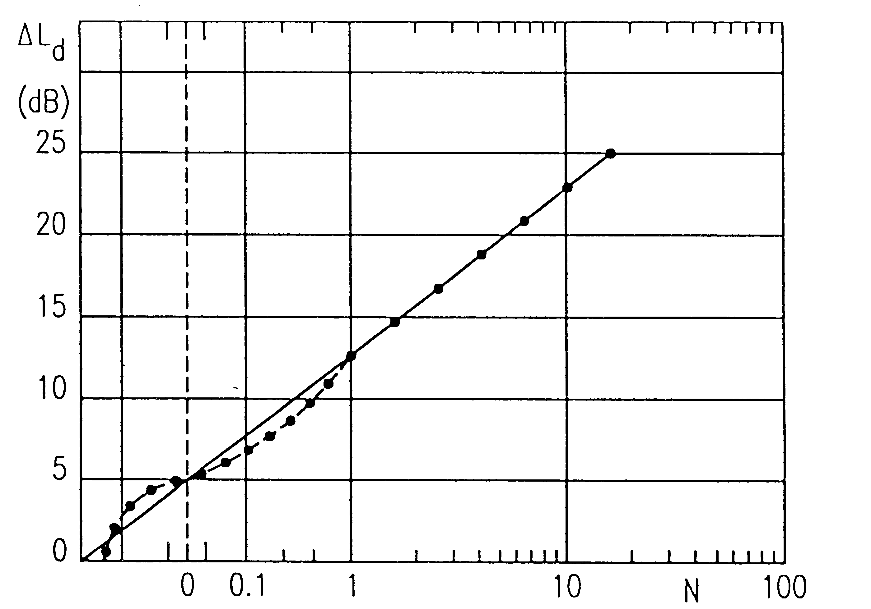

In the graphic, the straight, solid line represents the Maekawa formula, while the curved, dotted line represents the actual pattern obtained by connecting the results of actual measurements.
When the Fresnel number is larger than 1, these two lines coincide.
For N<1, instead, the Maekawa formula causes some errors: for better accuracy, it is recommended to employ the Kurze-Anderson formula (which indeed provides accurate results also for N>1):

$$ΔL=5+\text{20}⋅\text{log}\left[\frac{\sqrt{2⋅π⋅N}}{\text{tanh}\left(\sqrt{2⋅π⋅N}\right)}\right]$$

The following chart represents the relationship between the Fresnel number N and the insertion loss ΔL for spherical fields and cylindrical fields.

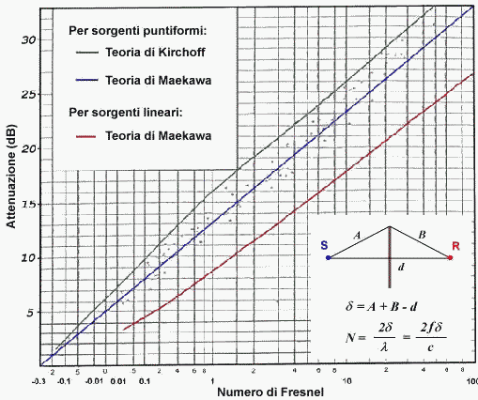

In this chart the blue line represents the Maekawa formula trend for spherical fields; the red line represents the Maekawa formula for cylindrical fields, and last of all, the gray line represents the trend of the Kirchoff formula, another formula to obtain the relationship between N and ΔL and which behaves quite poorly in real world.

At the bottom of the chart we can see a figure that clarifies some concepts.

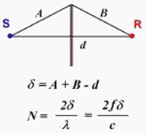 | First of all we can see without the meaning of δ: δ is the path difference among the diffracted and the direct sound.  We can also give a definition to the term effective height.  Effective height h_{eff}: it is a length, expressed in meters, that represents the distance between the upper border of the barrier and the intersection with the barrier of the line connecting the source and the receiver.
h_{eff} is not the same height as the barrier’s height, because if source and receiver are not on the ground, or if the ground is not horizontal, the effective height is systematically smaller than the total height of the barrier. This concept can be better understood thinking that the barrier is divided in two parts: the lower one reaches the “see-not-see” height, at which the receiver can barely see the source through a line-of-sight which is tangent to the screen. All the further elevation of the barrier above this “line of sight” becomes the effective height of the barrier.
One could think that, for getting any effective sound attenuation, the barrier must be taller than the “line of sight”, and if the barrier is too short, allowing the receiver to “see” the source, there is no attenuation.
However, adopting the convention that the Fresnel number is positive whenever h_{eff} is positive, and that N becomes negative when h_{eff} is negative (that is, when the barrier is below the line-of-sight), we see that the Maekawa formulas still work, as shown in the charts above, if N > -0.3

And this means that some small sound reduction is obtained even when installing a noise screen, which appears too short, as it allows the receiver to “see” the source.
When the value of N=0 (that is, when the height of the barrier is tangent to the “line of sight”), we still get a significant attenuation, which is equal to 5 dB for a point source and 2.5 dB for a line source, as shown by the Kurze-Anderson formula and by the Maekawa chart.

Noise screens: finite length

If the length of the barrier is not long enough, we must also consider its lateral edges.
Each edge has its own Fresnel number (N₁, N₂) and this causes a change in the formula relating the Fresnel number with the insertion loss.
The new formula is:

$$ΔL={ΔL}_{b}−\text{10}\text{log}(1+\frac{N}{N_{1}}+\frac{N}{N_{2}})$$

Valid for values of N,N₁,N₂ >1 – in this formula ΔL_{b} is the insertion loss caused by the upper edge, evaluated with the Maekawa or Kurze-Anderson formulas.

We have to use this formula whenever the side edge is closer than 5 times the effective height.

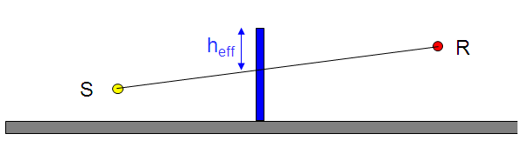

The insertion loss changes with frequency: hence we have to draw the noise spectrum twice, both in absence and in presence of the barrier.
It is observed that the insertion loss increases with frequency.
In the figure below we can see the noise spectrum without the barrier (in blue) and the one with the barrier (in red).

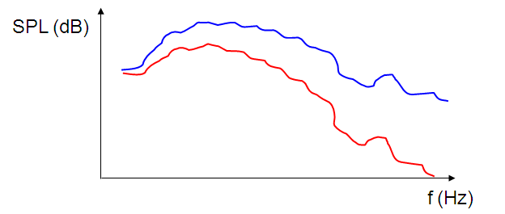

For evaluating the total, A-weighted sound reduction caused by a barrier in dB(A), we have to compute ΔL separately at every frequency (for example in octave bands).
Then we compute the total A-weighted SPL for the spectrum before the installation of the barrier, we recompute the new total A-weighted SPL after the installation of the barrier, applying at every frequency the proper value of ΔL, and finally we get the A-weighted insertion loss, ΔL_{A}, as the difference between the two A-weighted values of total SPL, before and after the barrier installation.

${ΔL}_{a}=L_{\text{Abefore}}−L_{\text{Aafter}}$

This means that, whilst the values of ΔL at single frequencies depends only on the geometry, the total insertion loss in dB(A) also depends on the spectrum of the noise source.
And, as shown in the figure above, the value of ΔL increases with frequency. Hence, the very same barrier will provide a large reduction of the A-weighted noise level for sound sources having a spectrum that contains a lot of energy at high frequencies (example: train), and a significantly smaller reduction of the A-weighted SPL for noise sources having most energy at low frequencies (large Diesel engines, trucks, highways, etc.).

