Digital Signal Processing

1 - SAMPLING 1
2 - COMMON AUDIO RECORDING TYPES 2
3 - IMPULSE RESPONSE 3
4 - CONVOLUTION 4
4.1 FFT ALGORITHM 4
4.2 FAST FIR FILTERING 5
4.3 THE OVERLAP & SAVE APPROACH 6
4.4 UNIFORMLY PARTITIONED OVERLAP & SAVE 6

Digital processing of acoustic signals is very useful to make acoustical measurement of noise inside Houses, Classrooms, Theatres, Churches. Generally speaking this analysis is made on Digital signals, which are a digital version of the analog signal, because, thanks to the increasing computational power of computers, performing this analysis is very quick. It is possible to convert audio signals from analog to digital through a process called Sampling.

1 - SAMPLING
Sampling a generic digital signal means measuring its value at a constant rate and store it into a storage data bank. Generally we analyze a Voltage (V) at a fixed sampling frequency f_{s} . However this type of conversion implies a loss of accuracy because of the nature of the A/D (Analog to Digital) converter. In fact the analog signal is transformed into an integer number with the precision (in bits) of the fixed bi depth of the A/D (typically ranging from 16 to 24 bits).

So the analog waveform in a time-amplitude chart is approximated by a sequence of points, which lye in the knots of a lattice, as both time and amplitude are integer multiplies of small “sampling units” of time and amplitude. It is to say, sampling introduces a considerable amount of sampling error: as it can be seen in the graph, the red signal, which is the digital one, is never the same as the blue one, which the original analog.
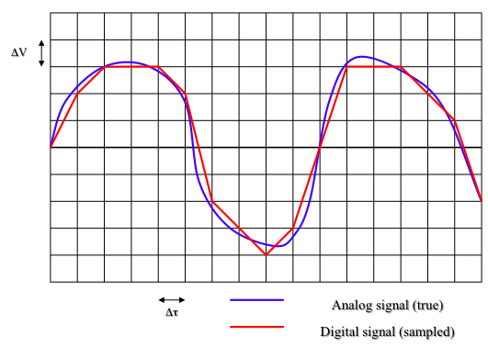
Fidelity is a topic that must be analysed during this analysis: can a digital signal represent faithfully the original analog one? Generally NO, because of distortion introduced by the A->D conversion. It is possible, if and only if the hypothesis of the Shannon Sampling theorem is verified:

Sampling frequency must be at least twice of the largest frequency in the signal being sampled.

A frequency equal to half the sampling frequency is named the “Nyquist frequency”, and is the maximum frequency allowed in the signal.
For avoiding the presence of signals at frequencies higher than the Nyquist’s one, an analog low-pass filter is inserted before the sampler.
It is called an “anti Aliasing” filter.

2 - COMMON AUDIO RECORDING TYPES

- CD audio – f_{s} = 44.1 kHz
Discretization is made at 16 bit: this is the minimum discretization quality, if I use less than 16 bit, the sampling distance is too big. The Nyquist frequency is 22.05 kHz and I may have aliasing, so I put a lowpass filter. In this case it starts at 20 kHz, so that at 22.05 kHz the signal is already attenuated by at least 80 dB. Hence the filter is very steep, causing a lot of artefacts in time domain.

- DAT recorder – f_{s} = 48 kHz
Discretization is made at 16 bit. Nyquist frequency is 24 kHz, the anti-aliasing filter starts at 20 kHz, so that at 24 kHz the signal is already attenuated by at least 80 dB. Now the filter is less steep, and the time-domain artifacts are almost gone.

- DVD Audio – f_{s} = 96 kHz
Discretization is made at 24 bit. Nyquist frequency is 48 kHz, but the anti-aliasing starts around 24 kHz, with a very gentle slope, so that at 48 kHz the signal is attenuated by more than 120 dB. This technology is very good, so much that the digital signal quality is almost the same as the analog original one.

3 - IMPULSE RESPONSE

The acoustic analysis of a system can be made using the impulse response: it is the response of a system to a Dirac delta. This kind of signal does not exist in reality; however it can be reproduced in different ways in many scientific ambits. In acoustics for example, the sound of a clapping machine can be used as an approximation of a Dirac delta.

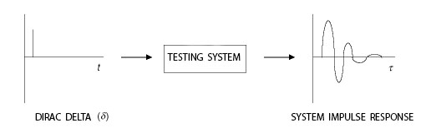
A SIMPLE LINEAR SYSTEM

Let’s analyse a simple linear system made by a CD Player, an amplifier, a Loudspeaker, a Microphone and a Sound analyzer. In analog analysis if there’s need to analyse the characteristics of a room for example, the sound is reproduced by the CD player and the amplification system and then recorder by the microphone, and finally analysed. The Amplifier + Speaker + Room + Microphone group of factors can be represented analytically as a system, a filter that creates a modification on the signal. The sound “filtered” from the room is then analysed by the Analyzer.
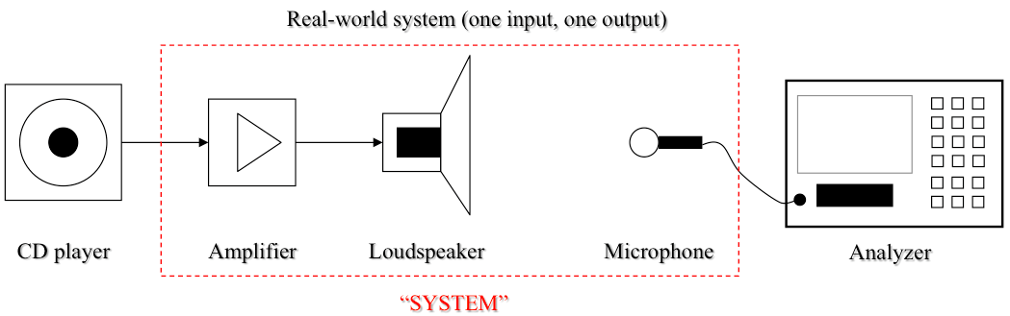

What happens in the “SYSTEM” block can be seen in the following image: an Input signal x(t) is filtered by a System which has impulse response h(t) and becomes the Output signal y(t).

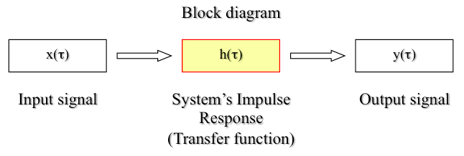

In a mathematical point of view working with sampled digital signals. The thing is just a sum of products. It is possible to calculate the value of every sample of y(t) as the sum of N values of x(t) multiplied by the correspondent N values of h(t) the impulse response, in this way:

$$y(i)=\sum_{j=0}^{N−1}{}x\left(i−j\right)⋅h\left(j\right)$$

This kind of linear combination (or sum of multiplications) is generally called, in Acoustics, CONVOLUTION. It is also called FIR filtering, that means Finite Impulse Response. There is also a different filtering technique, called IIR (Infinite Impulse Response), which is not explained here.

4 - CONVOLUTION

The convolution is in fact a compact way to express the sum of multiplications at the base of the FIR filtering. The most common convention to represent Convolution Operator is the following, an “x” inscribed in a circle. This symbol in many cases is substituted by an asterisk.
$y(i)=x\left(i\right)⊗h\left(j\right)$

4.1 FFT ALGORITHM

The FFT Algorithm is widely employed in acoustics as it allows to make very quickly and with simplicity the following tasks:
- Performing spectral analysis with constant bandwidth
- Fast FIR filtering

The FFT Algorithm gets a chunk of signal in time domain called “FFT Block” of a certain length of samples. And then a mathematical algorithm provides its spectrum.
For maximum computational speed, the number of points in the time block must be a power of 2 – for example: 4096, 8192, 16384, etc.
So this algorithm is very useful, as it provides the spectrum of a time domain signal with constant frequency resolution starting at 0 Hz (DC) up to Nyquist frequency (which is half of f_{s} ).
The longer the time segment is, the narrower will be the frequency resolution: sampling N points in time, we get N/2 + 1 frequency bands.

The +1 represents the band at frequency 0 Hz, that is the DC component; however in acoustics this is always with zero energy, so it does not appear in the spectrum. For example, if we use the FFT algorithm on a signal of 64 samples, we can get its spectrum of 32 bands.
One of the greatest qualities of the FFT algorithm is that it is reversible. It is possible to get the spectrum of a sample block and then go back to the original time-domain block: this is very useful for filtering and also to make precise equalization of a signal. I can do my equalization in frequency domain and go back to the time domain.

4.2 FAST FIR FILTERING
The real useful employment of the FFT algorithm becomes clear when there’s need to make convolution. The convolution between two signals in time domain can be a very heavy and long task even for the newest computers. So it is much simpler to transform signals into their Fourier transforms and pass to the frequency domain, as convolution in time domain becomes simple multiplication in frequency domain.
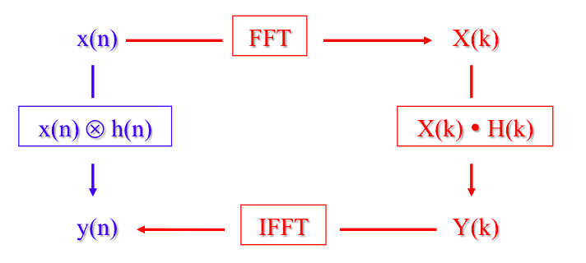

Considering that the number of samples required for describing an acoustical impulse response can be in the order of hundreds of thousands, the computational requirement to make convolution is very large. In fact, for 100.000 input samples, for every output sample to be computed, 100.000 products and 100.000 sums are required!
Instead, passing to the frequency domain, the operation is just a multiplication, so we reduce the computational requirement of a factor 2N, which is huge.
Nowadays no one performs time-domain processing any more, as it is very cheap to perform it using FFT algorithms and FIR filters.

However this approach isn’t still the most efficient one, as it presents some problems:
- As there’s need to transform the signal into its spectrum, all the input signal must be recorded before being processed.
- If the number of samples N is large, a lot of memory is required to allocate the big sample Chunk.

4.3 THE OVERLAP & SAVE APPROACH
Instead of processing the whole length of the signal x, we process a chunk of this signal which is typically longer than the impulse response but not much longer. For example, for a 1sec impulse response (Q samples) we can use a 2 seconds chunk (N samples).
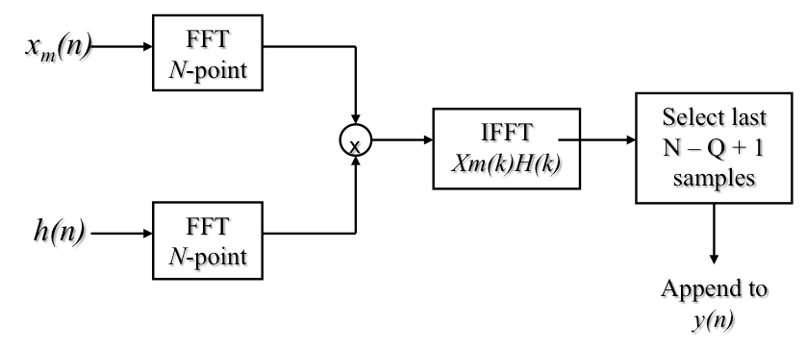
The process is simple, we first compute the N-point FFT of the input chunk and of the zero-padded impulse response (we add a number of zero-valued samples after the Q points of the IR, for making it N-samples long), then we make the product of the two and we make an Inverse FFT to get the output chunk of N samples, and finally we discard the “initial tail” of it, and by choosing the last N-Q+1 samples. After this operation we can move the input window of N-Q+1to the right, and get another chunk of signal.
However this approach presents a high latency problem caused by the length of the impulse response, it’s not suitable for real time processing, and still requires a lot of memory. The solution is the Uniformly Partitioned Overlap & Save.

4.4 UNIFORMLY PARTITIONED OVERLAP & SAVE
In this case both the input sample chunk and the impulse response are partitioned into blocks. This is very useful because latency and memory occupation are divided by the number of partitions. In the following example the impulse response is divided in 4 blocks, but no one prevents us from partitioning it in even more blocks, 8, 16, 64, etc. .

