IMPULSE RESPONSE MEASUREMENTS

Impulse
response
measurements
Impulse sources
Traditional
measurement methods

Microphones

In the past, traditional measurements in the time domain were made with impulsive sounds and omnidirectional transducers.
Later, acoustic measurements were carried out based on computer hardware, loudspeaker and an omnidirectional microphone.

However, in the present, for electro-acoustical measurements we use a standard sound card, a dodecahedron omnidirectional loudspeaker, and multiple microphones(2 to 8).

In the future, it is planned to use microphones arrays for capturing high-order spatial information and artificial sound sources employing a dense array of loudspeakers, capable of synthesizing the directivity pattern of any real-world source.

IMPULSIVE SOURCES

In the figure, we can see an example of impulse response: there is a signal coming out of a microphone. The input signal is propagated not only in the environment, but at first it goes to an “object” that is the loudspeaker. Small or large, the loudspeaker distorts the initial signal by a non-linear distortion. The non-linear distortions are a big problem!

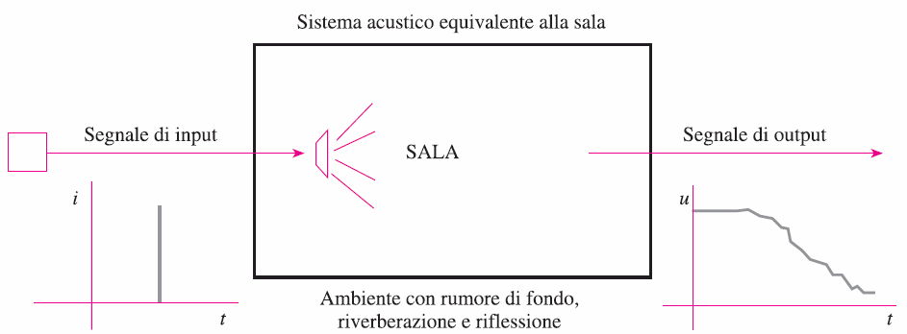

In general, the environment is not excited by the signal x(t), but by the signal w(t): it is the distorted signal from the loudspeaker.
However, in most cases the acoustical propagation inside the room is a linear phenomenon. Only rare cases there may be loosely-attached panels that vibrate, causing the acoustical propagation in the room to become non-linear.
Finally, we have the noise that is superimposed.
We want to suppress the non-linearity and the environmental noise.

Why we would measure the impulse response?

The impulse response is important to measure reverberation.

By definition, the reverberation time is derived from the slope of the decay curve.
It is much easier to measure the impulse response than the decay of a stationary noise stopped. How it works? Mathematically we reconstruct the decay of the stationary noise by a procedure which is called BACKWARD INTEGRALTION or SCHROEDER INTEGRATION.

The total energy of the stationary source can be calculated by impulse response in this way:
∫g^2(t)dt (the extremes of the integral are: 0,∞)

From this total integrated value, we subtract the reflections at every time. The reflections are:
∫g^2(t)dt (the extremes of the integral are: 0, t)

By the integral properties, we can write the integral with this extremes: t, ∞.
This is the SCHROEDER INTEGRATION: the integral of the squared impulse response between t and ∞ gives us the decay curve of the stationary noise.

TRADITIONAL MEASUREMENT METHODS

We analyze different cases of explosive sources with 4 different instruments: balloons, blank pistol, firecracker, clapping machine.

_ Balloon

The balloons have problems of frequency response, because they must be
large for radiating low frequencies. But a large balloon is never an omnidirectional source…

In the figure, we can see how the size influences low frequency spectrum.

Ordinary balloons (with diameter 18 cm) operate from 500 Hz up and so they are not useful for acoustic measurements.

MANCANO I PETARDI, ed il loro spettro

_Clapping machine

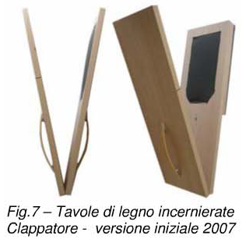

The clapping machine represents the top: good frequency response and repeatability. He has a low cost also. To obtain low frequencies we need “doppio scatolato” (it has a cavity), but for our example and the classroom size we can use also “legno-gomma”.

Verification of the repeatability.

It can be seen how the 12 pulses are identical to each other. Instead, the balloons had an intrinsic variability.
The problem of the clapping machine is highlighted by following diagrams. They are the radiation diagrams of the clapping machine.

It can be see that at high frequency it is very directive.

This is a big problem, because the response varies depending on how we orient the object.

_Blank pistol

MANCA UNA FIGURA DI UNA PISTOLA A SALVE CON DIFFUSORE OMNIDIREZIONALE
By octave-band spectrum we can see that the blank pistol has the typical bell trend centered in 1kHz. The spectrum is not flat, but it has the largest energy at the center frequencies.

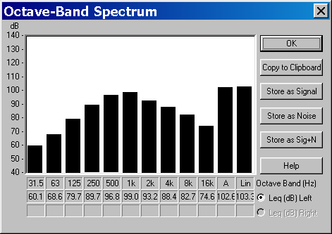

By looking at the impulse response, we have seen that at 1000Hz there is a very good signal-noise ratio: the decay curve is perfectly linear.

MICROPHONES

We analyze different types of microphones.

_Omnidirectional microphones

Manca la figura di un microfono omnidirezionale

ISO3382 recommends the usage of omni mikes of not more than 13 mm (small microphone). The frequency response of these microphones is absolutely flat: this is an ideal form.

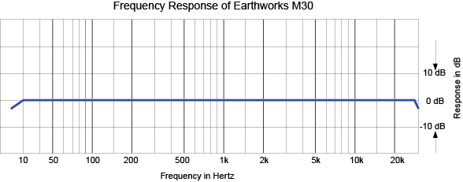

But, for measuring “spatial acoustical parameters”, the usage of stereo microphone systems is quite common.
The initial approach was to use directive microphones for gathering some information about the spatial properties of the sound field “as perceived by the listener”. Two different approaches emerged: binaural dummy heads and pressure-velocity microphones.
We make a test with binaural microphones that simulates the human ear.
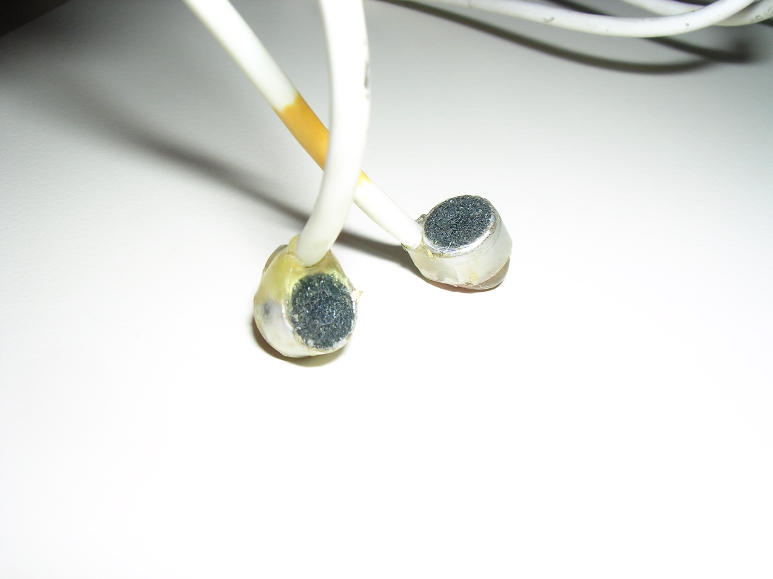
They are cheap and so accurate!
Manca una figura di una testa binaurale!!!

Gerzon and Craven created and developed the Soundfield microphone, a tetrahedral microphone. This is modern version:
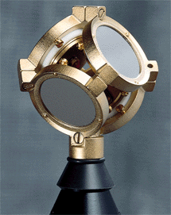
.
Manca una figura che mostra il microfono “chiuso” nella sua protezione, della sua “black box” che processa i segnali, e manca la spiegazione dei 4 segnali che escono (B-format)

Type of microphone allows to make simultaneous measurements of the omnidirectional pressure and of the 3 cartesian components of particle velocity.

Manca la figura dei polar pattern dei segnali B-format

