Sound insulation:
Is a process whereby structures and materials are arranged to reduce the transmission of sound from one room or area of a building to another or from the exterior to the interior of a building, when there is a need to keep sound from filtering into or out of the space. Sound insulation techniques are often used in business settings, as well as in multi-family dwellings like duplexes and apartment buildings.

Sound against a wall:
Basically a sound is reflected, absorbed, transmitted externally and internally reflected when the sound wave encounters an obstacle. Reflection and absorption are dependent on the wavelength of the sound. The total amount of sound transmitted through an obstacle depends on how much sound is reflected and how much is absorbed.
r= Wr/Wo : reflected,
a= Wa/Wo : absorbed,
t= Wt/Wo : transmitted
r + a + t = 1

Materials: sound insulating & sound absorbing:
SOUND INSULATION MATERIALS : Sound insulation Materials are sort of soundproofing that prevent sound from entering or exiting an enclosed space that is, whereby a barrier is created between the interior and the exterior area. These materials are normally heavy and stiff in nature and are able to minimize or reduce the transmitting of power or energy” Wt”
SOUND ABSORBING MATERIALS: These are materials which are cable of o transforming acoustical energy into some other form of energy, usually heat, sound Absorbing materials are used to absorb, minimizes, damp or block acoustical energy and are mostly Soft and porous in nature , “Wr”.

The Sound Reduction Index R:
Sound Reduction Index, R, in dB, or Transmission Loss, is determined by how effective a wall, floor, door or other barrier is in reducing the passage of sound. The unit of measure of sound transmission loss is the decibel (dB). The higher the transmission loss of a wall, the better it functions as a barrier to the passage of unwanted noise.
t is the transmission coefficient, and is obtained by diving the transmitted power Wt and the incident power Wo.
$$t=\frac{\text{Wt}}{\text{Wo}}$$
Whereas Sound Reduction Index, R is giving by
$$R=\text{10}{\text{log}}_{\text{10}}\left[\frac{1}{t}\right]$$

Change of R with frequency
The mass law
$$\begin{aligned}R=\text{20}⋅\text{lg}\left(σ⋅f\right)−\text{42}\text{.}5\begin{matrix} & (\text{theoretical})\end{matrix} \\ R=\text{20}⋅\text{lg}\left(σ⋅f\right)−\text{44}\text{.}0\begin{matrix} & (\text{practical})\end{matrix}\end{aligned}$$
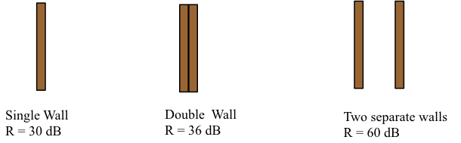
Coincidence frequency: The frequency of a sound is important ,the human ear is not equally sensitive to sounds to sound of different frequency .it is most sensitive at about 3,000 Hz and become less sentive at the limits of the frequency range reached about 20- 20 000 Hz
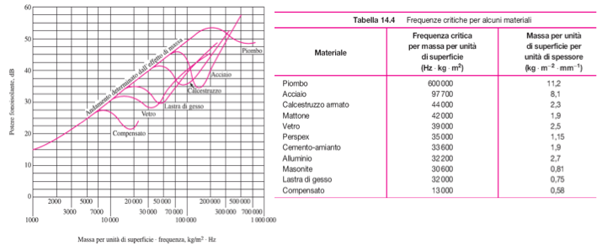
Example: steel, F_{cr}=97700 Hzm²/kg, s’ = 8.1 kg/(m²mm)
s = 10mm, hence s = s’s = 8.110 = 81 kg/m²
f_{coinc} = F_{cr}/s = 97700/81 = 1206 Hz

Sound Insulation D vs Sound Reduction Index R
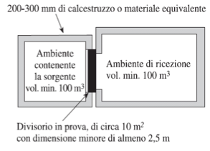
These two parameters are normally used to describe the sound insulation of a partition, D and R. D (Sound Insulation Index) represents the sound insulation between rooms on-site. Since these figures determine the final site requirements, D (Sound Insulation Index) levels are specified by customers and Building Regulations. R represents the lab tested sound insulation of an element making up a partition wall/floor type. The conversion between R and D should always be calculated.
The Sound Reduction Index R is defined by:
The Sound Insulation D is defined by:
We can make an energy balance of the energy passing through the separating wall, having surface S_{div}, and reverberating in room 2, having an equivalent absorption area A₂:
This is how we find the relationship between R and D

Apparent Sound Reduction Index R’
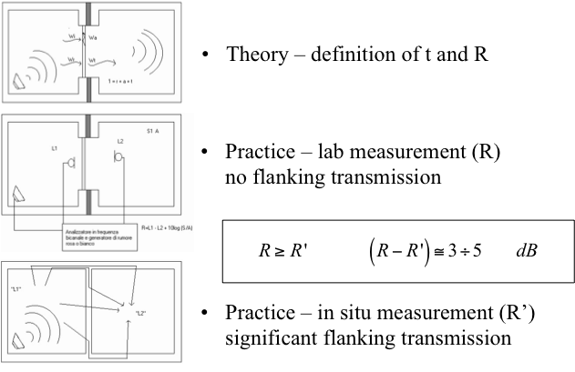

Weighted Sound Reduction Index R_{W}
A reference curve is shifted down at 1 dB steps, until the sum of unfavourable deviations becomes smaller than 32 dB:
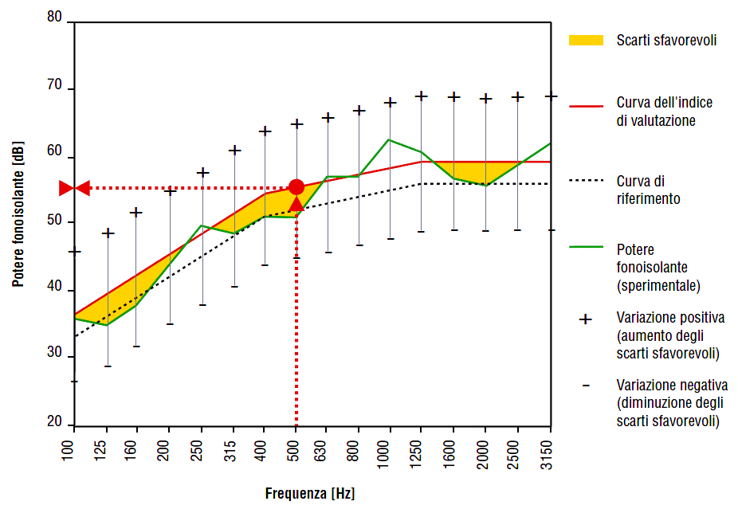
- At this point, the weighted value of the Sound Insulation Index, Rw,
is read on the reference curve at the frequency of 500 Hz.

