INDEX of lesson of 23/11/2010 – topic: LEGISLATION ON ENVIROMENTALE NOISE

- Old (but still in force) Italian law
- Actual parameters
- Actual limits
- Acoustical zoning in Parma
- Main contents of new CEE directive n.49/2002
- Legge delega di recepimento (n.306 del 31/10/2006)
- New parameters from new directive
- Pratical effects at noise surces
- Pratical effects of the new limits

Our legislative decrees

Parameters actually in force

LEGISLATION ON
ENVIROMENTAL
NOISE
OLD LEGISLATION
Limits actually in force
Acoustic zoning in Parma
NEW LEGISLATION
New directive CEE n.49/2002
Legge delega di recepimento - 2010
New limits
Assumptions about new limits
Practical effects of the new limits

BRIEF INTRODUCTION
In Italy we have the most powerful legislation about outside noise constraints. In this field, professional acousticians are paid so much earning a lot of money, because they have to work with difficult (and also expensive) softwares and they deal with a lot of hurdles, bureaucratic and technical.

Old (but still in force) Italian law
We have a lot of decrees which give you details about this limits and about the measurement of this limits. Those decrees specify how to detect the noise and setting the limits in different environments, as: railway, highway, etc.
The most important among this rules is surely Legge Quadro sull’inquinamento acustico (1995) and all the others are ancillary laws of this one. The acoustician has to know perfectly our legislation, because there are more than twenty different laws and some of these are in contradiction. When a contradiction between two different laws occurs the acoustician technic should know what is the priority of those laws, because there are three different levels of division and on the top level we have Legge Quadro, that imposes above others.

Actual parameters
Old Italian law (1995) shall specify three parameters, three quantities that have to be checked; we should have an integration of the surveys in a specify range of time and this result have to be lower than the limit imposed from the municipality:
- L_{eq,day} → Average value checked during the day (from 6 up to 22), keeping a range of time of 16 hours
- L_{eq,night} → Average value checked during the night (from 22 up to 6), keeping a range of time of 8 hours
- L_{diff} → Short - time measurement, where you have two measurements: one with noise’s source on and the other one when noise’s source is switched off. You make the difference between those two results and will obtain the differential level; if this level exceed the fixed limit my source of noise has to be permanently switched off. This is the real trouble, the biggest issue to solve for a lot of factory that use noiseless machinery.
L_{eq,day} and L_{eq,night} are absolute values, evaluated outside the buildings, instead L_{diff} is checked indoor booth with opened windows and closed windows.

It’s shown below an example of measurement of the levels above, made in Via Duca d’Alessandro in Parma.

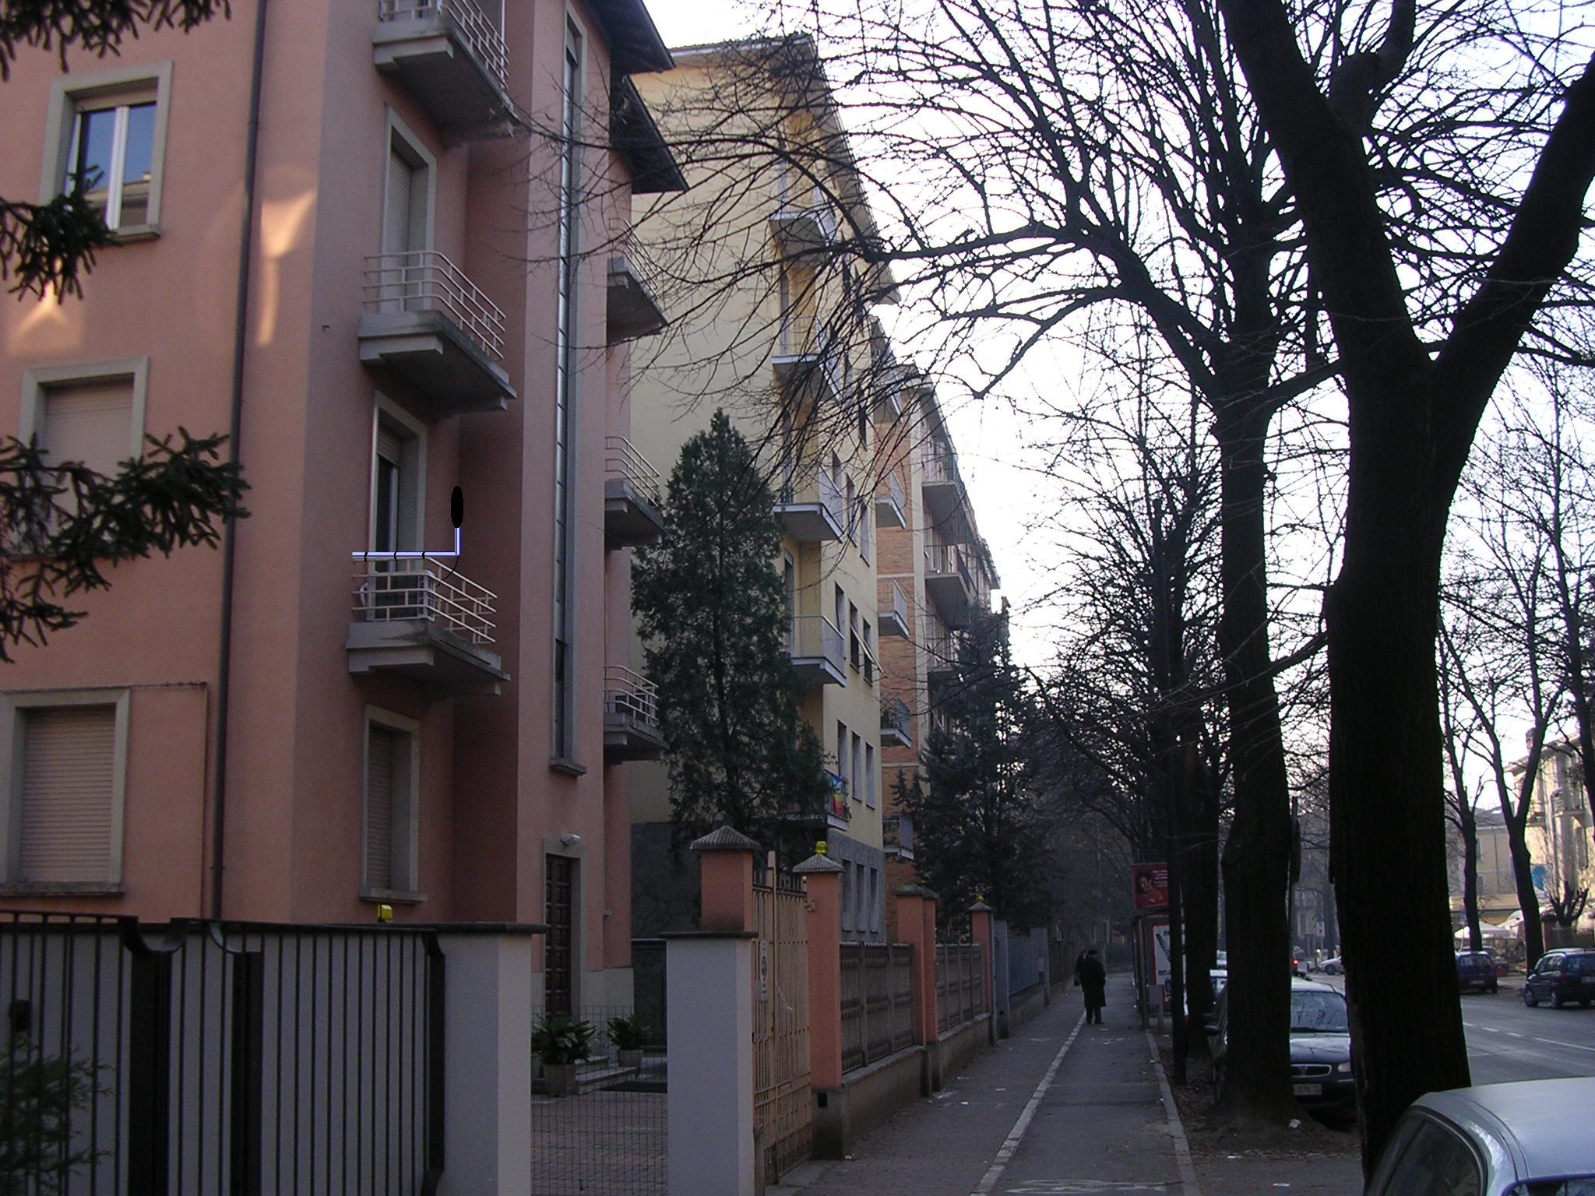
Microphone at 1 mt from the reflecting facade
Figure 1 – Measurement made with an outdoor microphone, designed to survive to rain, snow, wind, and from bird’s defecations. Making the installation of this dispositive we have to wait for 24 hours, or even a week, recording and look which are the results.

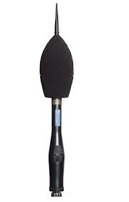
Figure 2 – Example of outdoor-microphone

L_{eq,day} = 67.7dBA
L_{eq,night} = 57.1dBA
Figure 3 – One minutes measurements of L_{eq} and their average value

You have to make a lot of one minute measurements and have the average of them, because by law what matter is just the average over the range of hours over day and night.
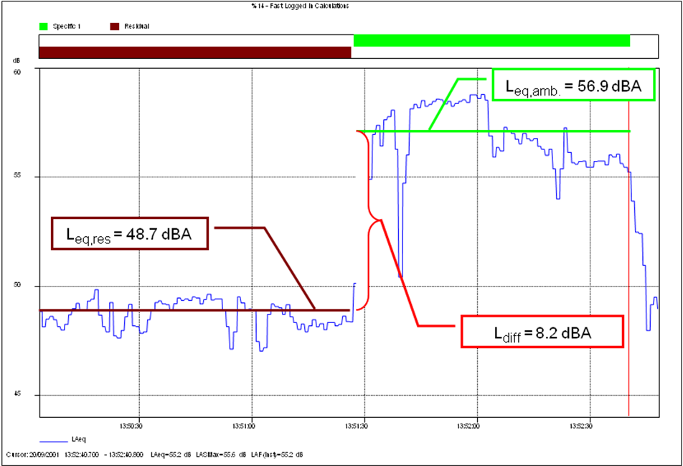
Figure 4 – Differential level measurement
In the last figure it’s shown with a brown line the situation when the noise’s source is switched off (L_{eq,res}), instead green line represent the ignition of the machinery in the factory (L_{eq,amb}). Having the difference between this two level we can find the final L_{diff} value, that in this example is so huge. A differential level too large means the closure of the production in a factory. The law provides to give two warnings before the definitive production blocking.
Often the most relevant problem is the background level of the factory, the residual noise, that is not under owner’s control, so it’s not reducible.

Italian law has others two peculiarities; for all the level measured you can apply booth a tonal correction and an impulsive correction and each of these corrections are of 3dB.

TONAL CORRECTION: if your noise has a tonal character, you should increase the level measured by the sound level mitter by 3dB. Having tonal correction we have to made two check, so my spectrum has to satisfy two criteria:
- The minimum band frequency level exceed from the value of the neighboring by more than 5dB
- The tonal component has to not be masked, so if it touches a isophonic equal or higher than the highest reached by the other spectral components

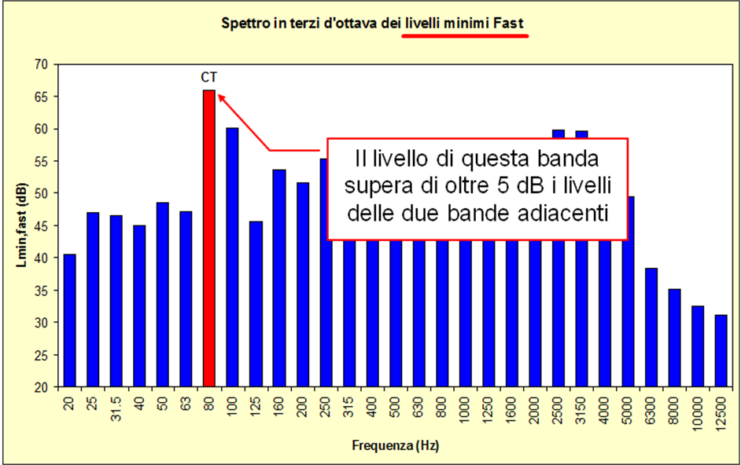
Figure 5 – Example for first criterion for tonal correction

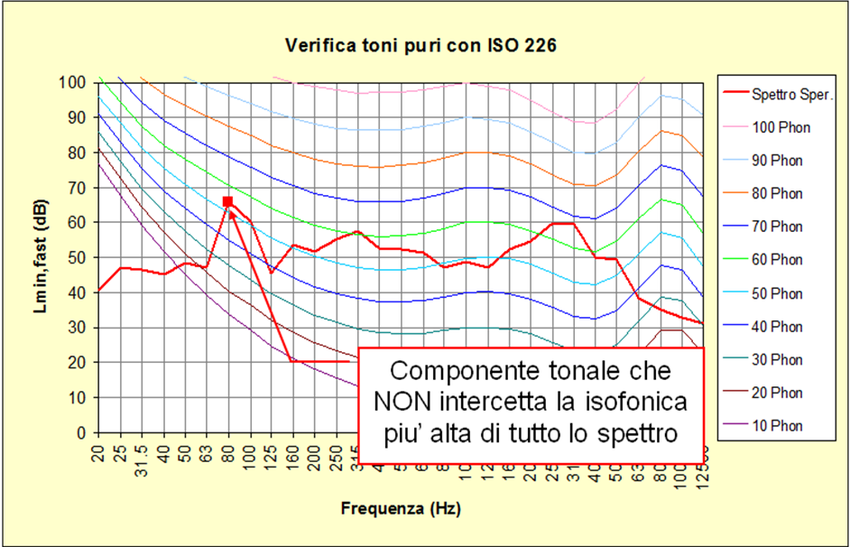
Figure 6 – Example for second criterion for tonal correction
In example above the tonal character passes the first checking, but not the second one because the detected peak does not exceed the highest isophonic.

IMPULSIVE CORRECTION: if your sound has an impulsive character, you should increase the level measured by the sound level mitter by 3dB. Also here I have to do two different checking to apply impulsive correction:
- I analyze my noise with three different time constants: the impulse (red one), fast (blue) and slow (green). The sound is impulsive if the difference between the maximum sound pressure level with impulse constant is 6dB or more than the maximum slow value.
- Looking up the fast time constant; the duration of the pulse measured at 10dB below the maximum fast value, must be less than 1second
If my sound respects these two criteria, I can apply the correction by 3dB.
Indeed a sound to be impulsive must respect a third constraint actually:
- the impulsive event must be repetitive, so it must have repeats at least 10 times / hour during the day and 2 times / hour at night
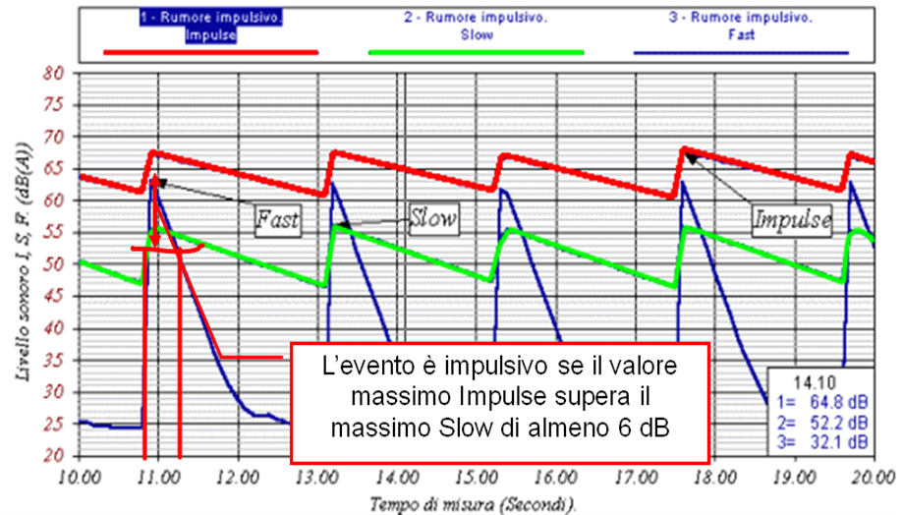
Figure 7 – Example for impulsive correction

Limits actually in force
Are shown now the limits give by the law for absolute levels, that depend from the zoning of the territory, and differential level that is equal for all different areas.

Class of intended use | L_{eq,day} | L_{eq,night}
- Specially protected areas | 50 | 40
- Predominantly residential areas | 55 | 45
- Mixed type areas | 60 | 50
- Intense human activity areas | 65 | 55
- Predominantly industrial areas | 70 | 60
- Exclusively industrial areas | 70 | 70

CLASS I : Protected areas, like schools or hospitals
CLASS II: Residential areas; type of zoning make up in the past, in some sights named dormitory where there were just houses, so no kind of services are localized in this area. This was a big trouble, because if someone had necessity to buy something they were forced to have too long walks to reach de destination
CLASS III: Most common one, about the 90% Italian’s areas are of this type. CLASS IV: Area typical within the ancient walls of the towns; includes pubs, restaurants, discos, so in this area there are a lot of activities and there are less stringent constraints
CLASS V: Mainly industrial areas. Here we can find some homes
CLASS VI: Here there are just industrial warehouse, without houses. The night limit is equal to day limit, because no one sleeps in this area

 | Day | Night
Differential level | 5 | 3

This limit is applied equally in different areas and it’s not applied in exclusively industrial area, because there are no houses there and the differential limit is an indoor measurement.

Acoustic zoning in Parma
The zoning of Parma was be adopted in 2003 and substitute a previous zoning of 1998. All the city centre is actually red (class IV), because the municipality allows higher level than others Italian towns, so the limit is kept large, because there are a lot of factories near the houses; the issues is the differential limit. However we can easily see that large part of the city is drawn in brown, so that means that most of the town is in Zone III as usual for all others cities in Italy.
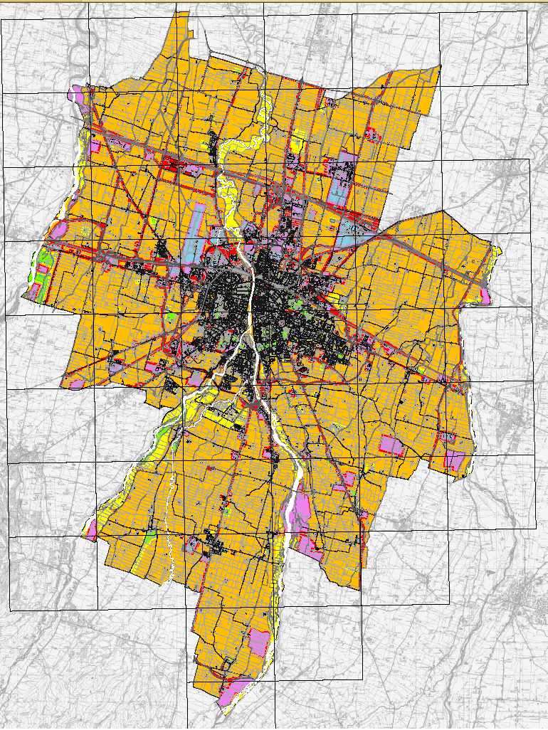
Figure 8 – Actual zoning in Parma
SCALING PRINCIPLE: To ensure the precise respect of the limits, all towns’ zoning must respect the scaling principle, so there would be a gradually passage among different levels. In Parma there are no boundaries that exceed more than one level.
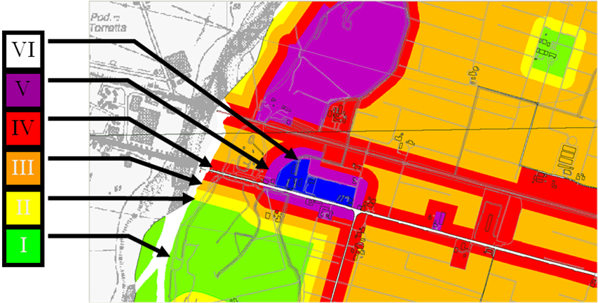
Figure 9 – Example of application of scaling principle
In example shown in Figure 9 above we can see clearly the application of this principle in the green zone on right size of the map, which is bounded by a yellow barrier in order to avoid a direct contact between Zone I and Zone III.
However there can be some exceptions of some sights, that are built without the respect of this principle as shown in Figure 10 below:

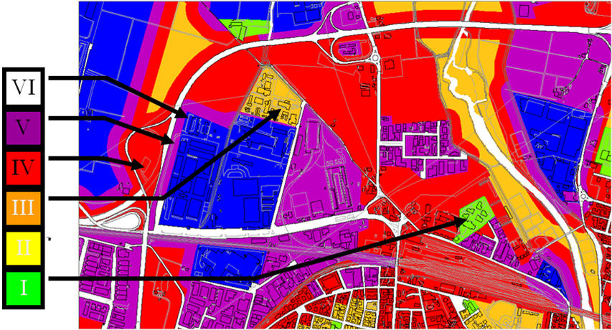
Figure 10 – Exception to scaling principle
Here we can see some zone where scaling principle isn’t observed; particularly the green zone indicated by the arrow is an example of a school, surrounded by Zone IV without any boundary zone. In this case a barrier would be required by law, but if was not possible install a too tall barrier, whose would be harmful for children’s growth, it would be necessary to build the edifice using soundly isolated windows.
Classes I maintaining their class even if they’re close to higher class Zone.

The Zoning of a town must be processed by a long bureaucratic iter, that provides a precise time scale, as following:
- Adoption in the municipal council
- 60 days to submit comments
- ARPA’s (Agenzia Regionale per la Prevenzione e l’Ambiente) opinion
- Approval of the city council
- Transmission to the province and entry into force
- Within 6 months the activity evaluate the respect of zone lmits
- Within the same months give, if it’s necessary, a Recovery Plan
- Within 2 years from the presentation carry Recovery Plan out

Instead there are some obligations for companies that must be observed in 6 months:
- To verify compliance with the limits of the area for the noise emitted by the production site
- The verification shall be carried out by a Competent Technician in Environmental Acoustics, writing to the list of regional technical experts
- If the zone limits are exceeded, provide a noise abatement plan, to be submitted to the City
- The plan may provide for graduated interventions over time, depending on their technical complexity and their costs, up to a maximum of 2 years from date of submission

New directive CEE n. 49/2002

The new law has not been completely approved yet, because in Italy we have a law that theoretically follows European directives, but in practice this was never completed by the decree which should fix the limit of new parameters introduced by this directive. The contents of this new directive come from Legislative Decree of 19/08/2005, n.194. Here there are just few points that are significantly important. The points of this directive are listed below:
- Definition of a common methodology to assessing the environmental noise
- Normalization of objective parameters
- Limits of acceptability for objective parameters are not given
- Member States had to amend their legislation in order to make it fair with the new parameters by 18/07/2004 (before 30/06/2004, according to L. 31/10/2003)
- Each Member State is free to set the limits of acceptability appropriate
- There was the obligation to realize the acoustic map of all towns with more than 250000 inhabitants, but also of highways, railways and airports

There are also some attachments of this directive, that are always listed below:

- Definition of new acoustic descriptors
- Methods to define these new descriptors
- Dose – Effect relationship
- Data to send to the Commission within 30/12/2007 (acoustic strategic maps

With the first attachment are defined some new parameters that should substitute the old. Particularly an unique parameter is used by the new directive named L_{den (Day Evening and Night)} , the equivalent continuous long-term weighted determined over daily periods of a calendar year. It’s composed from three different levels
- L_{day} → measured from 06 up to 20
- L_{evening} → measured from 20 up to 22
- L_{night} → measured from 22 up to 06
To calculate the value of L_{den} we have to add:
- 5dB to L_{evening}
- 10dB to L_{night}
- 0dB to L_{day}
and by the use of related formula we have that:

$L_{\text{den}}=\text{10}⋅\text{lg}\left[\frac{\text{14}⋅{\text{10}}^{\frac{L_{\text{day}}}{\text{10}}}+2⋅{\text{10}}^{\frac{L_{\text{evening}}+5}{\text{10}}}+8⋅{\text{10}}^{\frac{L_{\text{night}}+\text{10}}{\text{10}}}}{\text{24}}\right]$

(1)

Assumptions about new limits

It’s necessary to mention some clarification about this parameter:

- It is used for new designs when the law requires the measurement by mandatory
- Its three levels are measured outside the buildings, but excluding the refelction effect over reflecting façade. So usually it necessary to delete 3dB to measure value; so according to Europe this value is thrown away
- Any Member State can modify the range of time to measure these three limits according with citizens lifestyle
- In Italy as in others countries is required by law the separation from L_{night} and others levels. It’s applied just to residential building, in order to protect the sleep of the residents

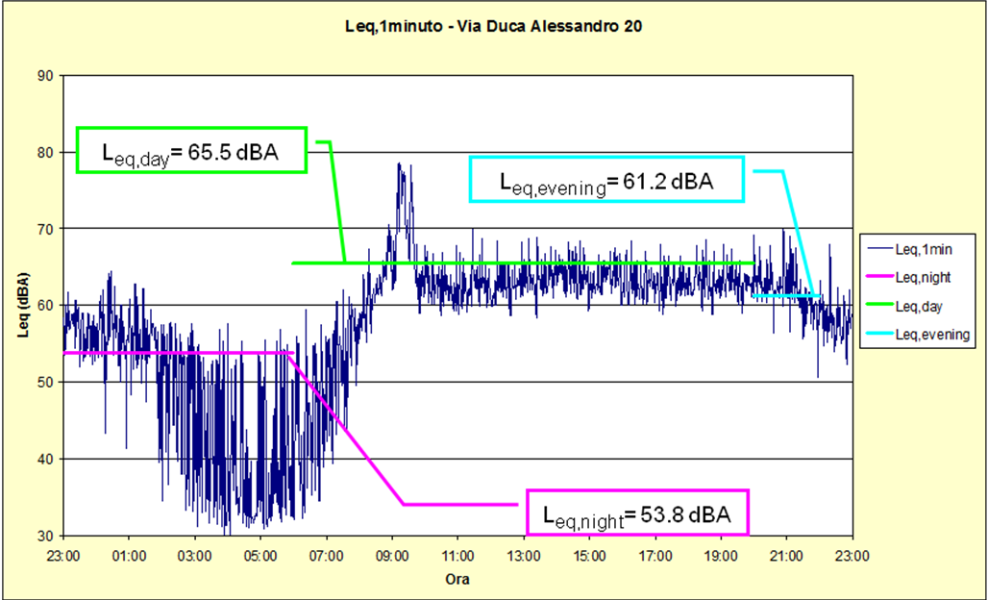

Figure 11 – Same example of Figure 3 measured with L_{den}
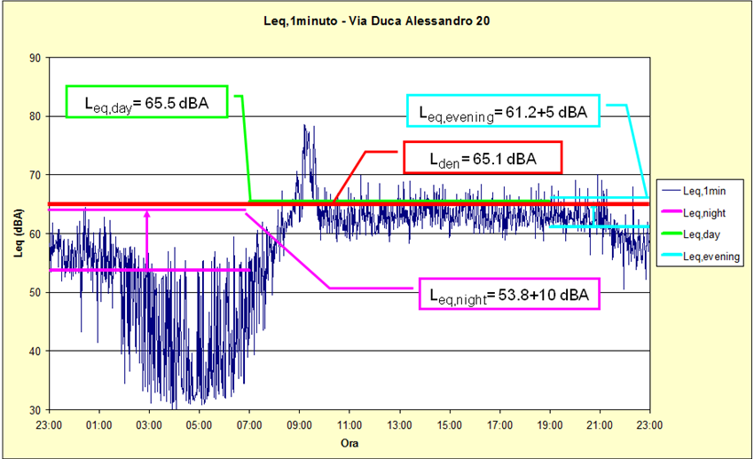
Figura 12 – Equivalent value obtained by three levels, implementing the increase over day and night levels

Pratical effects of the new limits

We can compute the last result in Figure 12 with the result in Figure 3; making it we find that substantially no differences arise from old to new type of measures.
Can we say that new descriptor L_{den} is more or less restrictive than the previous one?
To answer at this question we should evaluate if using the new descriptor, supposing that the legislator keeping valid also for L_{den} the actual limits, the noise emitted by some typical sources is higher or lower. So there are some different cases to observe:

HYPOTHESIS 1: RAILWAY MILAN – BOLOGNA

In this case we’ve a flat profile, because the noise produced by the source is more or less always the same every time. We can verify that new regulation is more restrictive than the current one.

Figure 13 – Example of flat profile

NORMATIVA VIGENTE |  | NUOVA NORMATIVA
L _{eq,G} = | 70.0 | L _{den} = | 73.4
Limite = | 70.0 | Limite = | 70.0

HYPOTHESIS 2: FACTORY THAT WORKS ONLY DURING DAY

In this case the background noise is low and L_{eq,day} would be more stringent than the new L_{den.}
Figure 14 – Example of low background noise

NORMATIVA VIGENTE |  | NUOVA NORMATIVA
L _{eq,G} = | 68.0 | L _{den} = | 63.4
Limite = | 70.0 | Limite = | 70.0

HYPOTHESIS 3: FACTORY WITH HIGH BACKGROUND NOISE

Here unlike the previous case we’ve more background noise that provide to bring together the two results.
Figure 15 – Example of high background noise

NORMATIVA VIGENTE |  | NUOVA NORMATIVA
L _{eq,G} = | 68.7 | L _{den} = | 68.2
Limite = | 70.0 | Limite = | 70.0

To be more precise it is possible to evaluate the difference between the new and the old legislation with a practical and real example:

Figure 16 – Measurement in “Via Spezia”

NORMATIVA VIGENTE |  | NUOVA NORMATIVA
L _{eq, g =} | 58.0 | L _{eq, d} = | 55.6
L _{eq, n =} | 49.0 | L _{eq, e} = | 52.1
 |  | L _{eq, n} = | 46.4
 |  | L _{den} = | 55.5

By results with the same noise profile there is an increase of tolerance using the new regulation. However if we keep our actual table of limitations, nothing of dramatic will occur.

CONCLUSIONS

Acutal limits are so restrictive, so a reduction of these limits would be harmful for activities business activities as pubs or factories.
In some areas the new legislation can be more or less restrictive, however L_{night} remain unchanged and stricter than the day one.

