SINGLE EVENT LEVEL (SEL)

Single Event Level (also known as SEL) is a concept strictly connected to equivalent continuous level (Leq). While the instantaneous sound pressure level depends on time and changes for example according to the passage of vehicles, indeed we can define the equivalent continuous level as the constant value of pressure level which gives the equal acoustic energy for the same time interval: the word “equivalent” means an energetic equivalence and the flat profile of equivalent level and the variable one have the same energy.
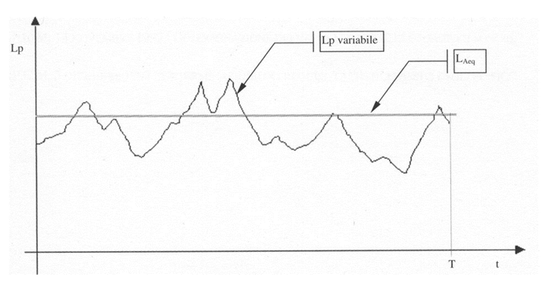
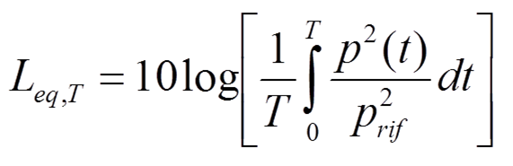

Single event level is the pressure level that gives the whole energy packed in one second.
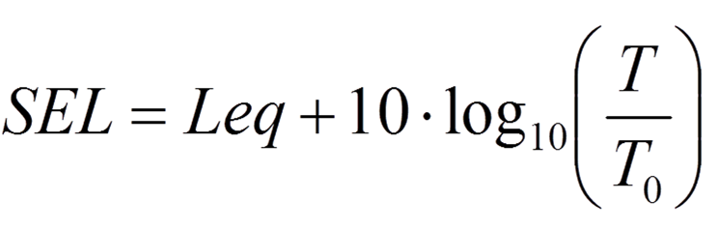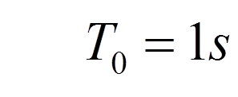

The concept is that instead to have the energy “spread” evenly over the duration of the measurement (which can be very different from time to time) it concentrates the energy in just one second. The number becomes larger increasing time of measurement, because integrating over a longer time is considered more energy.
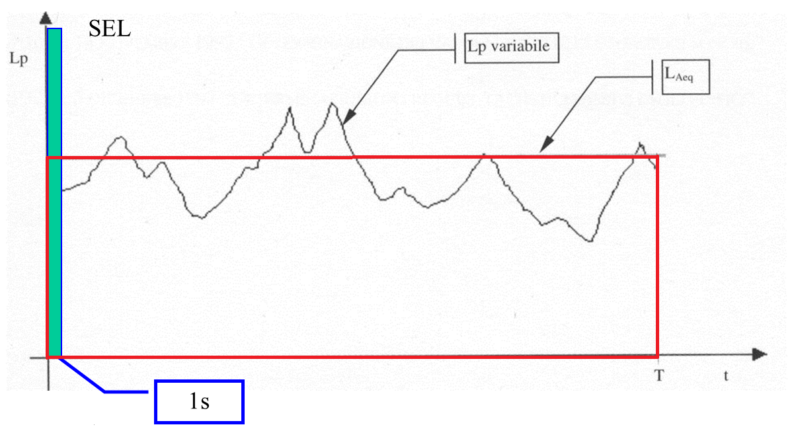

The area of the two rectangles is the same; it should be noted that three decibels more means doubling the energy.

Usually Single Event Level is used when a single vehicle is passing through and it’s measured in the so-called “passing through test”, that’s can be done on every type of vehicle with a Sound Level Meter. In fact, what is interesting in many cases isn’t how long is the sound profile and how much is larger the maximum sound pressure level, but is the total energy get by a receiver. So it’s important the speed of the vehicle and the total area subtended under the profile, not its details (which depend also on vehicle directivity).

NOISE FROM ROADS AND RAILWAYS

The noise of vehicles on railways or roads can be represented as the noise of a continuous line source, which is a mathematical abstraction. In this abstraction there are two possibilities: coherent emission and incoherent emission.

The first one is like a pulsating cylinder with the same motion law for every point of it: this radiates coherent emission and the analytical solution is given by this formula

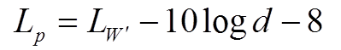

In which “d” is the distance from the line source and “Lw’” is the sound power level per meter of line source. This is the power level of a cylindrical field and it can be noted that the level decay is 3 dB doubling the distance, while for a spherical one is 6 dB per doubling distance.
If the sound is instead radiated incoherently that means that every point of the source radiate independently by the others: so in this case we have not a single source, but we have an infinite number of very small noise sources completely unrelated. The summation of sound levels result in a value which is approximately 2 dB louder than the coherent source of the same power:

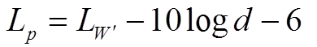

What happens is that with random phases the energy always sum at the receiver, because energy is a positive quantity. Instead with coherent emission half of the length of the source radiates in opposite phase than the most short distance radiations and so we can divide the linear source in positively radiating and negatively radiating regions. The phase changes with the distance of propagation: changing the distance change the time the sound takes to reach the receiver and, when the time difference is an odd number of half a period, phases are opposite and the pressure summation is destructive.

In the real world sound sources are not continuous, but they are discrete: for example noisy elements in a train are just wheels, which make noise rolling on railways; in a street road vehicles along the road are discrete sources spaced by a certain average distance “a” (this average distance is an approximation).

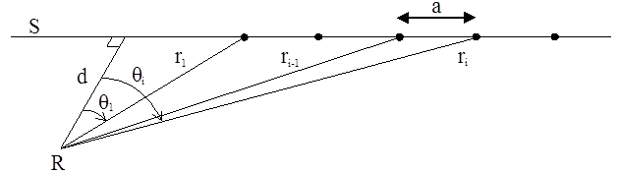

To study this case we have to use the formula of the incoherent emission and to obtain the sound power level per meter (Lw’) we have to dilute the power of one vehicle (L_{Wp}) over the length of the road, that is schematized as a sequence of point sources, which are vehicles.

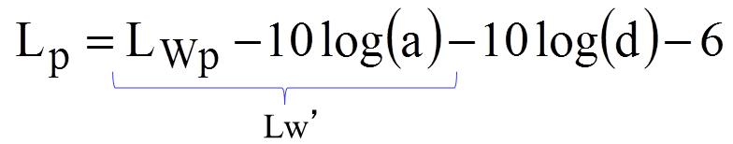

SEL can be used to analyze the flow of vehicles over the road. Consider the passage of a vehicle: one can see that the equivalent level depends on time measurement and if we take for example a longer time that takes also background noises the value of Leq will be smaller because the energy is more diluted; instead packing all the energy in one second the total energy is substantially the same. So the nice thing of SEL is that if the experiment is not careful and was measured tails of background noise, its value doesn’t change (it’s a robust quantity). For this reason SEL characterize very well the noise of a vehicle. It is usually measured at the standard distance of 7,5 meters.

RELATIONSHIP BETWEEN SEL AND THE POWER LEVEL OF THE VEHICLE

If SEL refers to just one vehicle passing in an hour and is measured at a distance of 7,5 meters, we obtain this formula
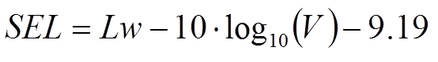
In this equation there’s the speed as the only variable, because the other ones are all fixed and grouped in the term “9.19”. According with this formula we can see that the noise is reducing with speed; this happens because increasing the speed the profile become shorter and the area subtended under it become smaller. Conversely reducing the speed the noise increases because the vehicle takes more time to switch and consequently the noise stay for longer time. Of course sound power level is not constant and independent from the speed, or better it’s constant for low speeds, because noise is caused only by mechanical parts, but after 30 Km/h the SPL increases slightly due to the rolling noise and above 70 km/h it starts to increase significantly (about 6 dB for doubling speed) due to aerodynamics noise.

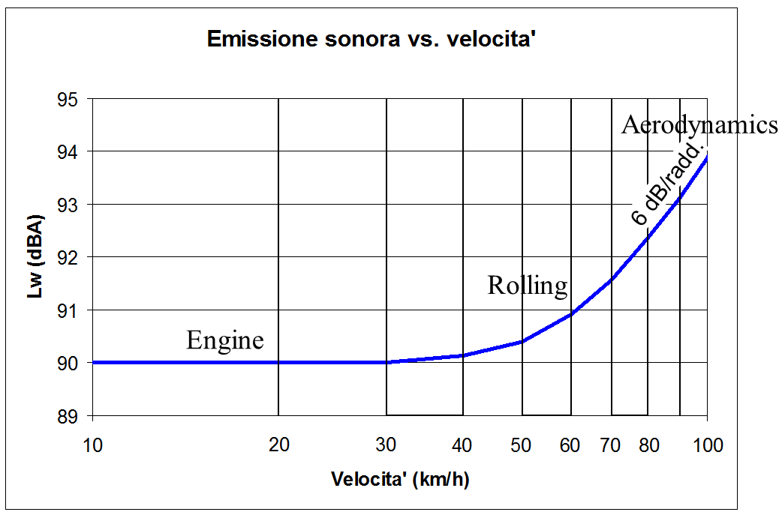

So how SEL depends on the speed of the vehicle? You can see in following chart.

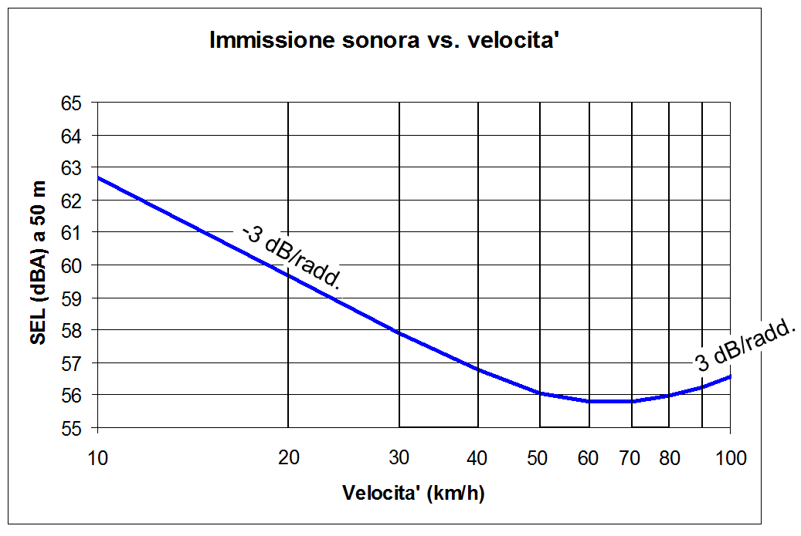

It can be seen that Single Event Level has a minimum around 70 km/h, although in reality it depends on the type of vehicle; for example for electric cars optimal speed is 100 km/h. For higher speeds than the optimal one the SPL of the vehicle increases and it’s lost part of the advantage of reducing the length of the profile. Similar arguments are valid also regarding the chemical pollution caused by vehicles and studies have shown that bring the speed limit in urban roads from 50 km/h to 70 km/h could halve the pollution.

PERSONAL EXPOSURE LEVEL (Lep)

There is a limit to how much noise a worker can be exposed during his working day and this limit is expressed by the personal exposure level. Lep measure the total noise to which a worker is exposed during the work shift and it’s computed on the personal exposure profile, that’s different from worker to worker. It’s like SEL but instead packing the whole energy in one second it is done in eight hours, which is the standardized duration of a work day.

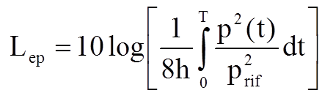
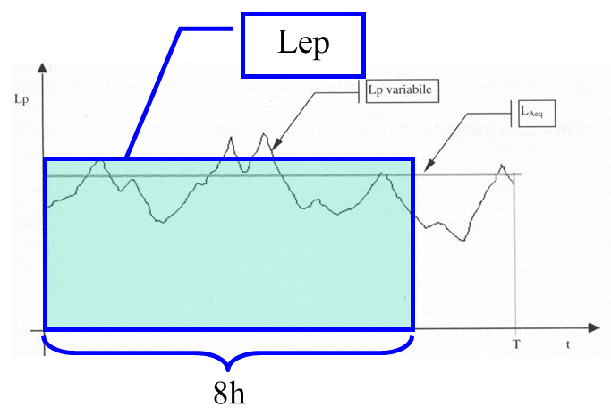

In the next formula you can see the relationship between Lep and the equivalent level, that’s very similar to that between SEL and Leq (we have 8 hours instead of one second).

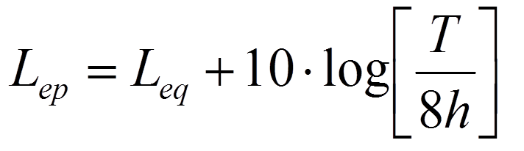
In which “T” is the working time in the day.

