INDEX of lecture of 07/12/2012 – Topic: Applied FFT Transform

The FFT Algorithm 2
Signals spectrum 2
FFT Blocks 3
Leakage 4
Windowing 4
Overlapping 5
Using the FFT 6
Fast convolution with FFT 6
Overlap and Save 7
Uniformly Partitioned Overlap and Save 8

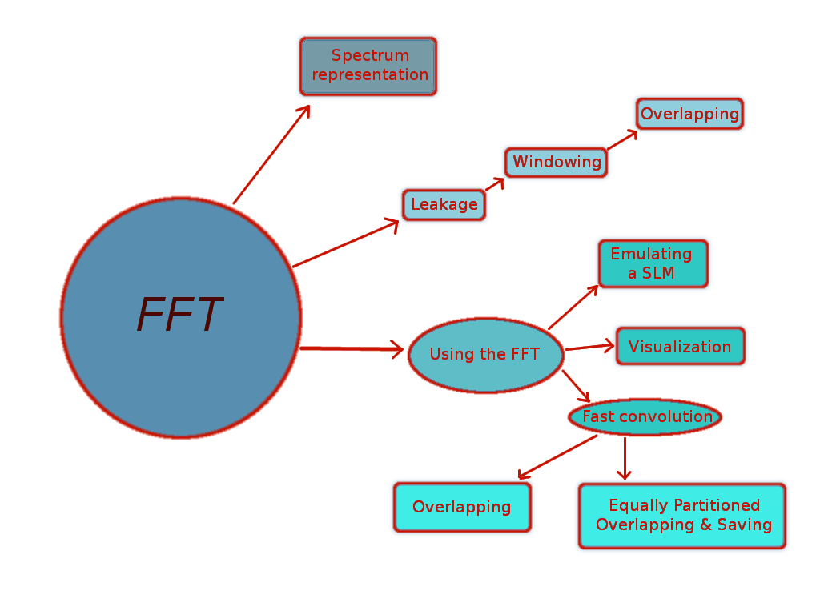

The FFT Algorithm - ( Fast Fourier Transform )

The FFT algorithm is used to compute the spectrum of a digital signal. Given our signal as a sequence of samples, these are processed by the FFT and we obtain another sequence that represents the spectrum.

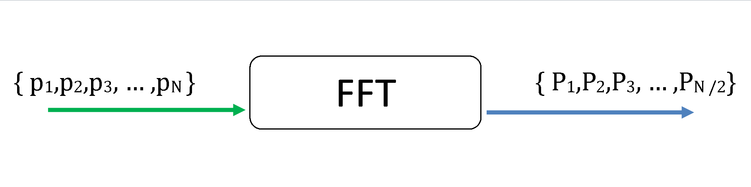
1. Block diagram of a FFT process

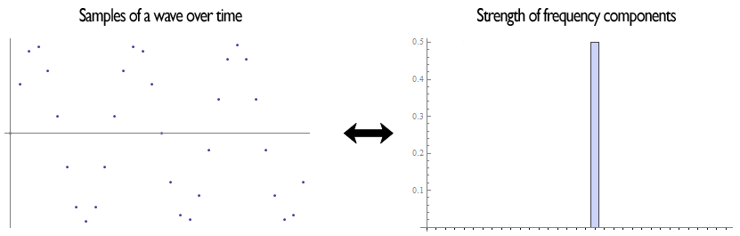
2. FFT applied to a sinusoid

Signal’s Spectrum

Since the spectrum is in general a complex number, it can be written as
$A⋅e^{iϕ}$
Where:
A is the magnitude
φ is the phase
i is the imaginary unit

Magnitude: In most cases we're just interested in the magnitude of the spectrum [ noise, music, voice... ]. In particular we can calculate the squared pressure at each frequency as

$L_{p}(f)=\text{10}⋅{\text{log}}_{\text{10}}\left[\frac{P_{r}(f)^{2}+P_{i}(f)^{2}}{p_{0^{2}}}\right]=\text{10}⋅{\text{log}}_{\text{10}}\left[\frac{P(f)⋅P(f)^{}}{p_{0^{2}}}\right]$ (1.1)
Where:
P(f) is the spectrum
P_{r}(f) is the real part of the spectrum
P_{i}(f) is the imaginary part of the spectrum
P(f)* is the complex conjugate of the spectrum

Phase: There are some cases where the phase contains information, typically when our signal is the impulse response of a system. It shows how much delay the system introduces. The longer the delay, the steeper will be the phase curve in the phase domain.

Both information, magnitude and phase, are plotted on bode charts:

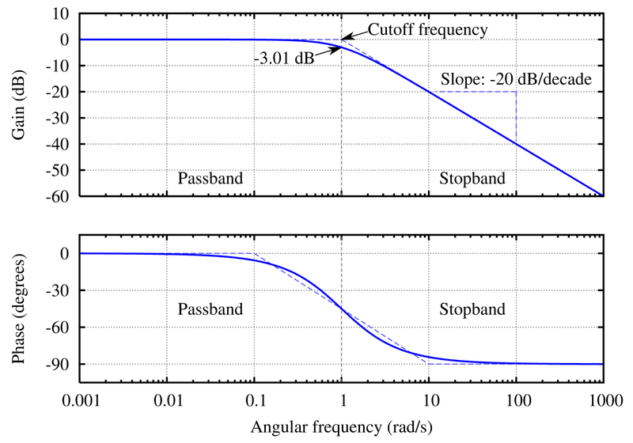
3. Bode plots of a Butterworth filter

FFT Blocks

For the FFT to perform optimally, we must split the incoming signal in blocks of length 2^{n} with n = 1,2,3… These blocks will be processed individually. However, in some cases we may want to use blocks of arbitrary size.
Trick: To use a block of arbitrary length, we just add padding zeroes to the block until we reach the next power of two.
e.g. Suppose we want to use a block of 6000 points, then, we just need to add zeroes until we reach 8192 = 2¹³


4. FFT processing requires the signal to be cut in equal blocks
Leakage

The FFT operates under the assumption that the block analyzed is a complete period of the signal itself, however this is not necessarily true in reality.
Since the block size is fixed to 2^{n}, the signal may be not periodic over the block or may be not periodic at all. This causes a discontinuity between the blocks. In time we hear it as a click, in frequency we see it as leakage.

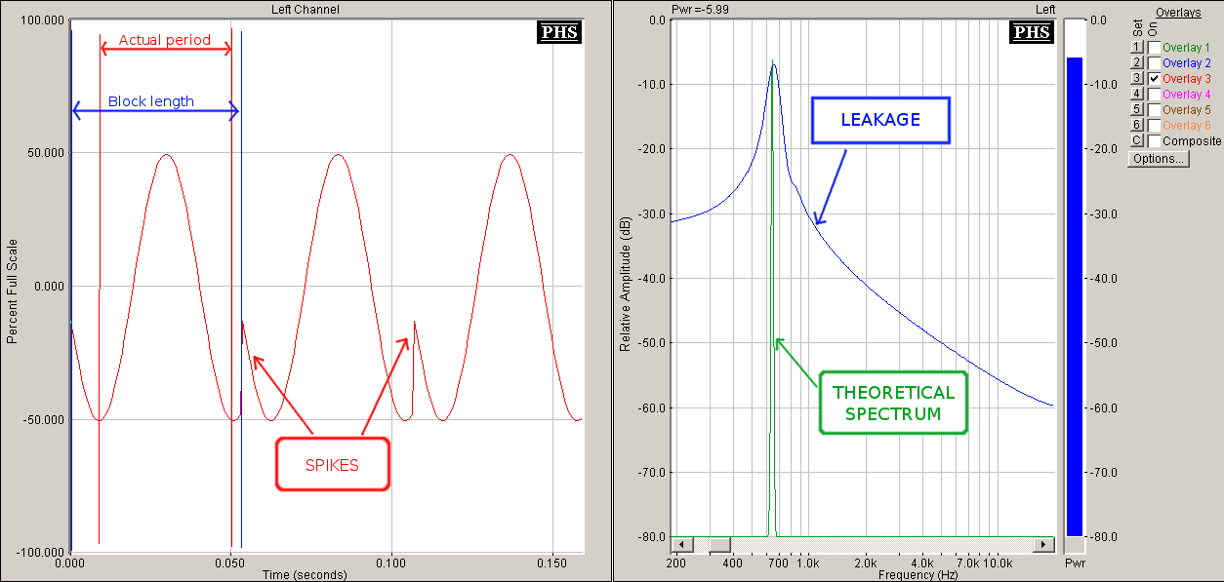
5. Leakage on a sinusoid
In figure 5 we see a block cut from a sinusoid with a length larger than its period. In time this causes the discontinuity shown as a little spike. In frequency, instead of having a sharp peak we have a leakage of the energy over all the frequencies.

Windowing

To avoid leakage, we force continuity over the block edges, imposing an amplitude of zero at the beginning and at the end of the block. To do this we “window” the block, multiplying it for a signal that starts from and goes to zero. This process reduces the power leak over the other frequencies.

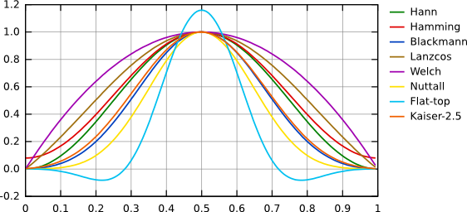
6. Various window types: they all start and end at zero

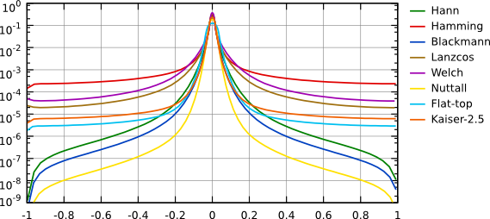
7. Various window types in frequency domain

Overlapping

Since with windowing we force the signal to zero at some time, we lose information, to avoid this we use overlapping. We overlap adjacent blocks, usually 50%, or, better, 75% of the block size, as required by the Italian law.

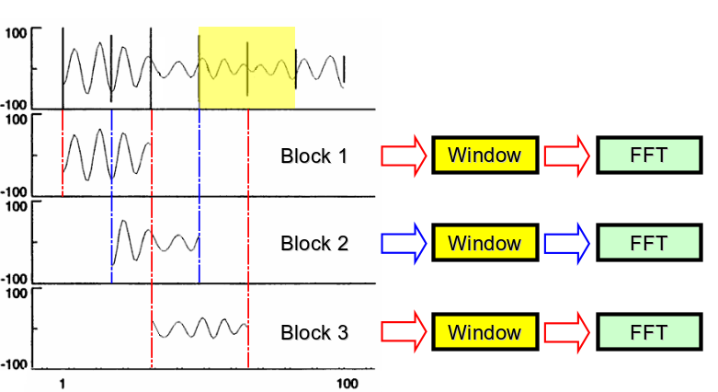
8. 50% overlapping

Figure 8 shows the process of 50% overlapping. We take the FFT of the first block, then we shift the block analysis by a 50% of the block length and take another FFT. This block will include half of the previous block recovering information where the window would have forced to zero the signal.

Using the FFT

When we have the sequence of blocks we can:

- Average them with the techniques already seen for sound level meters: exponential slow, exponential fast, linear. With this procedure we emulate the time response of a sound level meter.

- Visualize them with two different kind of visualization: spectrogram and waterfall.

  - Waterfall: it’s a 3D visualization, on the horizontal plane we have frequencies and time, on the vertical axis there’s amplitude.
  - Spectrogram: it’s a 2D visualization, on the horizontal axis there’s time, on the vertical axis there’s frequency. The amplitude is encoded with colors.

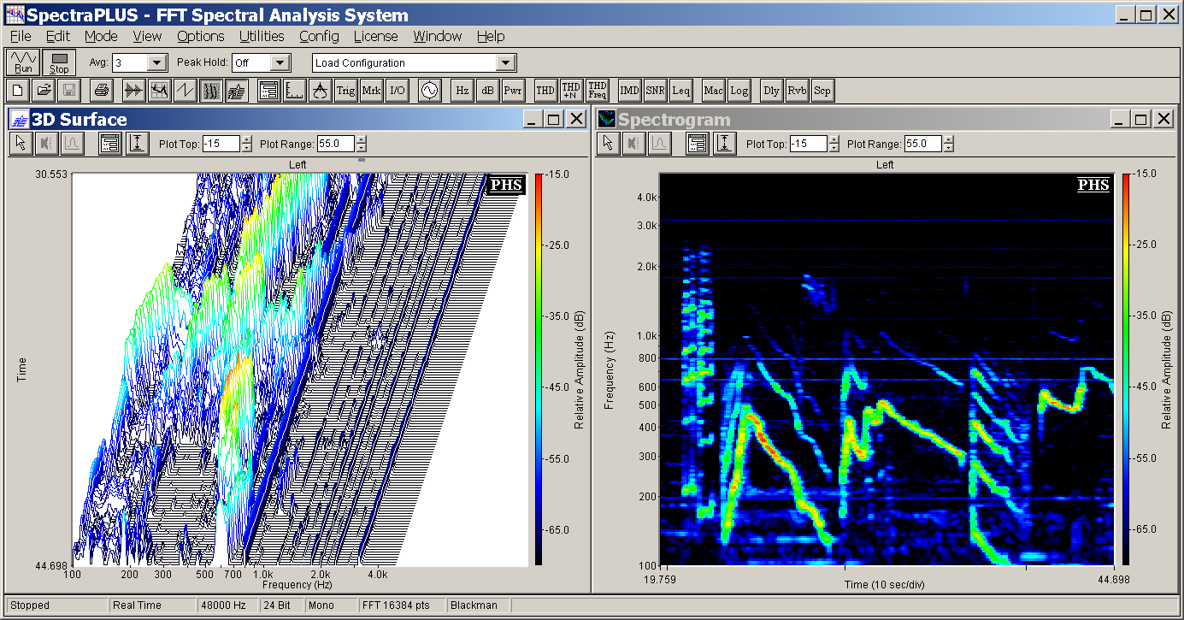
9. Waterfall [3D] and spectrogram [2D]

Fast convolution with FFT
Another important use of the FFT is to compute convolution faster. In fact, a convolution of two signals in time, is a multiplication of the spectrum of the two signals in frequency. So, taking the FFT of the signals, multiplying them and then retransform them in time domain is much faster than computing a convolution directly in time domain. This reduces the number of operations needed by a factor of 2n, where n is the number of samples.

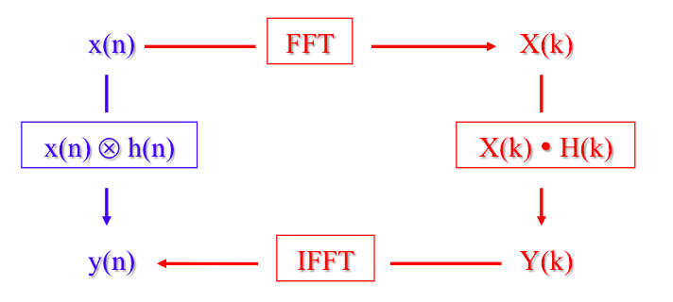
10. The convolution can be processed as a multiplication thanks to the FFT

However there are two problems: We need to have the complete signal in order to transform it with FFT, this makes the procedure not suited for live application. And we require a lot of memory if the number of samples n is large. To improve the situation we use the Overlap and Save Algorithm.

Overlap and Save Algorithm

We split our input signal in a sequence of blocks and perform the fast convolution on the blocks as time goes on.

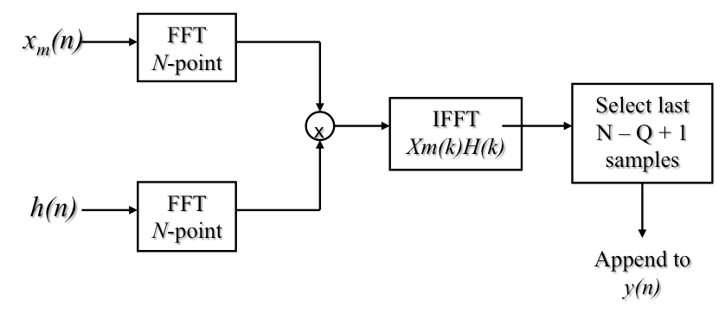
11. Block diagram of Overlap And Save algorithm
We compute the FFT of the incoming block x_{m} and of the zero-padded impulse response, then we multiply them and finally we retransform them with the IFFT ( Inverse FFT ). We obtain a sequence of samples that’s larger than our initial sequence, so we select only the last N-Q+1 samples (Where N is the x_{m} block size and Q is the length of the impulse response without padding).
Then we process the next block x_{m+1} shifting the input window of N-Q+1 samples and repeating everything.

However the problems introduced by fast convolution remain at least partially: latency and high memory usage. With this procedure they’re just reduced. To improve the situation we use another algorithm.

Uniformly Partitioned Overlap And Save

In this algorithm we partition also the impulse response in blocks of the same length. Better results are obtained when the size of the blocks is almost the size of the cache memory; this way the whole block of data can be accessed at once reducing computation overhead. In fact in modern processors, memory access is many times slower than sum and multiplication. Thanks to this algorithm, latency and memory occupation are divided by the number of partitions.

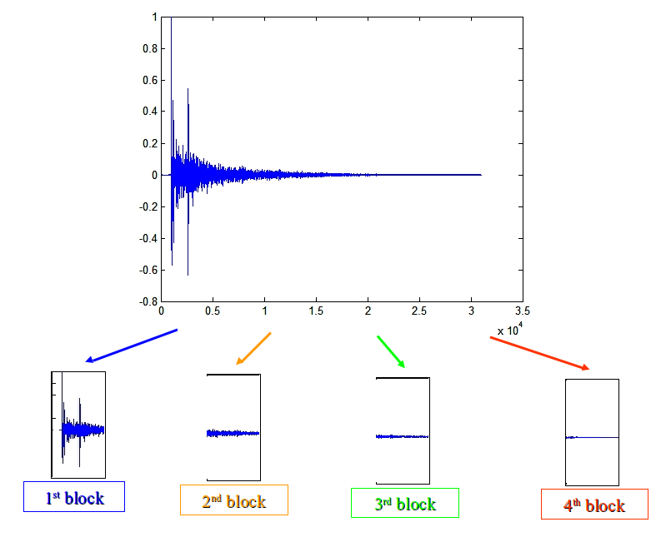
12 The impulse response is divided in blocks of equal length
Albeit in theory partitioned convolution requires more math operations than traditional Overlap-And-Save, in practice the processing load is smaller, as the number of memory accesses is reduced, and the blocks being accessed can be burst-loaded into the cache memory of the processor.

