LESSON INDEX of 14/12/2012 – ora 15:50-16:50
Topic: Sound recording and playback techniques

Concept Map 1
Virtual high-order microphones (Mark Poletti) 2
Wave Field Synthesis (WFS) 3
Theory 4
Sound focalization 5
Casa del Suono (S. Elizabeth Church) 7
Nicchie espositive 8
Lampadario Sonoro 10
Sala Bianca 12

Concept Map
Sound recording
and playback
techniques

WFS
Casa
del suono
(St Elizabeth Church)
Virtual H-O
microphones
● Technology
● Theory
● Sound
focalization
Nicchie espositive
Lampadario sonoro
Sala Bianca

Virtual high-order microphones (Mark Poletti)
They are based on an extension of ORTF method; instead of having only two microphones at 110°, there’s a ring of a certain number of equispaced microphones (tipically 32 or 36 along a 110mm-radius circumference). Processing all the microphones signals mathematically, it can be created polar pattern up to 5th order.

From these 36 impulse responses it is possible to derive the response of cylindrical harmonics microphones (2D Ambisonics) up to 5th order:
Order 0: $D_{0}=1$
1st order: $D_{1,n}=\text{cos}\left(ϑ+n⋅\frac{π}{2}\right)\begin{matrix} & \end{matrix}n=0,1$
2nd order: $D_{2,n}=\text{cos}\left(2ϑ+n⋅\frac{π}{4}\right)\begin{matrix} & \end{matrix}n=0,1$
3rd order: $D_{1,n}=\text{cos}\left(3ϑ+n⋅\frac{π}{6}\right)\begin{matrix} & \end{matrix}n=0,1$

At 1st order (ORTF method) there’s a lot of spatial leakage, because microphones haven’t narrow directivity pattern; with a ring of microphones, at high-order you can get much sharper directivity pattern and it can provide, at playback, a much better source separation.
Problem: it’s required to record a lot of channel (in this example 36); it’s really huge, and also today it’s not easy to record such a number of channel simultaneously on a SD card (it’s really expensive).
Limitation: it’s horizontal only.

Wave Field Synthesis (WFS)
In this case, the distance between microphones (along the microphones ring) is so small that it allows to capture the information of the curved waveforms, which can be recreated at playback by loudspeakers arrays.

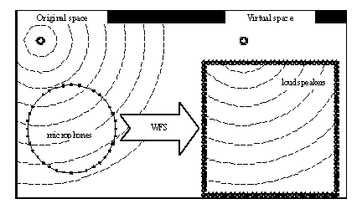
Figure 1-WFS process

In practice, WFS does in space what FIR filtering does in time, i.e. a sum of convolutions.
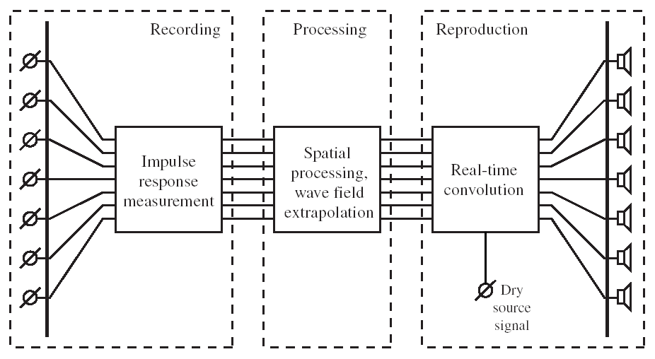
Fig. 2-WFS process

Result: creating in the listening room the same waveforms of the original space, you can get an excellent listening in the whole room (and not only in one point); the impression is that the virtual source is located in the real position. Moreover, WFS can create not only external virtual source, but also inside the room.
Problems: like virtual HO microphones, it’s really huge (it’s needed to record hundreds of channel); furthermore, you can get spatial aliasing if the maximum distance between 2 microphones is larger than half the wavelength.
Limitation: it’s an horizontal method, it doesn’t have the 3rd dimension (“z axes”).
WFS is the technology employed in “Casa del Suono”, Parma; it’s the biggest WFS installation in Italy and one of the most important in the world.
Theory
The WFS theory is based on spatial sampling (Huygens Principle): if there’s a true source radiating a set of curved waveforms, it can be replicated placing a number of smaller sources along one of these curved waveforms.
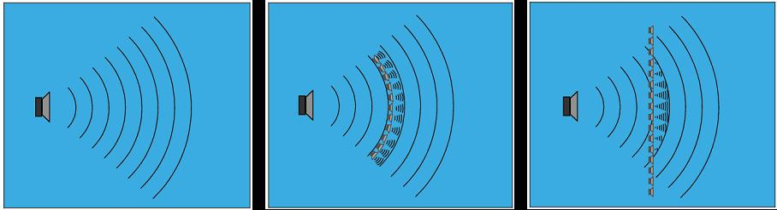
Figure 3-Waveform spatial sampling

With proper gains and delays, you can create a curved waveform (like it was radiated by a true source) even with a line array of loudspeakers, i.e. a straight line of loudspeaker, in which each loudspeaker is controlled independently with separated amplifications and DSP processing.
Not necessarily it has to be a surround system; a line array can be employed even only on one wall, giving the impression the virtual source is located beyond the wall, at infinite distance or also inside the listening room:
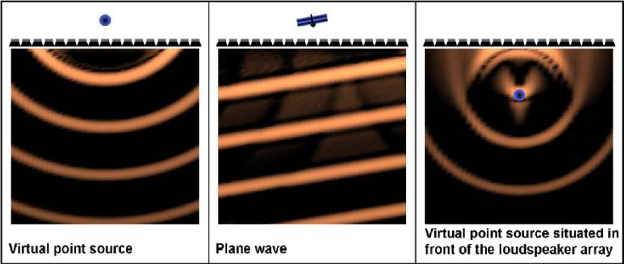
Figure 4-Different virtual sources
The workflow is similar to surround: you make your multichannel recording of what you like, and with a panner you can bring each sound track in the wanted position. This panner is employed by convolution in the Wavefield Synthetiser, which creates the effect of a virtual room.
Figure 5-Virtual environment synthesis with WFS

If you measure with a microphone mounted on a round table the impulse response of the real room, doing the convolution you can give to the listeners in front of the loudspeakers the impression the sources are located in a specific point within a virtual room, with the possibility of moving them during the digital performance (it’s really a virtual reality system).
In this way you are totally free to position sounds in space and in time.
Sound focalization
A line array can also focuses sound in a given position inside the room; beyond this focus point, you get the impression of curved waveforms coming from there and not from the loudspeakers.
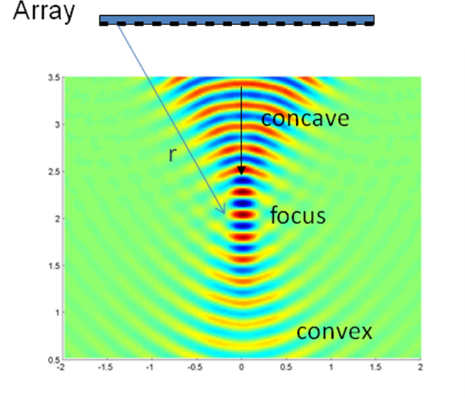 Figure 6-Sound focalization
The front curvature is achieved with a set of gains and delays, in particular each speaker has an advance in time equal to the fly time which separate it from the focus.
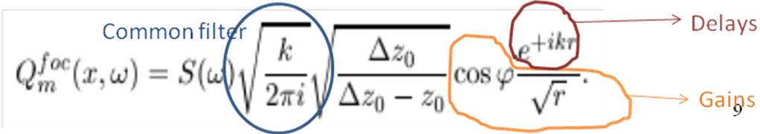
Figure 7-Formula for speaker signal,for line array

Like said before for microphones, you can get spatial aliasing with loudspeakers (it happens when you don’t comply with the spatial Shannon theorem): in fact, you should space loudspeakers maximum half the wavelength to avoid this problem.
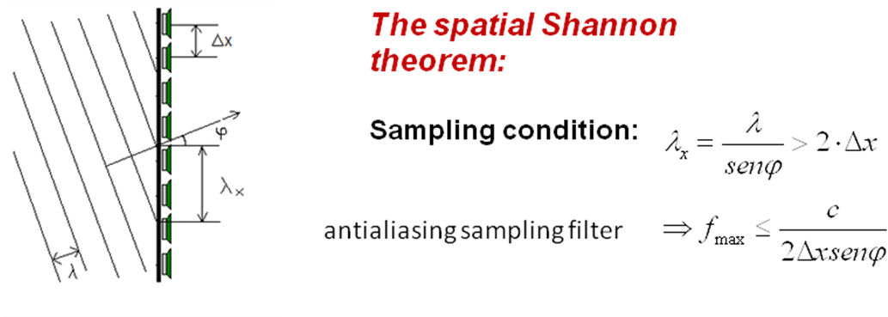
Figure 8-Spatial Shannon theorem

In spatial aliasing there’s a variable more than in time domain sampling (the angle of incidence φ); the largest the φ, the lower will be the maximum frequency before spatial aliasing starts to occur. When φ=0, the Shannon theorem is always verified; but you still need a reconstruction filter, because the secondary fronts are circular, and only in a sufficiently far field their envelope will be flat, whilst in the near field you will experience the spatial aliasing.
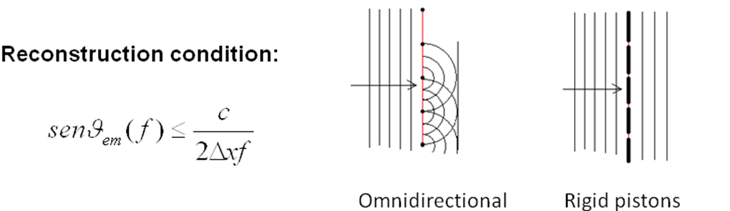
Figure 9-Discretization

Rigid pistons instead of point sources can solve the problem, since the front is flat from the beginning (in fact they can be considered like directional sources).
However, aliasing in space is not so bad as in frequency; spatial aliasing doesn’t destroy completely the audible spectrum, but creates second effects (secondary lobes), which create phantom sources usually more far than the principal one, and more weak.
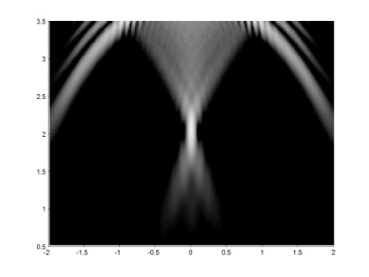
Figure 10-Secondary lobes
Another sensible parameter is the ratio array width on wavelength ($\frac{A}{λ}$), which mainly governs the beam and focus width: with λ comparable with the array length the focus will be very wide and the curvature of the fronts will be lost.
Casa del Suono (S. Elizabeth Church)

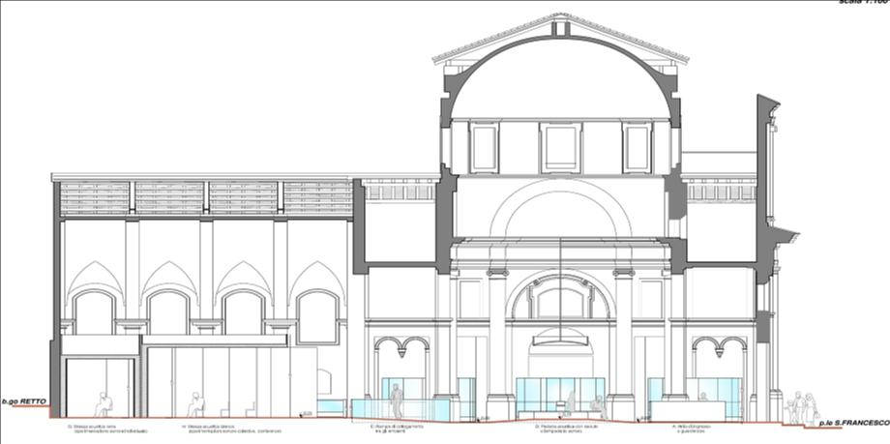
Figure 11-S.Elizabeth Church

This former church is now mostly converted in a museum of old radio equipment. Moreover, inside the building there are 3 sound stations installed: a sonic chandelier, 6 expositive niches and a WFS listening room (respectively SC, EN and LR in Figure 11).

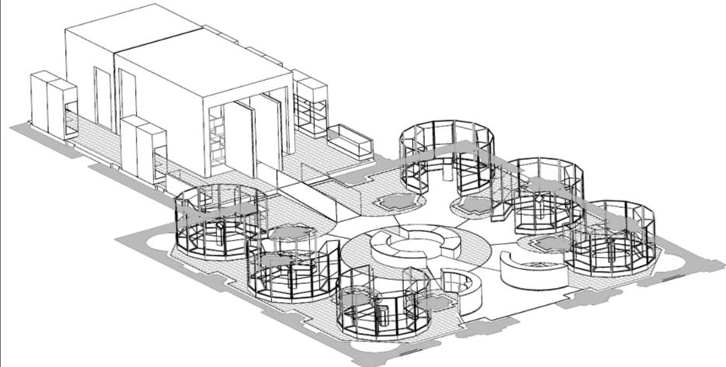
LR
EN
EN
EN
EN
EN
EN
SC
Figure 12-The sound stations

Nicchie espositive
Expositive niches are equipped with a playback system which makes you hear the sound of the exposed radio equipment, so you can hear how sounds were reproduced in a specific historical period.

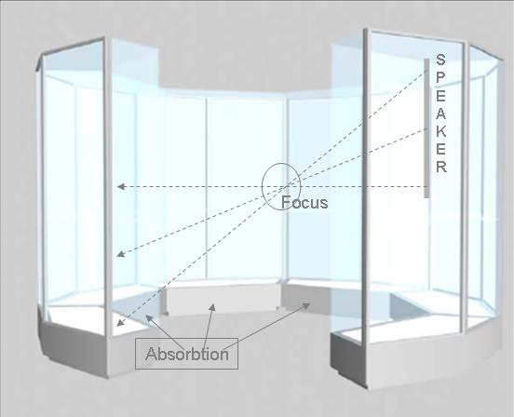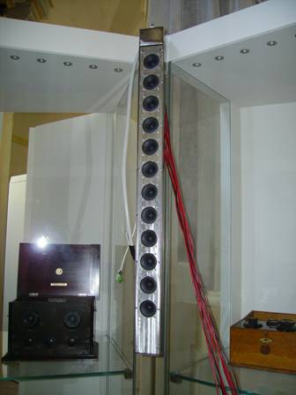
Figure 13-Niches sound system

The sound system is equipped with vertical line arrays of loudspeakers, mounted between glass cases, focusing the sound where the listener stays, i.e. in front of the touch screen computer, which allows the listener to hear music of the chosen historical period with the equipment of the same period.

Vertical array is controlled by QSC-BASIS DSP controller; again, it’s just a trick of gains and delays. Generally, all the programming is done graphically (and not writing codes for controlling).
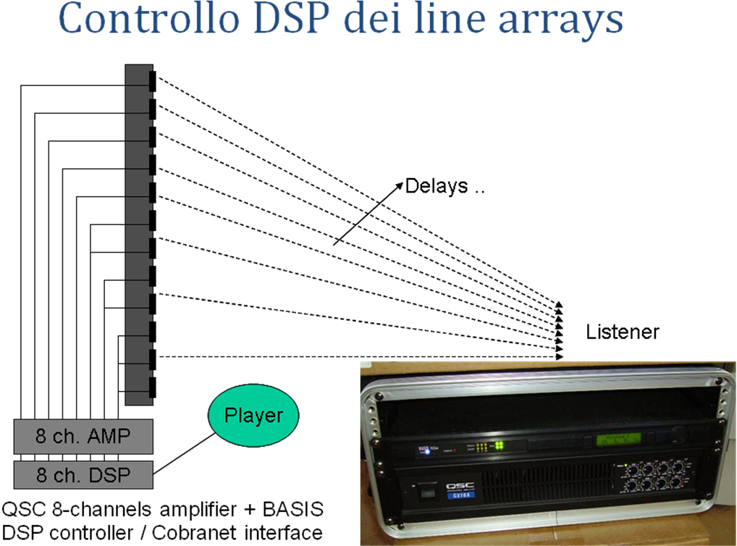
Figure 14-DSP controller

When you go in front of the computer, the sound appears magically at your ears and it’s focused only on you; thanks to sound absorbing material on the floor, you don’t pollute with music you’re listening the whole museum. Line arrays are almost invisible in the junction between two glass cases.
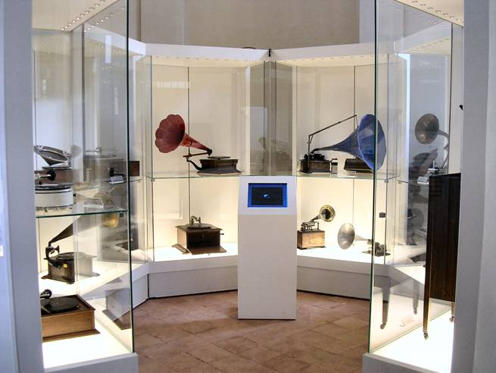
Figure 15-Nicchia 1:fonografi e grammofoni

Lampadario Sonoro
The sound is focused for people staying inside the central area, avoiding to launch sound everywhere (the museum was a church, reverberation time is long and it would be very noisy).
The floor is high-absorbing, and the focused sound is moved only around the listening area (about 0,5 m diameter); outside, the sound is bad and weak by purpose.

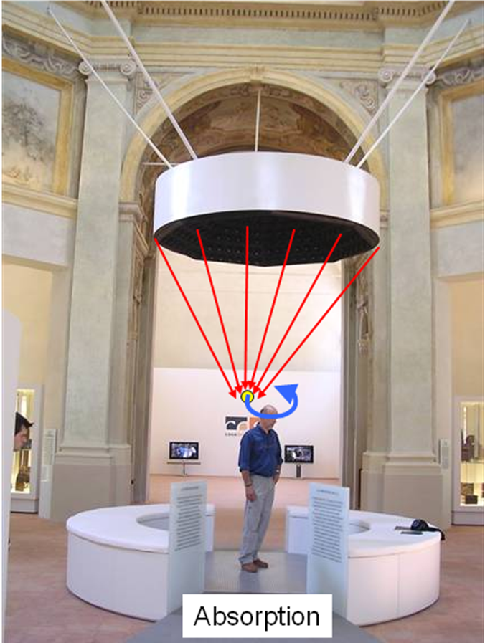
Figure 16-The sonic chandelier
At high frequency you get spatial aliasing and the focused area is smaller; at low frequency, you don’t have spatial aliasing but the focused area is bigger.
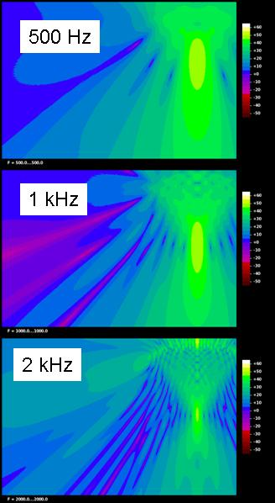
Figure 17-Sonic chandelier at different frequencies

A single PC with a MADI card controls the system; there are 8 DAC (Digital to Analog Converter), everyone capable of 8 channels. Each converter feeds an 8-channel power amplifier, so totally there are 64 channels of amplification.
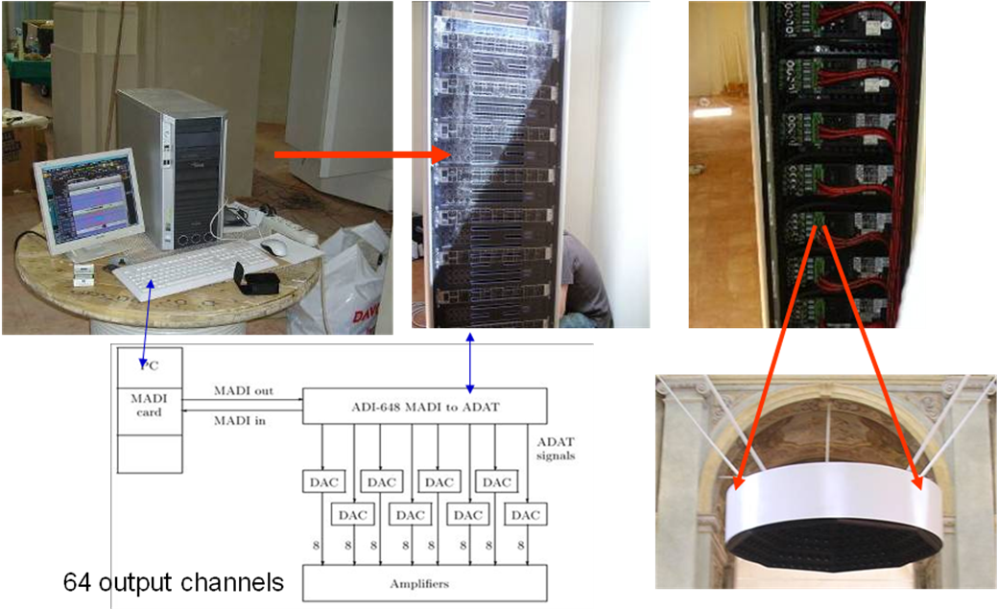
Figure 18-Hardware di pilotaggio

Loudspeakers are much more than 64 (more or less 226, wired together in groups of 2 or 3), so any channel doesn’t feed only one loudspeaker, but 2 or 3.
Sonic chandelier is substantially a musical instrument, where a music composer can choose where the sound comes; with a graphical interface, the artist can move the sound in the listening area like he wishes.
Sala Bianca
This is the WFS listening room; it employs 192 loudspeaker and it allows up to 30 listeners.
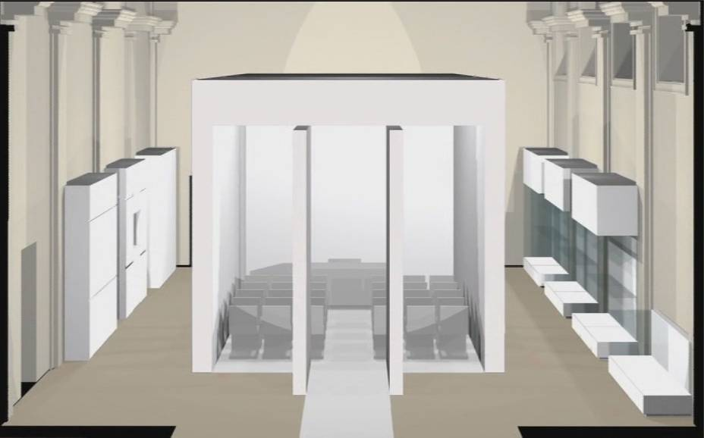
Figure 19-Sala Bianca

Loudspeakers are invisible, because embedded in the sound absorbing structure of the walls, so you just see white walls covered a material good for projecting images.
The system of Sala Bianca requires much more channel, because in this case each loudspeaker is independently controlled.

Finally, there’s the Single seat room (Sala monoposto): it’s located in Casa della Musica (in front of Casa del Suono).
The single-seat room is equipped with high-order Ambisonics and stereo dipoles, and it has 26 loudspeakers.

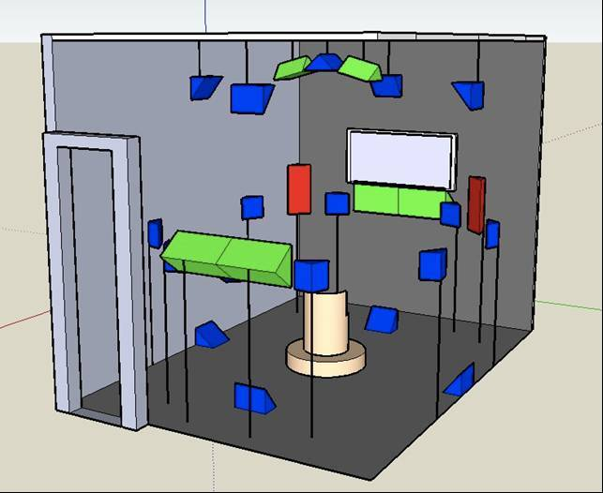
Figure 20-Sala monoposto

Below the separated groups of loudspeaker:
- Stereo standard;
- Horizontal 8-channel Ambisonics ring;
- Vertical 8-channel Ambisonics ring (which can work together with the previous);
- Frontal Stereo Dipole;
- Rear Stereo Dipole;
- Upper Stereo Dipole (but it doesn’t work).

